# Build a Cloud-native Web App to Manage Product Reviews using API Gateway, Aurora, and RDS proxy

Created by[Chandra Lingam](https://deloittedevelopment.udemy.com/user/e7c3b177-f449-448a-aff8-9ef970b23152/)

**AWS Workspace**

**120-180 minutes**

In this lab, you are a software developer building a web app for managing products and their reviews. The company you work for is new to the cloud. Your tech lead has asked you to build a proof-of-concept using AWS serverless compute offering such as Lambda for the application logic with data stored in an Aurora relational database. The solution you create must minimize the infrastructure footprint with elasticity to handle changes in traffic.

Our applications are currently hosted on on-premises servers, and the application traffic is unpredictable. So, we often end up with idling servers or over-utilized servers. As part of the cloud migration, we are looking at a cloud-native solution that can dynamically scale based on traffic. We also want to minimize expenses when there is no application traffic. As our team is new to AWS cloud, we want to build a proof-of-concept application and learn from it. You will build a micro-service for managing products and reviews. You will use API Gateway as the "front door" Lambda for the application logic, and Aurora Relational database for data storage. For hosting the web page, you will use Amazon S3.

The web page must use client-side JavaScript to interact with your API Gateway. For connection-pooling, your Lambda function must use RDS Proxy to talk to the database. You should maintain the database login credentials in AWS Secrets Manager, and RDS Proxy must use these credentials to connect to the database. Your Lambda function would acquire a connection from RDS Proxy using IAM Role. In this solution, only Aurora is server-based, and the rest of the application uses serverless technologies.

**How you'll work**

Your project has been broken into a set of tasks. To complete these tasks, use the provided workspace. You can launch your workspace by clicking below or using the button in the top right of the screen.

TASK

1-Design able for storing products and reviews(botto-up)

2-design resource and HTTP methods for API (top-down)

3-Launch Aurora database instance in default VPC

4-Configure Secrets Manager to store datsbase crendential

5-Launch RDS proxy in default VPC

6 Create a Lamba Layer for python pymysql library and IAM role for Lambda function

7-Create a health check Lambda function to test database connectivity,create table, and populate data

8-Integrate database Proxy and Lambda layer with health check lambda function

9-Invoke health check function

10-implement CRUD backend functionality

11-Integrate Database proxy and Lambda layer with the produc review function

12-Create an HTTP API Gateway

13-Integrate Test using API Gateway

14-configure a bucket in S3 to host your website

15-Upload webpage to S3

16-Visit the product-review website and test all features

17Clean Up

Design able for storing products and reviews(botto-up)

You need to design relational tables for storing products and reviews. There could be many products; each product could have several reviews. So, design two tables, one for "product" and another for "review". Ensure design allows a review only for existing products. You should use Aurora-MySQL data types.

1. Create a product table and add columns for the product category and product title
2. Include primary key to uniquely identify a product
3. Include sum of ratings and count of ratings in the product table to find the average rating
4. Here is what your Product table design table should look like:

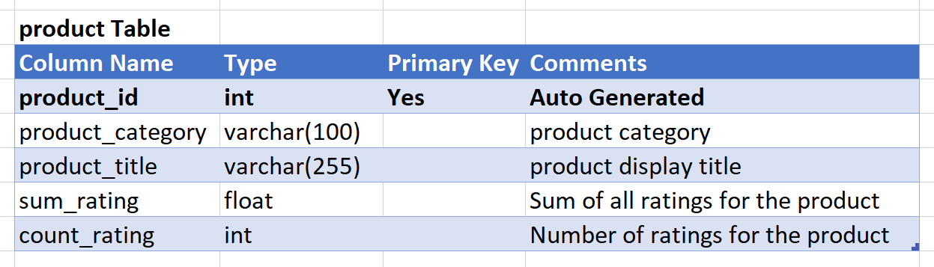

1. Create a review table, and include a foreign key to refer to the product
2. Add a date-time column to record when a review was added
3. You also need columns for review headline and body
4. Finally, add a column for rating given by the reviewer
5. Your Review table should look like this:

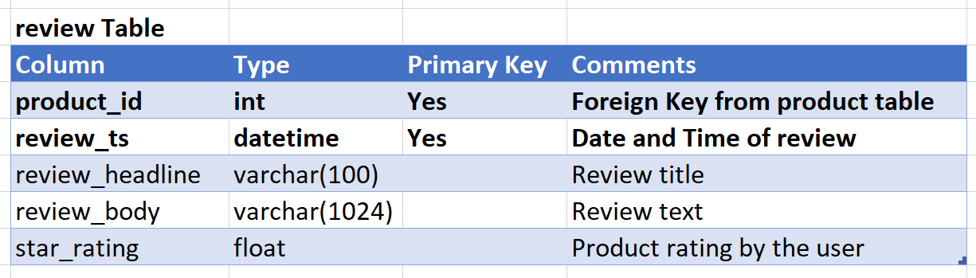

<https://www.w3schools.com/mysql/mysql_create_table.asp>

<https://www.w3schools.com/mysql/mysql_datatypes.asp>

<https://www.w3schools.com/mysql/mysql_autoincrement.asp>

Design resource and HTTP methods for API (top-down)

You will need to design a RESTful API for CRUD (Create Read Update Delete) of products and reviews. The API must allow a client application to view and manage products and reviews

1. For the API, create two resources: **products**, and **reviews**
2. For CRUD operations, use the HTTP methods **GET, POST, PUT, DELETE**
3. Include methods to read all products, to read a specific product, create a new product, update an existing product, delete an existing product
4. Include methods to read reviews for a specific product, create a new review, and to read a specific review for a product
5. Add a query string parameter to limit the number of results returned in a call and to filter the reviews by rating
6. Your API design would now consist of the following resources and methods:
7. GET /products # Read all products
8. GET /products?limit=10 # Read specified number of products
9. GET /products/{productId} # Read specified product
10. POST /products # Create a new product
11. PUT /products # Update an existing product
12. DELETE /products/{productId} # Delete an existing product
13. GET /products/{productId}/reviews # Read all reviews for a product
14. GET /products/{productId}/reviews?star_rating=4 # Read reviews with specified star rating
15. GET /products/{productId}/reviews/{reviewId} # Read a specific review
16. POST /products/{productId}/reviews # Create a new review

<https://blog.stoplight.io/crud-api-design>

Launch Aurora database instance in default VPC

Launch an **Aurora MySQL Compatible** database instance in the **default VPC**. Launch the database as a development instance without multi-AZ deployment. Name the **cluster** as **demodatabase** and with an **initial database** **productreview**. Ensure the database instance has the **default** security group attached.

1. Open RDS service console

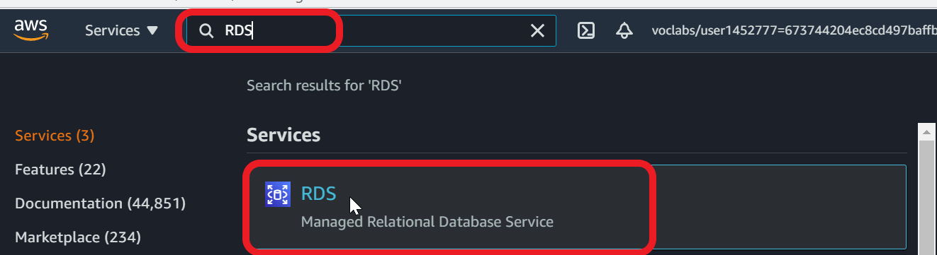

1. Select **Databases** in the navigation pane
2. **Create database**

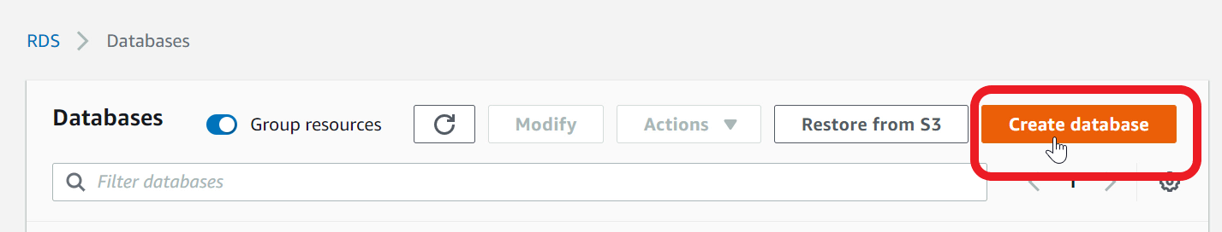

1. For **database creation method** - select **Standard Create**

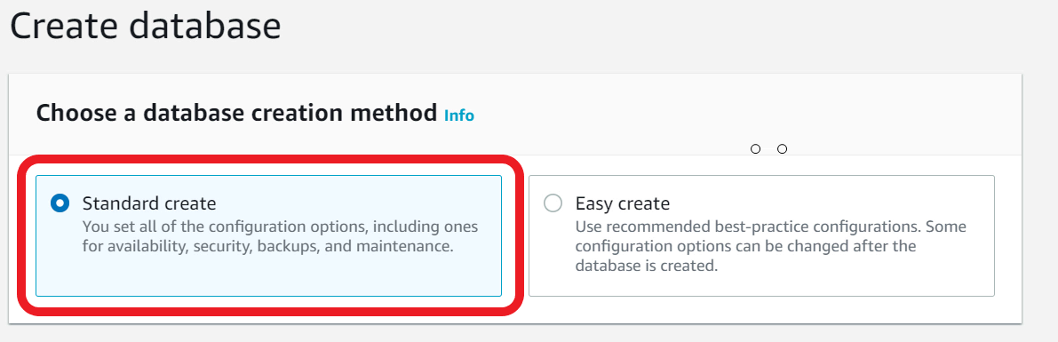

1. Under **Engine Type** - select **Amazon Aurora**

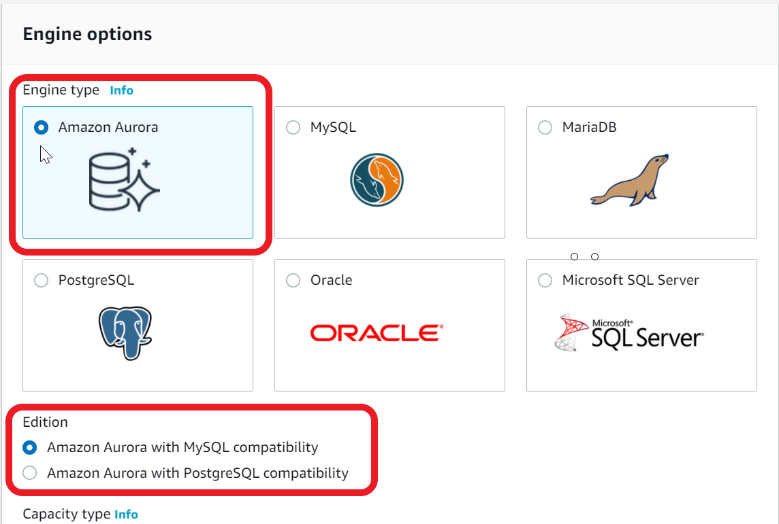

1. Edition - select**Amazon Aurora with MySQL Compatibility**
2. Capacity Type - choose **Provisioned**
3. Scroll to **Templates** section - select **Dev/Test**

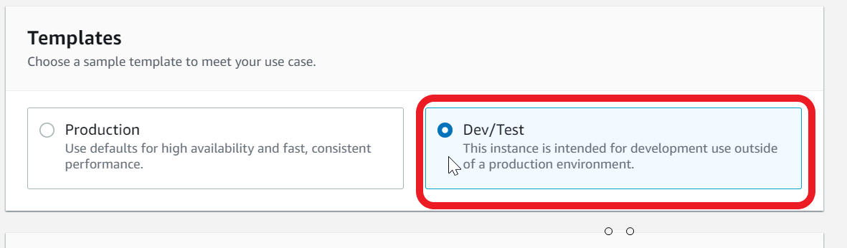

1. Under **Settings**, specify **DB Cluster Identifier** - type **demodatabase**

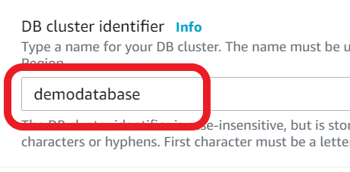

1. For **Master username** - type **admin**
2. For **Master password** - type **lab21Wow!**

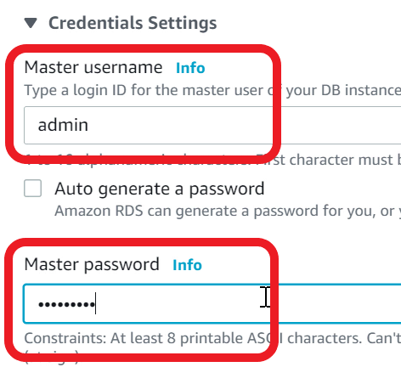

1. **Confirm password**
2. Under **DB Instance Class** - choose **Burstable classes**
3. Ensure **db.t3.small**is selected in the choice list

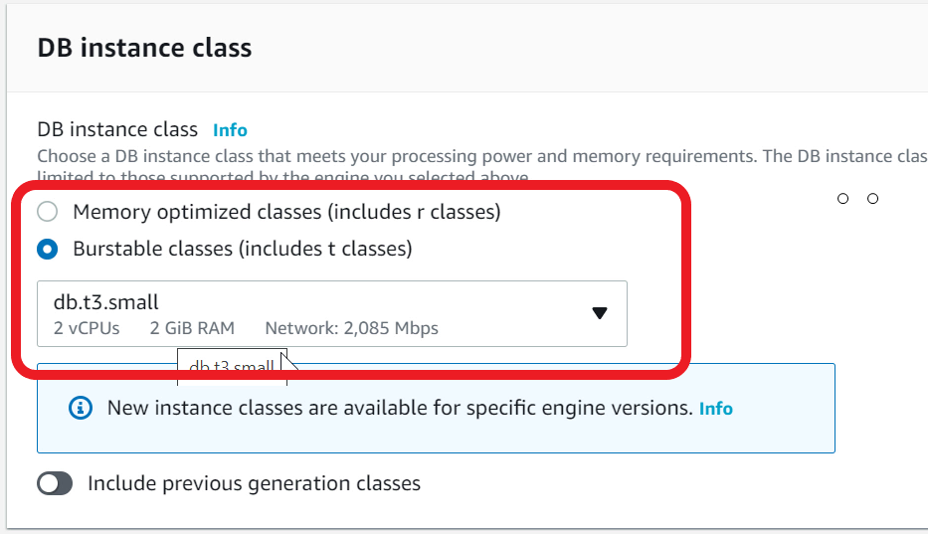

1. Under **Multi-AZ deployment** - select **Don't create an Aurora Replica**
2. Under **Connectivity** - ensure **Default VPC** is used

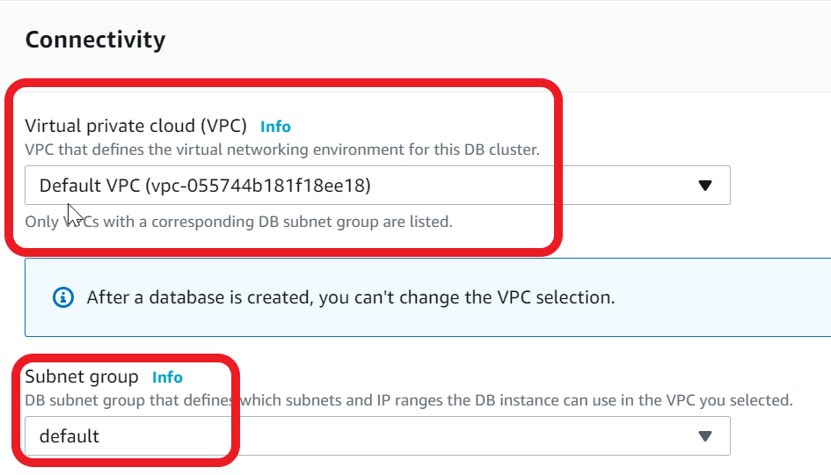

1. For **VPC security group -**select **Choose existing**
2. Ensure the **default** Security Group is attached

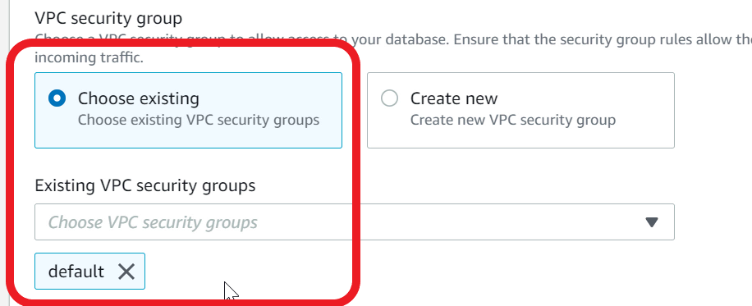

1. Expand **Additional Configuration**
2. For **Initial Database name** - type **productreview**

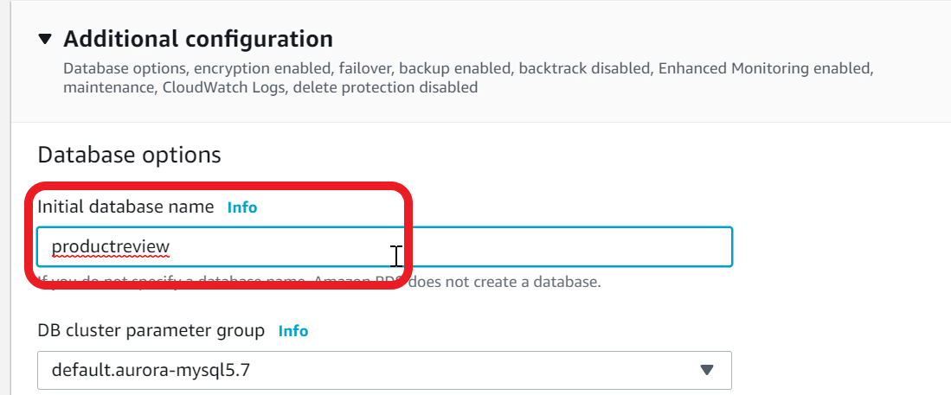

1. Scroll to bottom and **Create database**
2. Database instance creation will take 10-15 minutes
3. Wait until database **Status** changes to **Available**(you may have to refresh the page periodically)

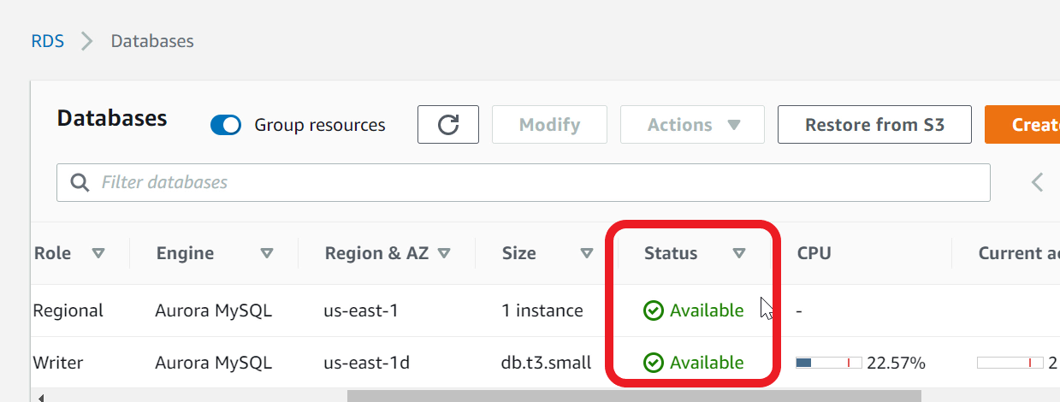

<https://docs.aws.amazon.com/AmazonRDS/latest/AuroraUserGuide/CHAP_GettingStartedAurora.CreatingConnecting.Aurora.html>

Configure Secrets Manager to store datsbase crendential

You will need to store the database **admin** user credentials in the **Secrets Manager**. The RDS Proxy that you will create later must use this secret to connect to the Aurora database.

1. Open **Secrets Manager** console

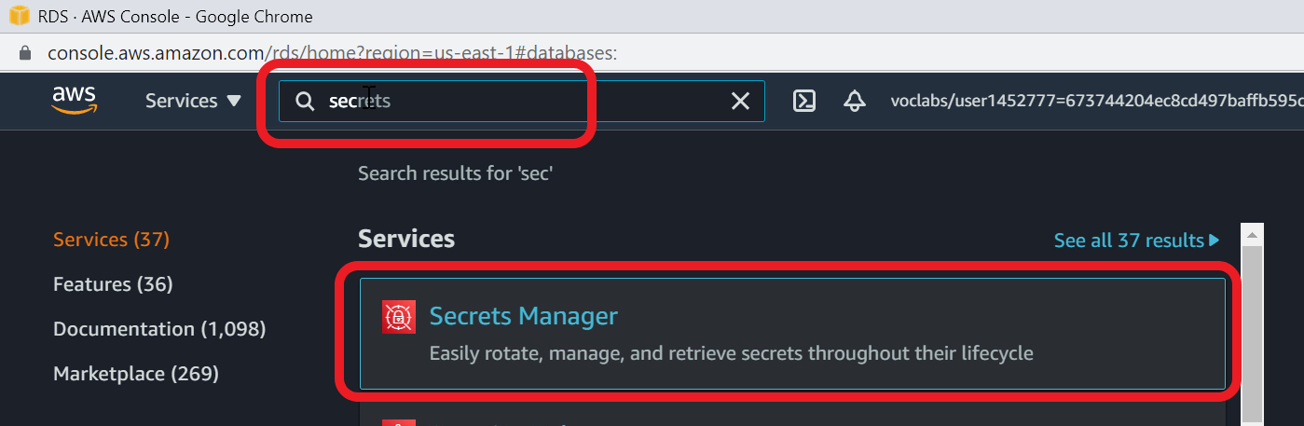

1. **Click on Store a new secret**

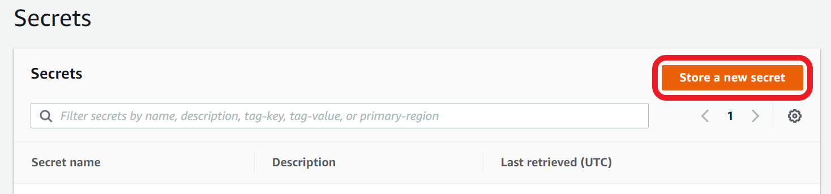

1. For **Secret type** - Select **Credentials for RDS database**

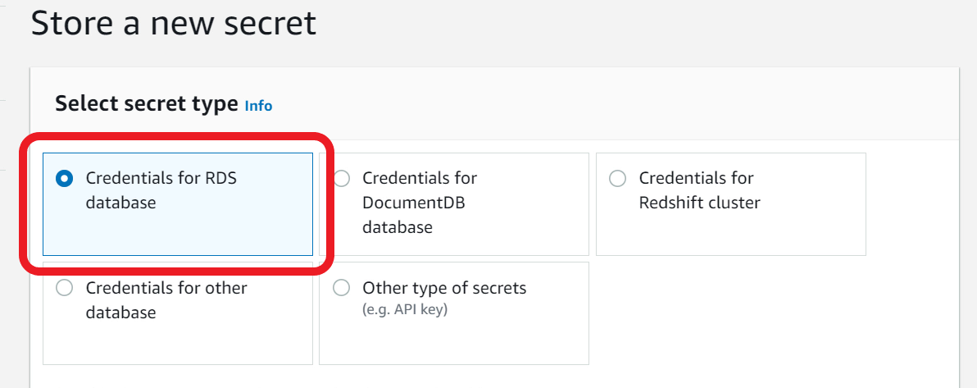

1. For User name - type **admin**
2. For Password - type **lab21Wow!**
3. Note: For production usage, you must create an application specific database user and not use admin
4. Scroll down to **Select which RDS database this secret will access**
5. Choose **demodatabase**

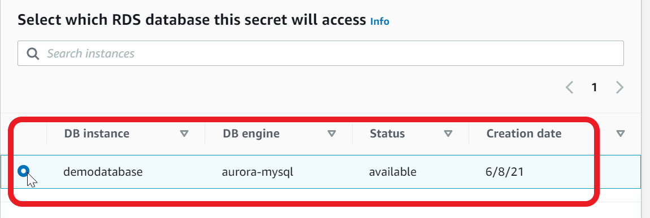

1. Go to **Next** page
2. For **Secret name** - type **productReview/demo/admin**

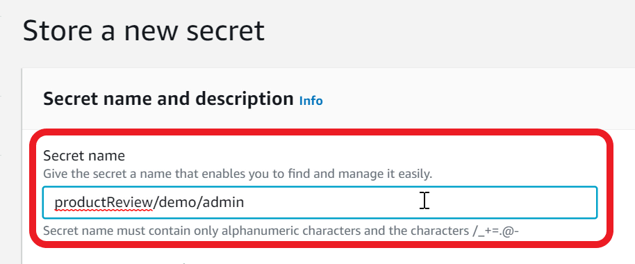

1. If you get an error that the secret name already exists or is scheduled for deletion, you can add a suffix to the new name such as **productReview/demo/admin01**. Make sure you use the new secret for subsequent steps
2. Continue to **next**page until you see the **review** page and **Store** the secret

Mark task as complete

Report issue

Launch RDS proxy in default VPC

You will need to launch an **RDS Proxy** for your Aurora-MySQL compatible database instance. Name the proxy as **productreviewproxy**.

Deploy the RDS Proxy in the **default VPC** and attach the **default securitygroup**. The RDS Proxy must require **IAM authentication** for applications to request connection. For database credentials, you must configure the proxy to use the **secret** that you created previously. Ensure proxy supports **Transport Layer Security**.

1. From **RDS Console**, Select **Proxies** in the navigation pane
2. Click on **Create Proxy**

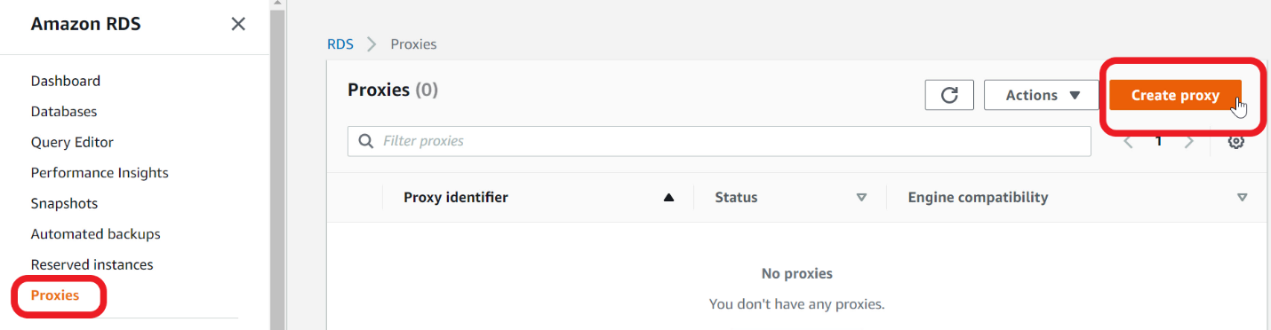

1. For **Proxy identifier** - type **productreviewproxy**
2. Ensure **Engine compatibility** is set to **MySQL**
3. **Select** the **Require Transport Layer Security** check box

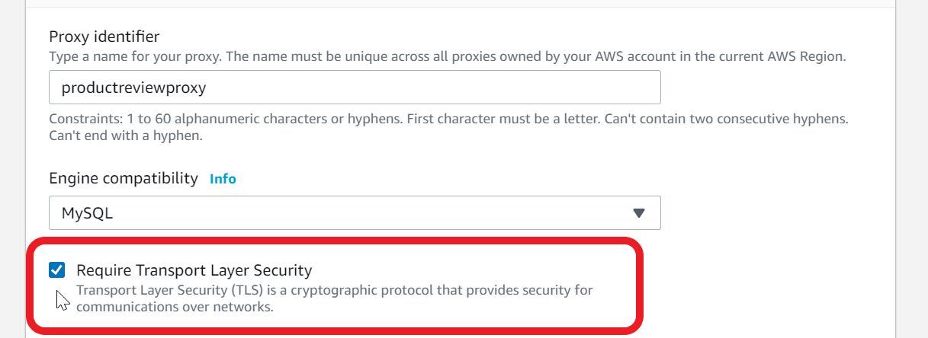

1. Scroll down to Target group configuration
2. For **Database** - select **demodatabase**
3. Goto **Connectivity** section
4. Under **Secrets Manager secrets** - select **productReview/demo/admin** that you created previously
5. For **IAM role** - select **Create IAM role**

Note - This will automatically create a new role with required permissions to access secrets manager

1. For **IAM Authentication** - select **Required**

Note - With this option, application can get connections from RDS Proxy using IAM roles - recommended and secure

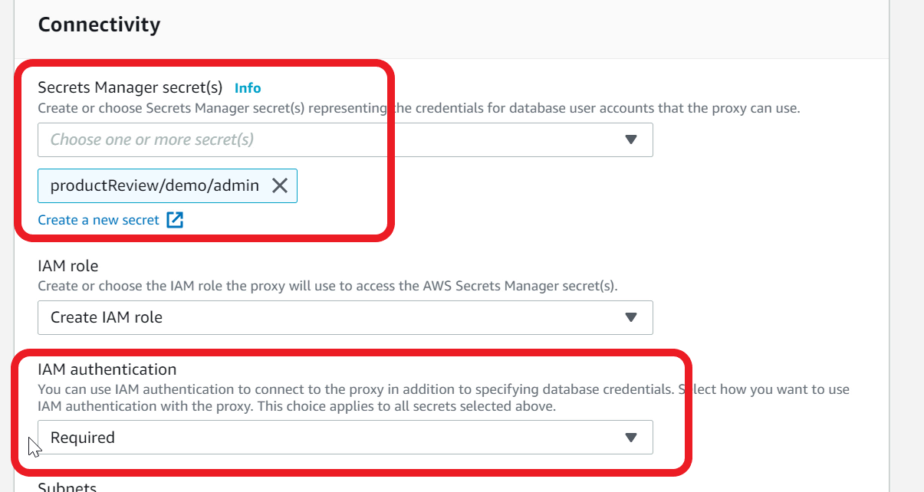

1. For **Subnets** - ensure all the subnets in the default VPC are selected. Note - the **subnet-ids** will be **different**.

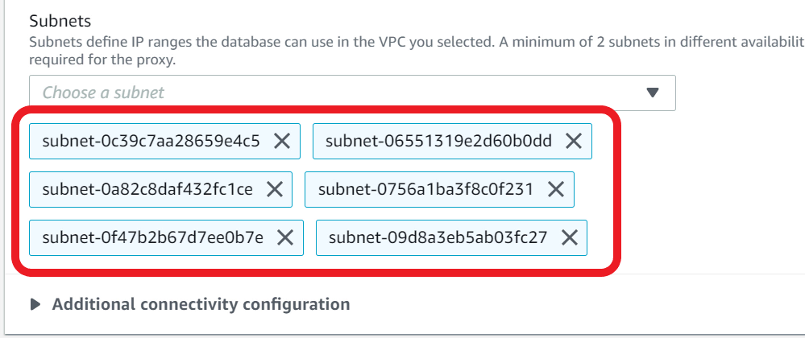

1. Expand **Additional connectivity configuration**
2. Ensure for **VPC Security Group** - **Choose existing**is selected
3. Ensure **default** security group is selected and shown in the **Existing Security Groups**

Note - Since Aurora database and RDS Proxy are in the same **default** Security Group, they can communicate with each other

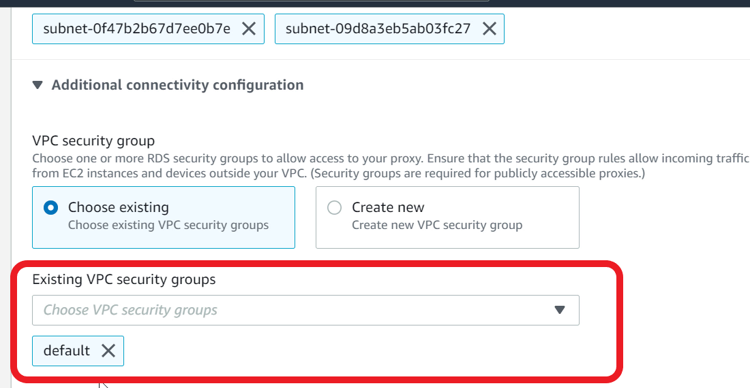

1. Click on **Create Proxy**
2. RDS Proxy creation should take **10-15 minutes**. Wait until the status changes to **Available**(you may have to refresh the page periodically)

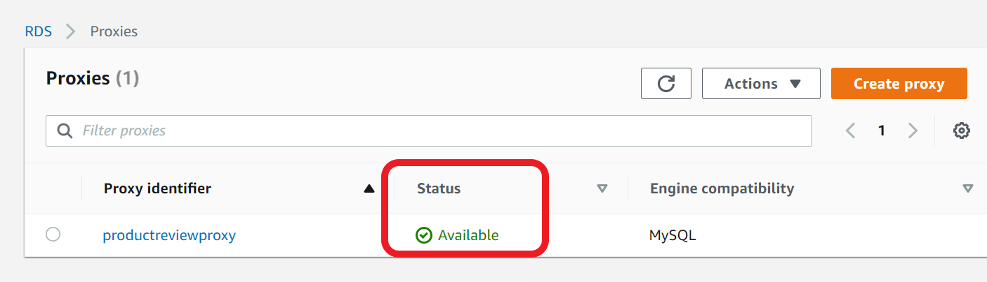

<https://aws.amazon.com/rds/proxy/>

Create a Lamba Layer for python pymysql library and IAM role for Lambda function

PyMySQL is a Python library that you can use in your Python code to connect to an Aurora-MySQL compatible database and RDS Proxy. PyMySQL is not part of the Lambda Python runtime, so you need to add this library as a Lambda Layer. Once the Layer is created, you can add the Layer to many Lambda functions. You would also need to create an IAM Role so that your lambda function can log to CloudWatch log and run inside a VPC.

1. Download the **layer-pymysql.zip** file available in the Resources folder under 'Assets'.
2. S**ave** the file to your local computer, and we need this zip to create a Lambda layer
3. Open **Lambda** Console

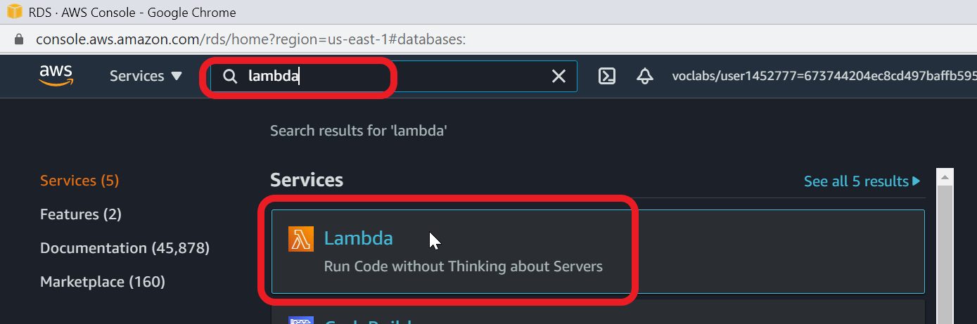

1. Choose **Layers** from navigation pane
2. Click **Create layer**

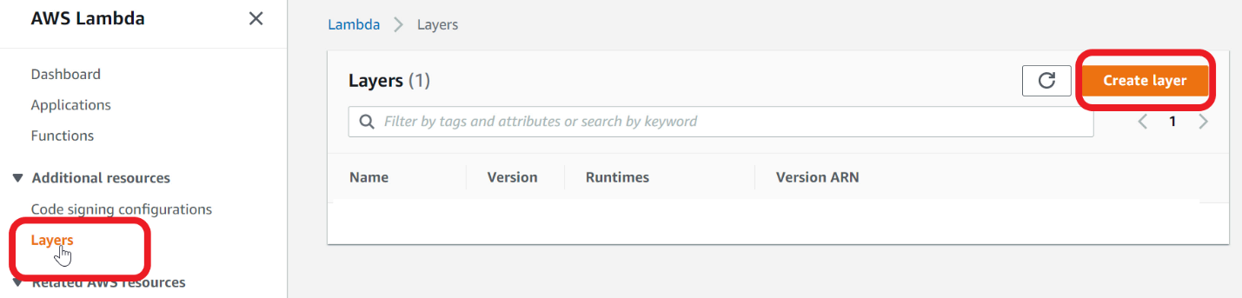

1. For **Name** - type **layer-pymysql**
2. Provide a **Description** - type **pymysql python library**
3. Select **Upload a zip file**
4. Choose the **layer_pymysql.zip** file that you saved earlier on your local computer
5. For **Compatible runtimes** - select **Python 3.7** and **Python 3.8**

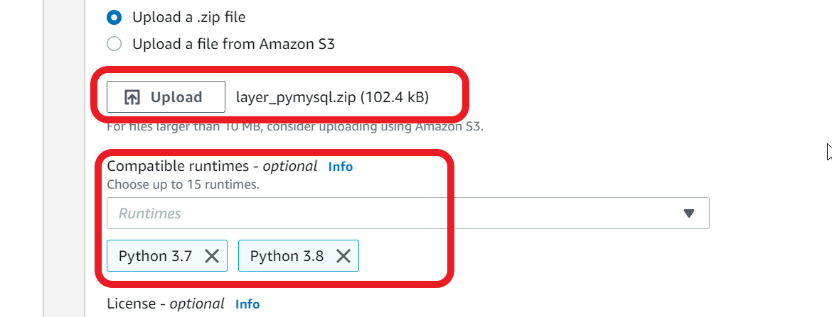

1. Click **Create** Layer
2. Lambda Layer is ready to use

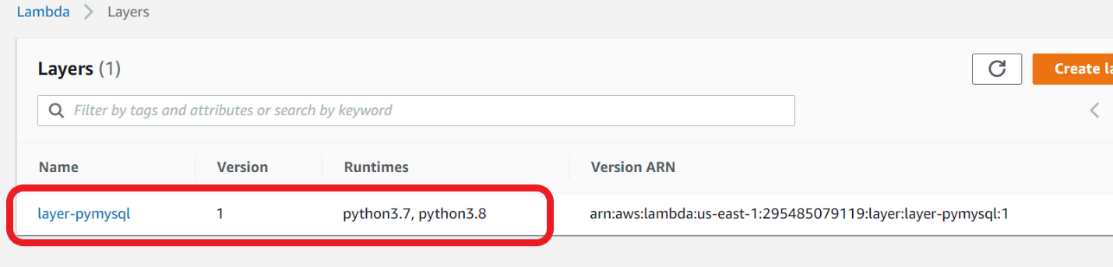

1. You now need to create an IAM Role for the Lambda function
2. Open **IAM** Console

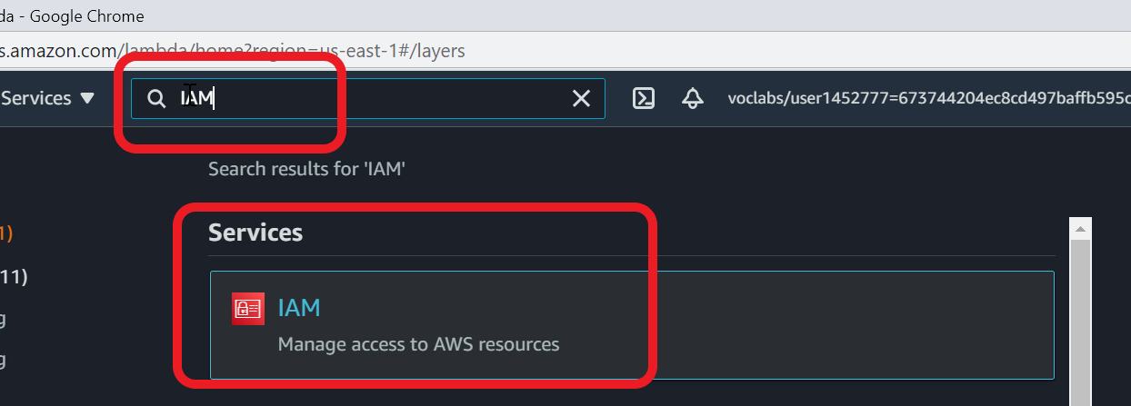

1. Select **Roles** from Navigation pane
2. Click **Create role**

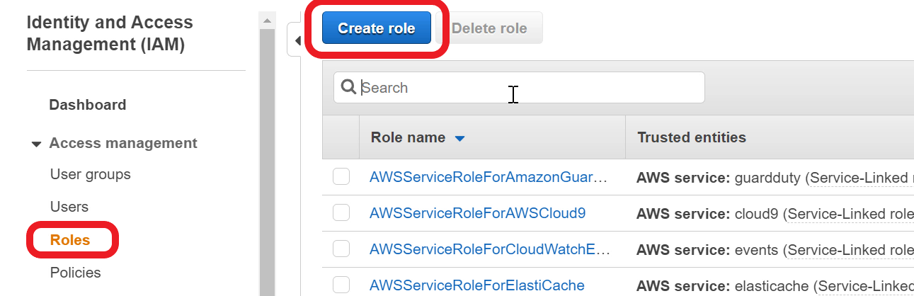

1. Ensure **AWS Service** is selected. Under **Choose a use case** - select **Lambda**

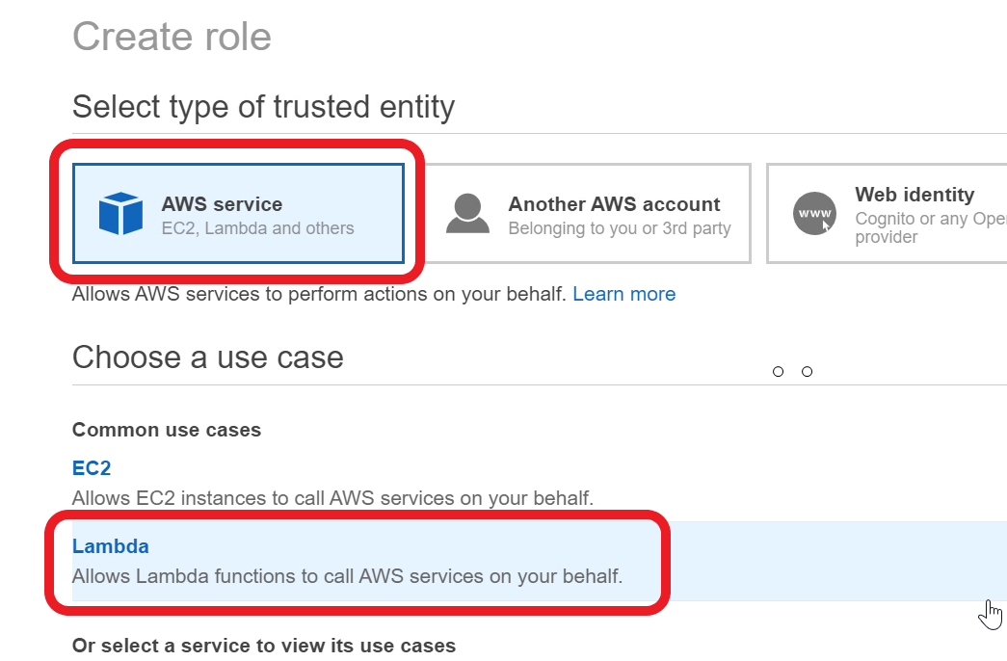

1. Go to **Next: Permissions** page
2. In the **Filter** text box - type **AWSLambdaBasicExecutionRole**
3. Select the **AWSLambdaBasicExecutionRole.** This grants permission to log to CloudWatch Log

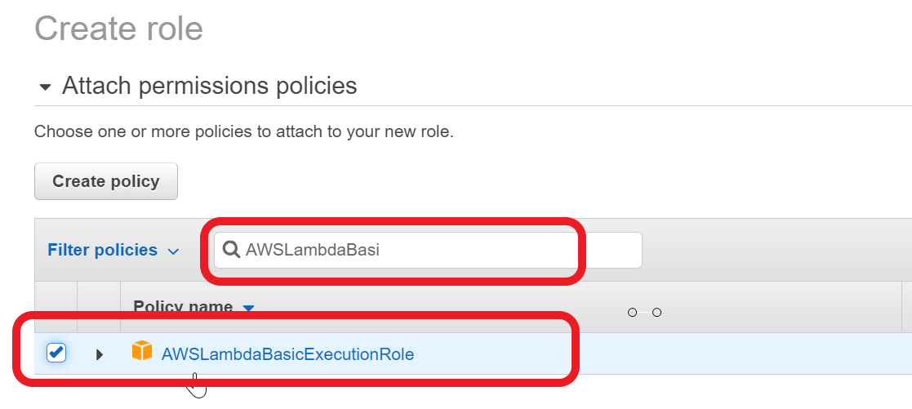

1. In the **Filter** text box, now type **AWSLambdaVPCAccessExecutionRole.**
2. Select **AWSLambdaVPCAccessExecutionRole.**This policy grants permission to create a network interface inside a VPC. This is needed as the health check lambda function will run in the default VPC

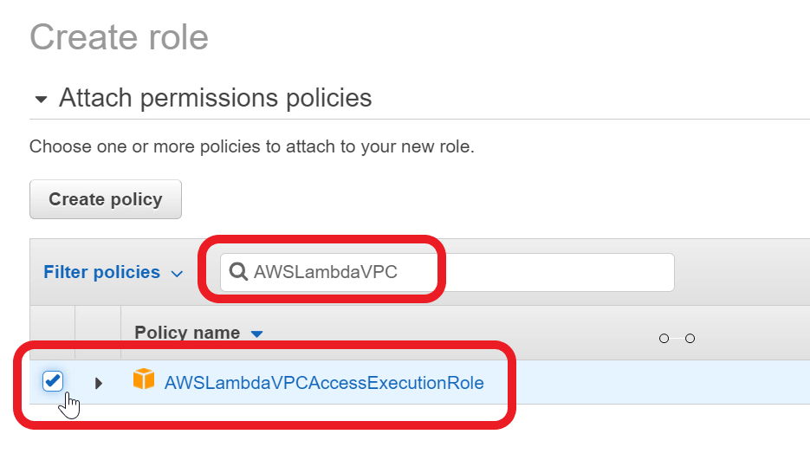

1. Go to **Next**page. Continue to **Next: Review**page
2. For **Role name** - type **lambda_rds_vpc**
3. For **Role description** - type **allow lambda to log, and run inside VPC**

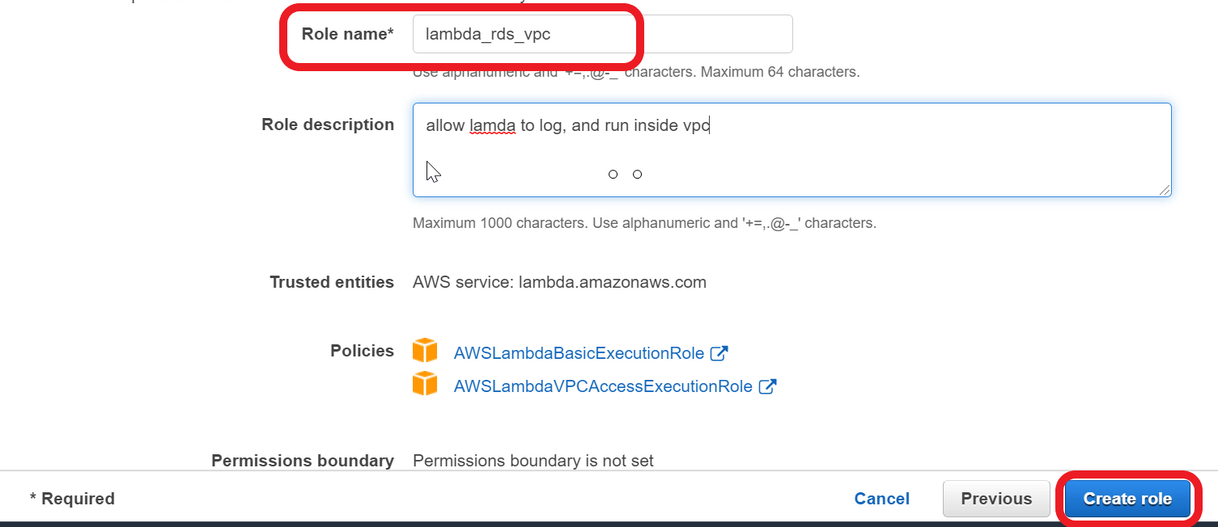

1. Click **Create role**
2. IAM role is now ready

Ref layer_pymysql.zip doc

<https://docs.aws.amazon.com/lambda/latest/dg/configuration-layers.html>

Create a health check Lambda function to test database connectivity,create table, and populate data

You now need to build a health check Lambda function to **test** database connectivity, create the product and review tables, and populate a couple of products and reviews. The health check function would help you troubleshoot and fix connectivity issues. This Lambda function needs to use the **RDS Proxy endpoint** to acquire a database connection. Deploy the Lambda function in the **default VPC** and attach the **default security group** to the function.

1. Open **Lambda** console
2. Click on **Functions** in the navigation pane
3. Click **Create function**
4. Choose - **Author from scratch**
5. For **Function name** - type **product_review_healthcheck**
6. For **Runtime** - select **Python 3.8**

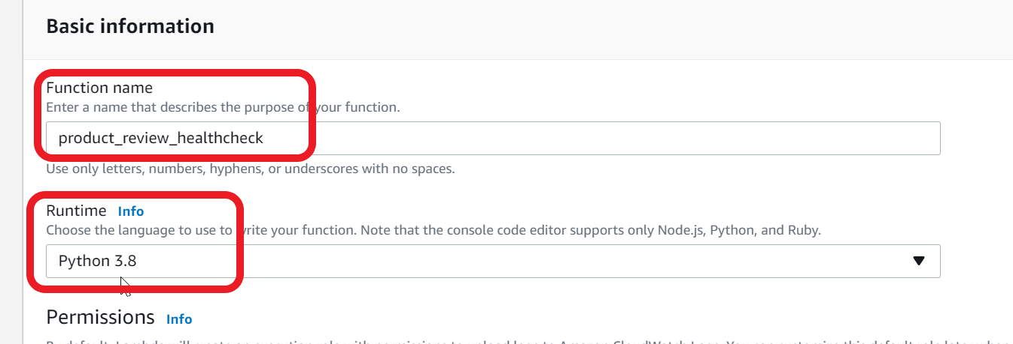

1. Under **Permissions** - expand **Change default execution role**
2. Select - **Use an existing role**
3. In the **Existing role** choice list - select **lambda_rds_vpc** role that you created earlier

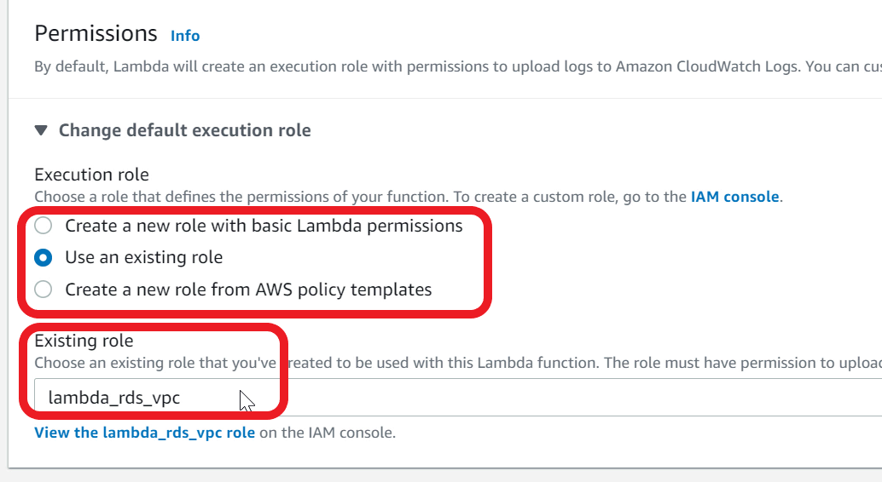

1. Expand **Advanced settings**
2. For **VPC** - Choose **Default**VPC. Note - VPC-id will be different for your console.

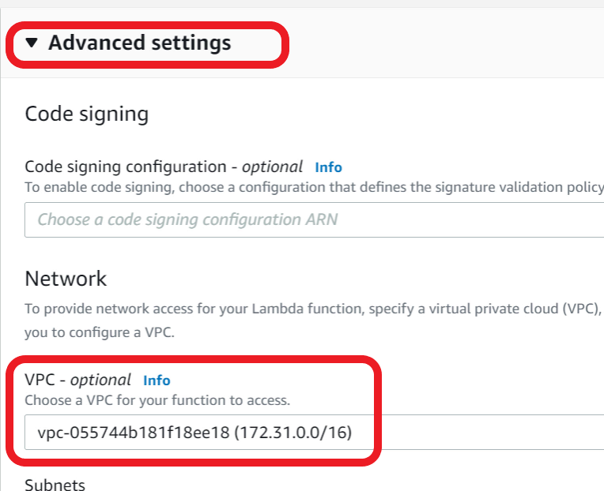

1. For **Subnets** - Choose all available subnets

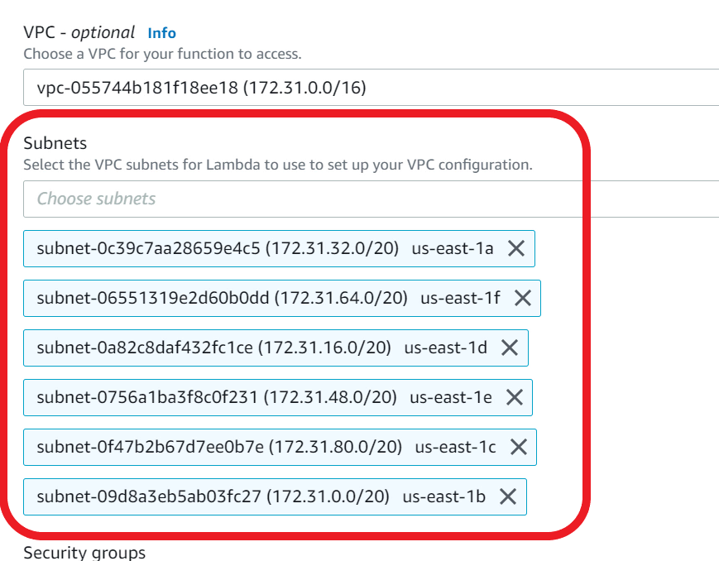

1. For **Security Group** - choose **default VPC security group**

This security group allows lambda function to connect to RDS Proxy as both are attached to default security group

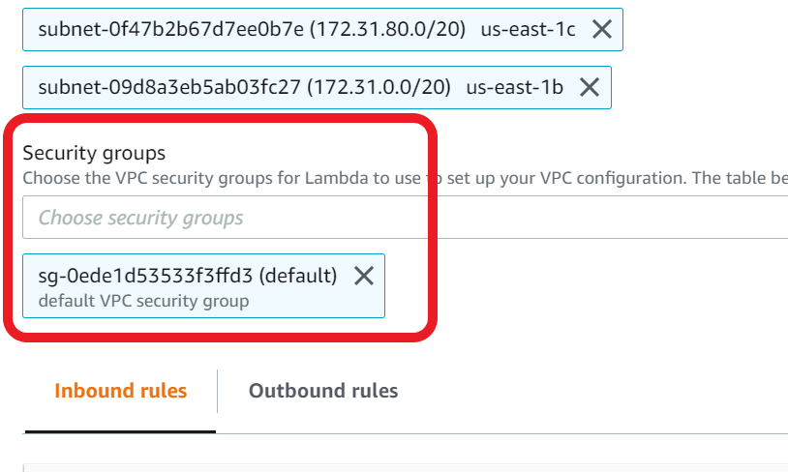

1. Click **Create function**
2. Lambda will take a **few minutes** to create the function and attach to VPC. You may notice the **screen refreshing** on its own when it is creating the function. Give it a couple of minutes for the function to be created
3. Download the **healthCheckLambda.zip** file available in the assets.
4. **Save** the file to your local computer. This file has the code for health check function
5. In the Lambda console, scroll down to the **Code** section

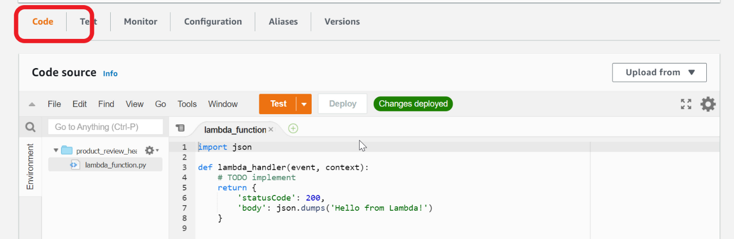

1. In the **Upload from** choice list, select **zip file**

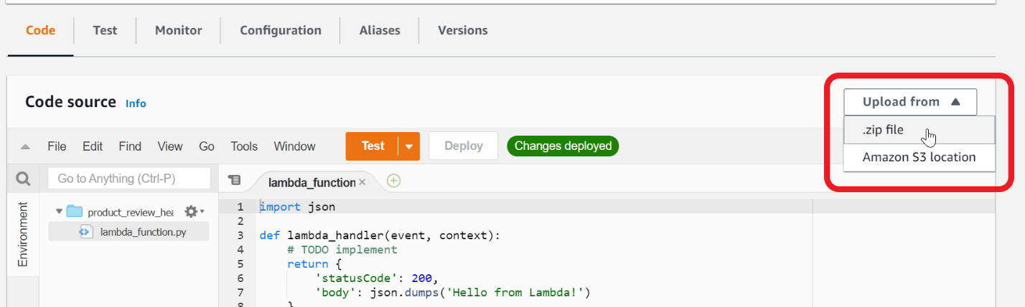

1. Choose the **healthCheckLambda.zip** file that you saved earlier on your local computer

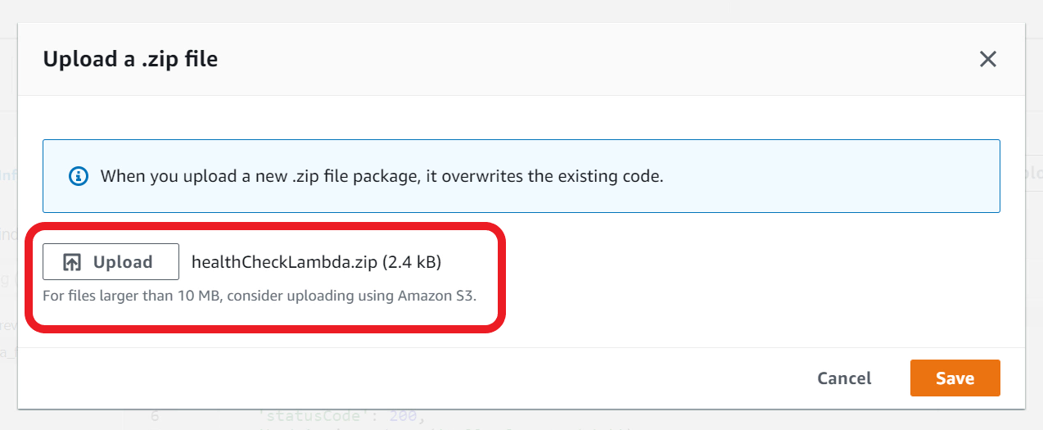

1. Click **Save**. You can now view the health check function implementation.

Ref healthcheckLamda.zip doc

<https://pypi.org/project/PyMySQL/>

Integrate database Proxy and Lambda layer with health check lambda function

Ensure your function code uses Database Proxy and Lambda Layer.

1. In the **product_review_healthcheck**Lambda function, scroll down to the **code section**
2. Update the **proxyEndPoint** variable value to point to your **database proxy endpoint**

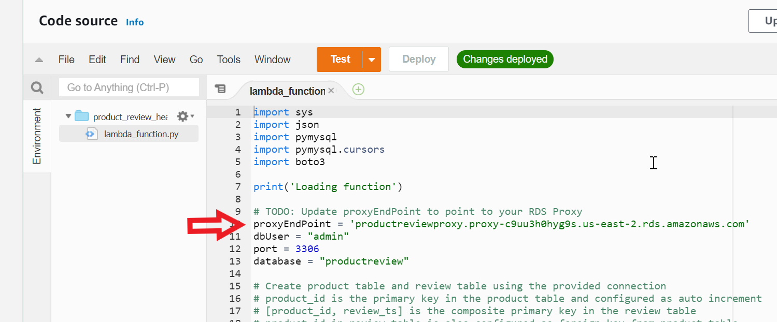

1. To find the Proxy endpoint, open **RDS** Console
2. Choose **Proxies** from the navigation pane. Select **productreviewproxy**

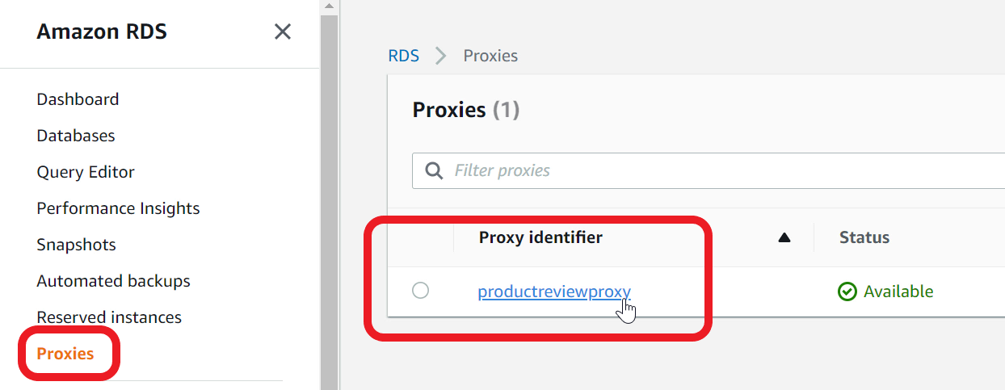

1. Scroll down to **Proxy endpoints**. There are two endpoints. The first endpoint is for reading and writing to the database. The second endpoint is for read-only queries. Copy the **first endpoint** (read-write)

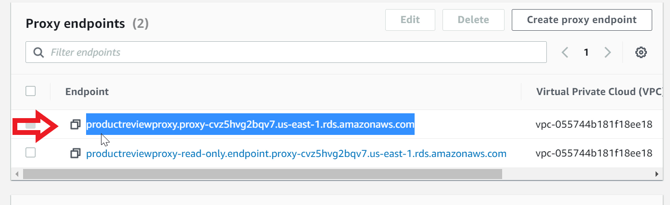

1. Go back to **Lambda** console, open **product_review_healthcheck** function
2. Update the **proxyEndpoint**variable value

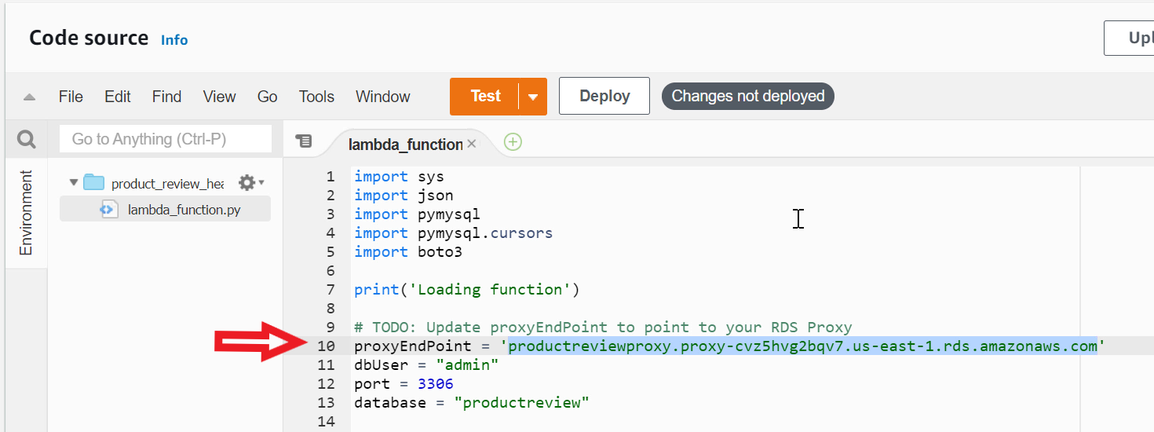

1. Click **Deploy** to deploy the updated code

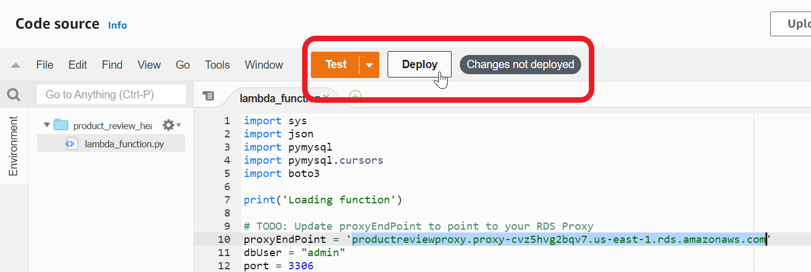

1. Now scroll down to the bottom of the page to **Layers** section
2. Click **Add a layer**

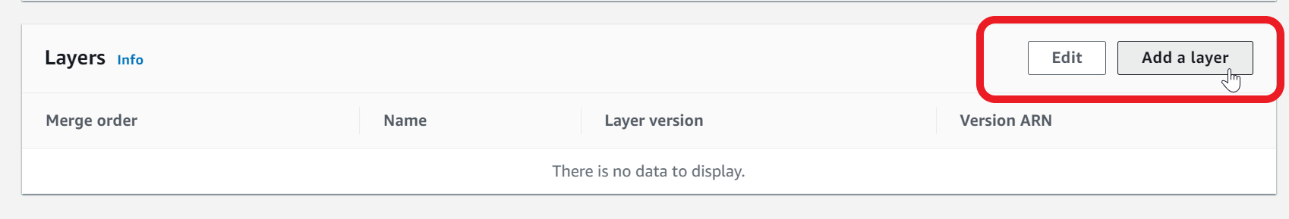

1. Select **Custom Layers**
2. In the **Custom layers** drop down - select **layer-pymysql**
3. In the **Version** drop down - select **1**

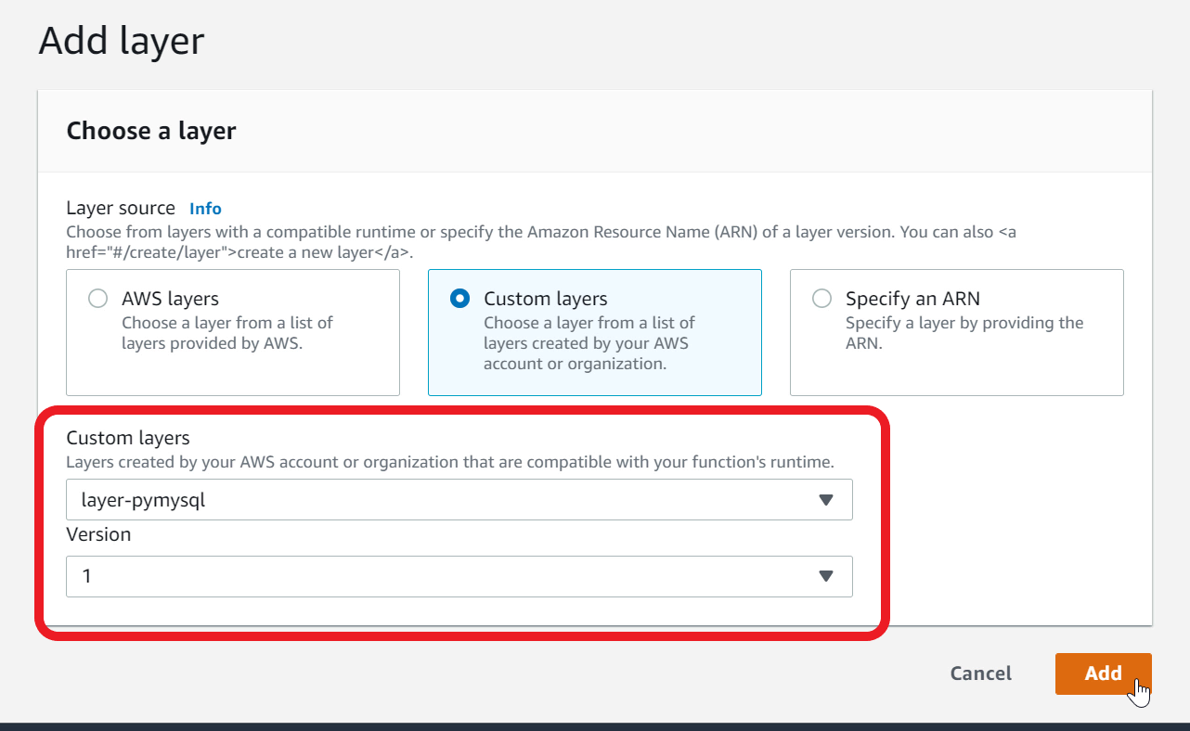

1. Click **Add**
2. You now need to add **RDS Proxy** to Lambda Function
3. Select **Configuration** tab

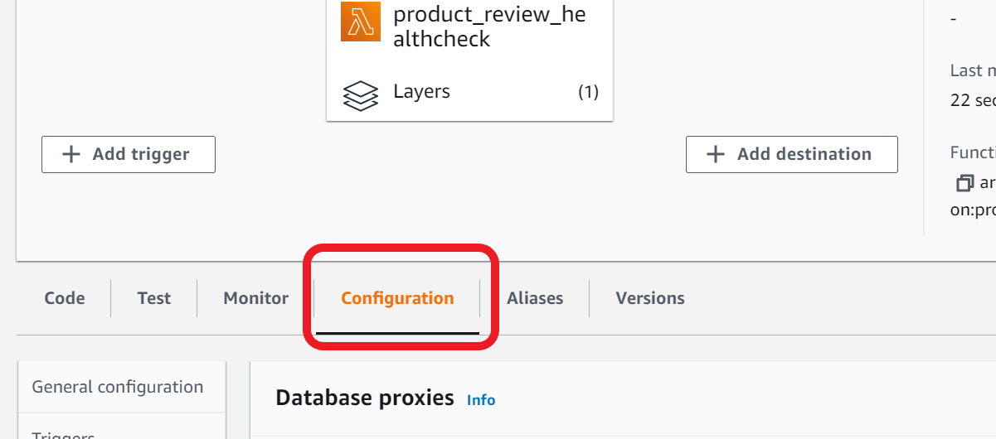

1. Select **Database proxies** in the navigation pane

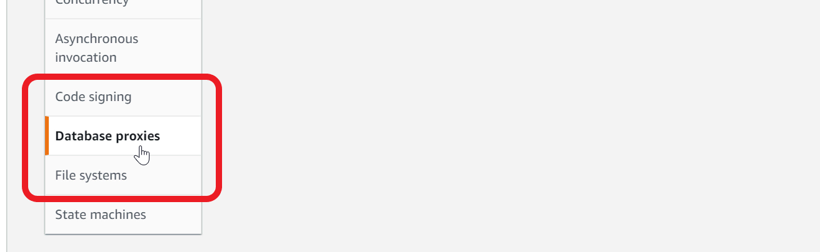

1. Click **Add database proxy**
2. **Choose an existing proxy**
3. Select - **productreviewproxy** from the drop down

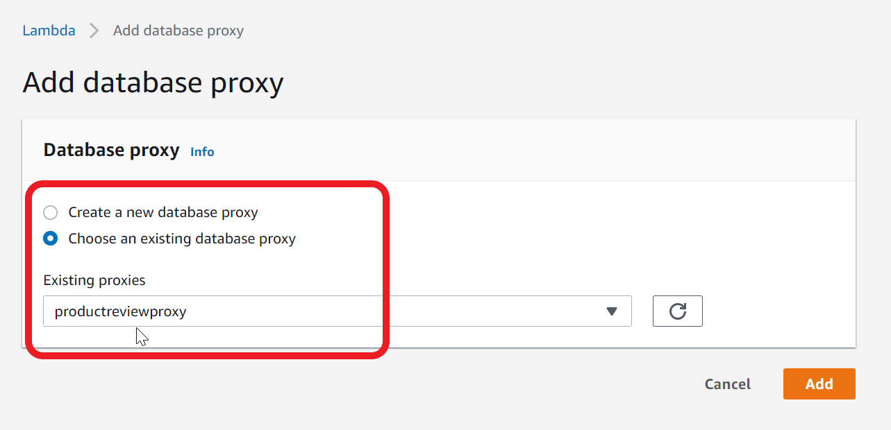

1. Click **Add.**This will add necessary permissions to your Lambda IAM Role to call database proxy and acquire connection
2. Lambda function is now ready to test

Invoke health check function

Configure a test event and invoke the product review health check function from Lambda console. Ensure product and review tables are created with sample data.

1. Go to the **code** section of the **product_review_healthcheck**Lambda function
2. In the **Test** dropdown, choose **Configure a test event**. You need to create a test event to pass to the lambda function

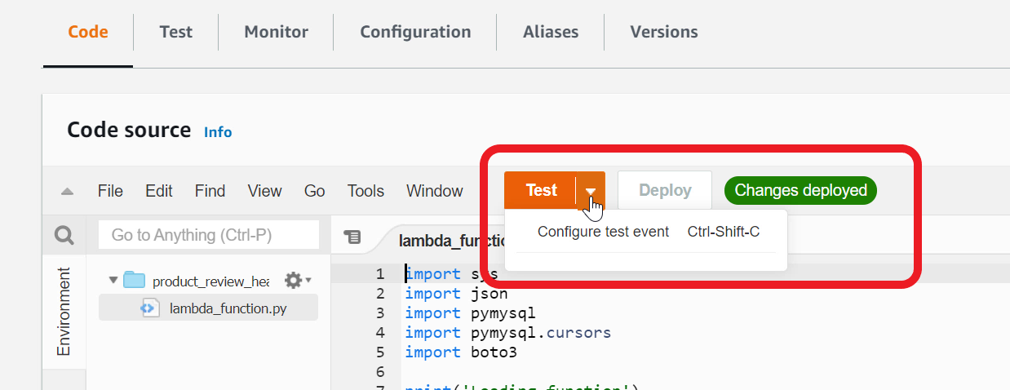

1. This function does not expect any particular event data - so a hello world event is good enough. In the **Event template** - make sure **hello-world** is selected
2. For **Event name** - type **healthCheckTest**

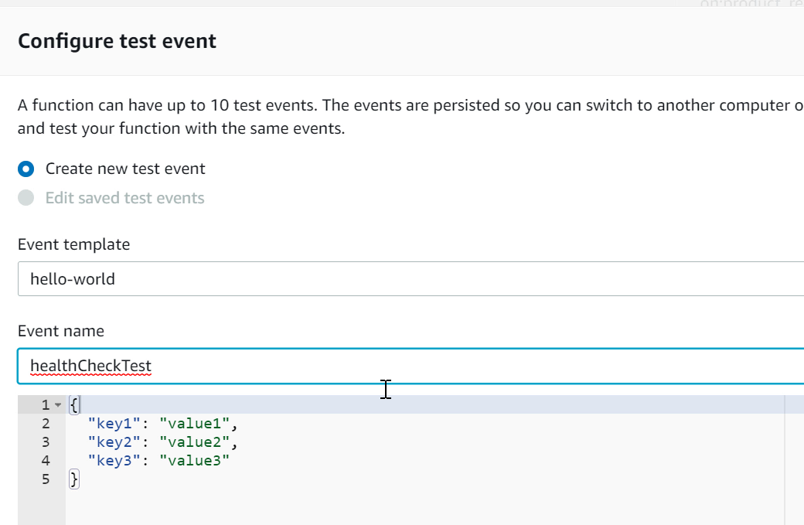

1. **Create** the test event
2. Click on the **Test** button (not the drop down arrow)**.**When you call the function for the first time, it will connect the database using RDS proxy, create the product and review tables in the **productreview** database, insert rows in product and review tables.

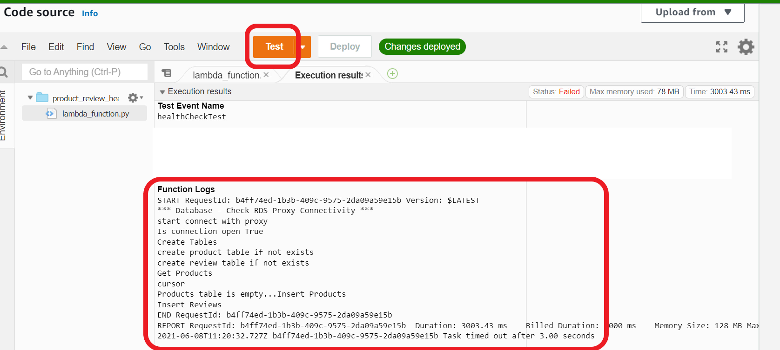

1. Click on **Test**again. This time, the function will read the rows and display **products**

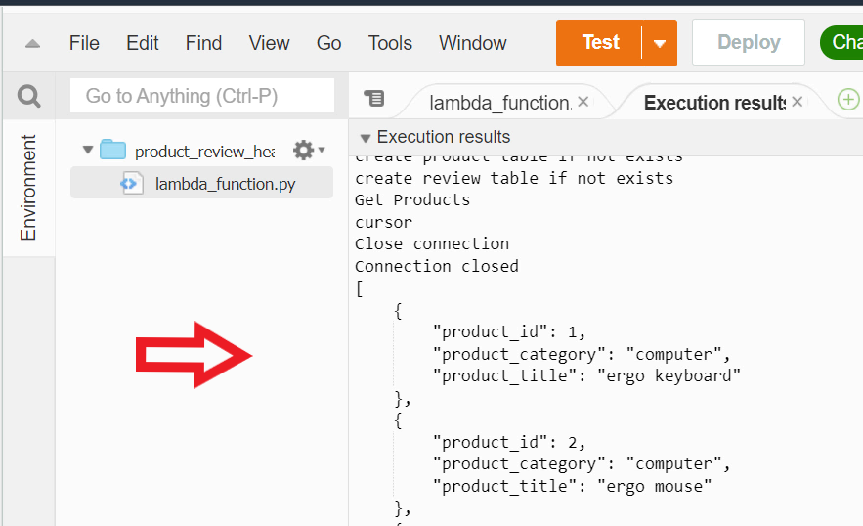

1. You can click on **Test** as many times as you like. You have now successfully completed a health check and created required tables and initial data

Mark task as complete

Report issue

Implement CRUD backend functionality

Create a new Lambda function **product_review_rds** and implement the backend functionality to manage products and reviews. The Lambda function must execute appropriate Create-Read-Update-Delete (CRUD) logic for the RESTful API that you designed earlier. This Lambda function needs to use the **RDS Proxy endpoint** to acquire a database connection. Deploy the Lambda function in the **default VPC** and attach the **default security group** to the function

1. Open **Lambda** console
2. Click on **Functions** in the navigation pane
3. Click **Create function**
4. Choose - **Author from scratch**
5. For **Function name** - type **product_review_rds**
6. For **Runtime** - select **Python 3.8**
7. Under **Permissions** - expand **Change default execution role**
8. Select - **Use an existing role**
9. In the **Existing role** choice list - select **lambda_rds_vpc** role that you created earlier

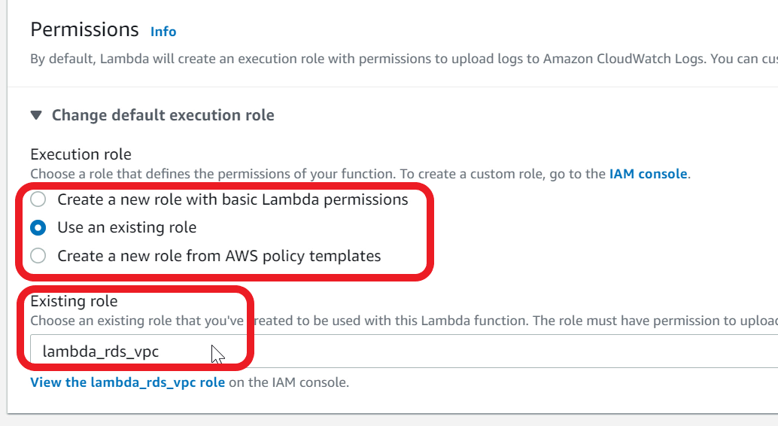

1. Expand **Advanced settings**
2. For **VPC** - Choose **Default**VPC

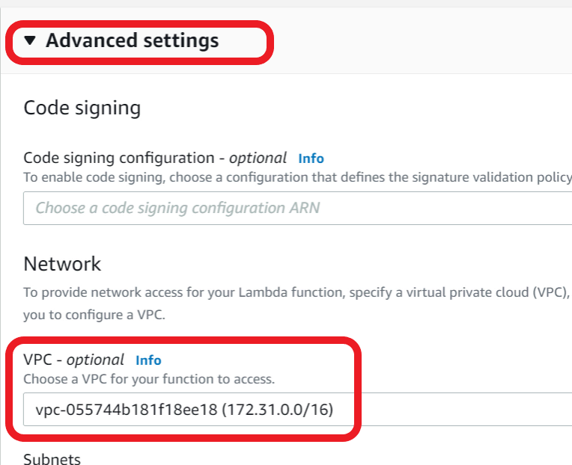

1. For **Subnets** - Choose all available subnets

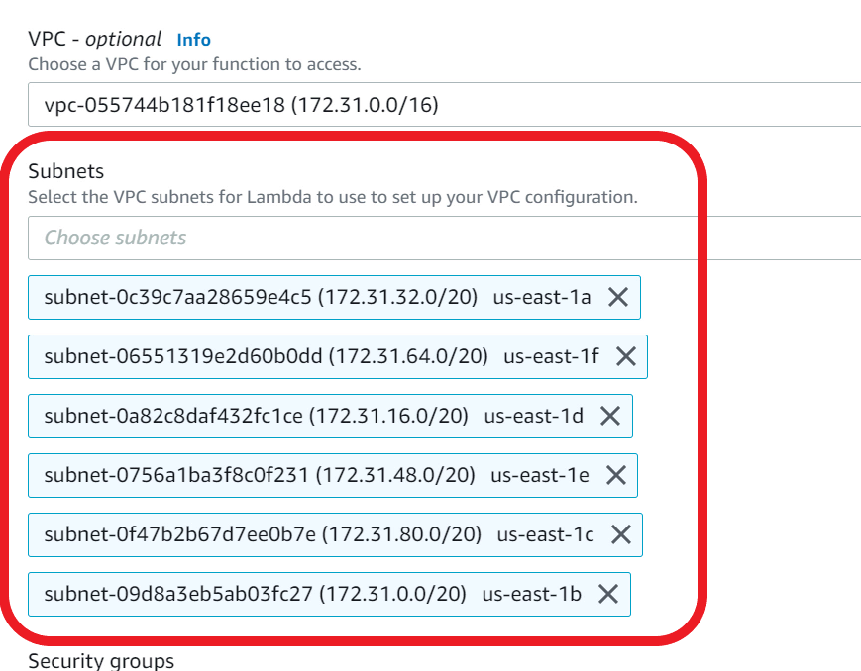

1. For **Security Group** - choose **default VPC security group**

This security group allows lambda function to connect to RDS Proxy as both are attached to default security group

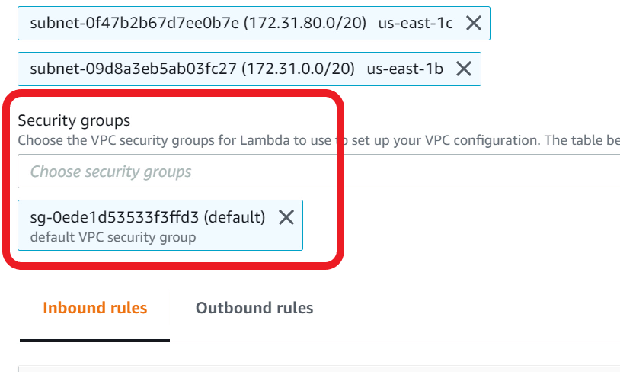

1. Click **Create function**
2. Lambda will take a **few minutes** to create the function and attach to VPC. You may notice the **screen refreshing** on its own when it is creating the function. Give it a couple of minutes for the function to be created
3. Download the **productReviewLambda.zip** file available in the assets.
4. **Save** the file to your local computer. This file has the code for function
5. In the Lambda console, scroll down to the **Code** section
6. In the **Upload from** choice list, select **zip file**

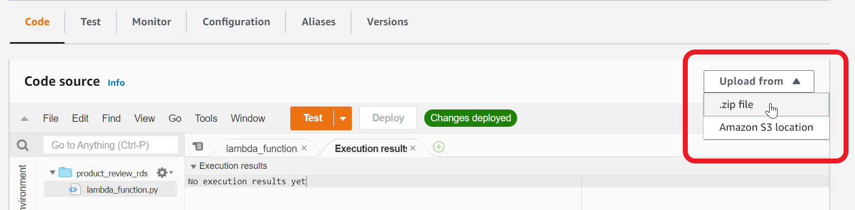

1. Choose the **productReviewLambda.zip** file that you saved earlier on your local computer

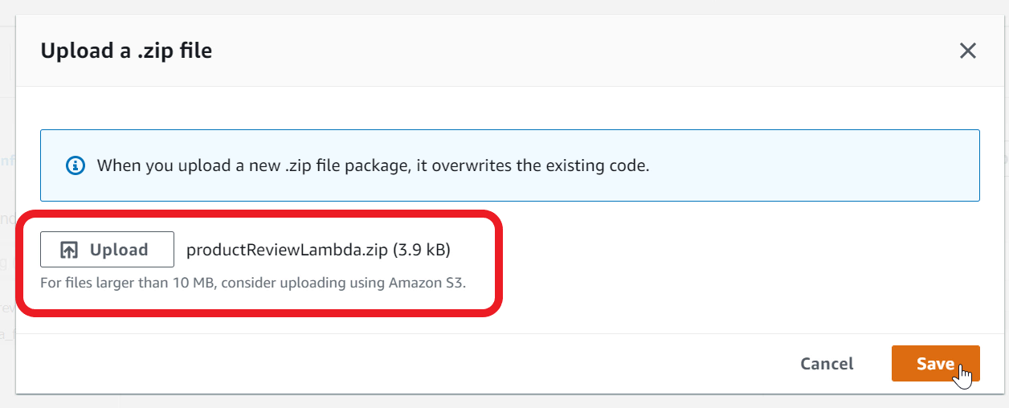

1. Click **Save**. You can now view the backend implementation for product-review CRUD

Ref productreviewLamda.zip

Integrate Database proxy and Lambda layer with the product review function

Ensure **product_review_rds**function uses Database Proxy and Lambda Layer.

1. In the **product_review_rds**Lambda function, scroll down to the **code section**
2. Update the **proxyEndPoint** variable value to point to your **database proxy endpoint.**You can copy the proxyEndpoint value from the health check Lambda function that you created earlier

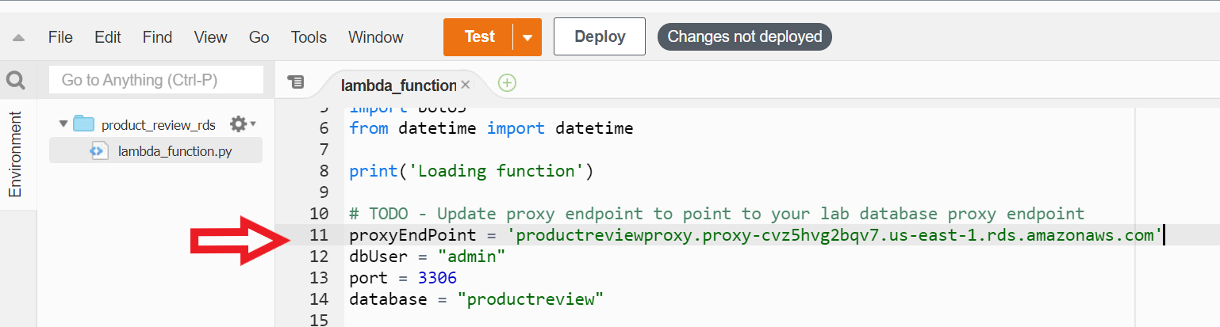

1. Click **Deploy** to deploy the updated code

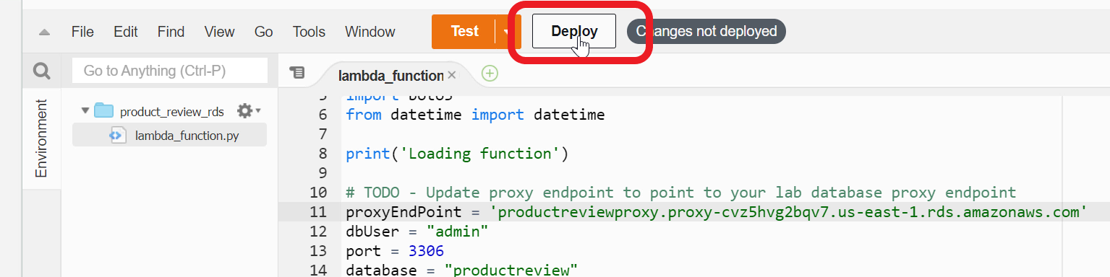

1. Now scroll down to the bottom of the page to **Layers** section
2. Click **Add a layer**



1. Select **Custom Layers**
2. In the **Custom layers** drop down - select **layer-pymysql**
3. In the **Version** drop down - select **1**

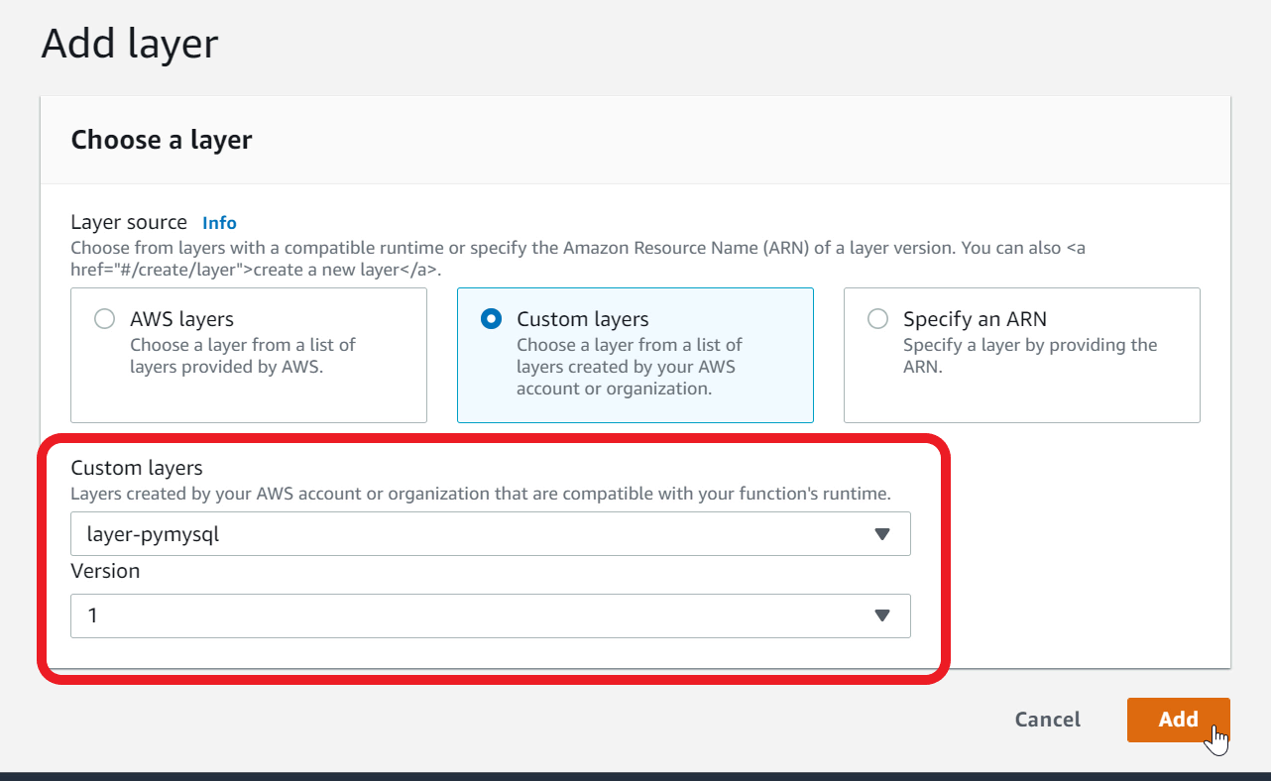

1. Click **Add**
2. You now need to add **RDS Proxy** to Lambda Function
3. Select **Configuration** tab

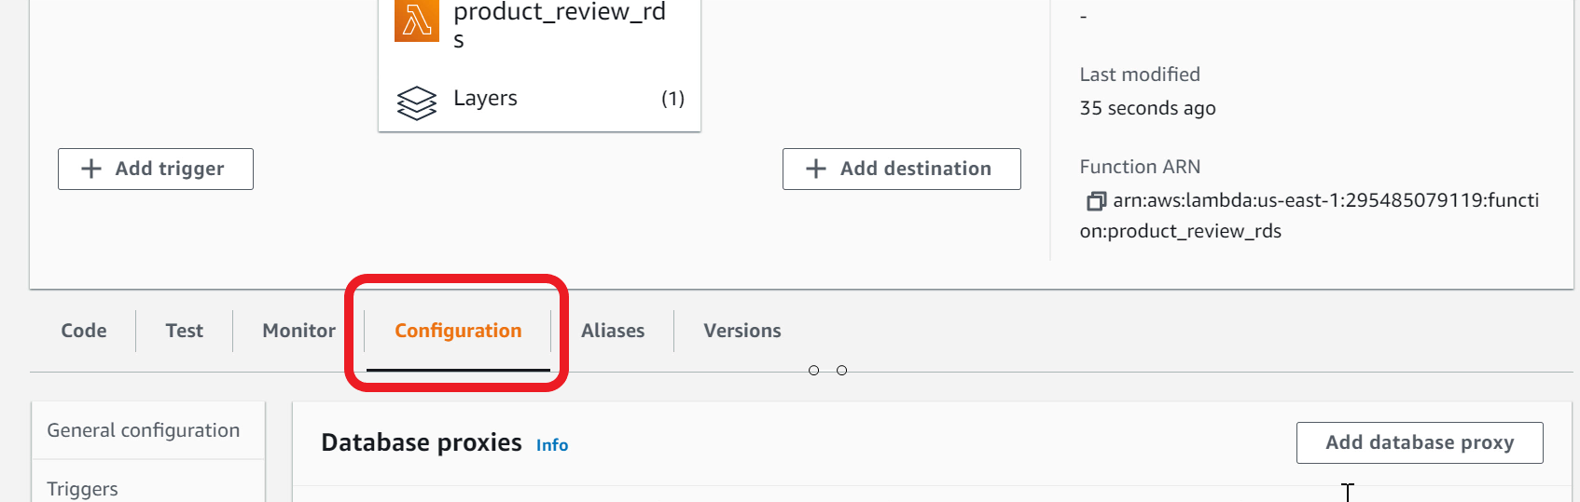

1. Select **Database proxies** in the navigation pane



1. Click **Add database proxy**
2. **Choose an existing proxy**
3. Select **productreviewproxy** from the drop down



1. Click **Add.**This will add necessary permissions to your Lambda IAM Role to call database proxy and acquire connection
2. Lambda function is now ready for integration test

Create an HTTP API in API Gateway

You will need to create an HTTP API in API Gateway. Ensure the API conforms to the design you did earlier. This API will be the front door for your web app to manage products and reviews. You also need to enable CORS (Cross Origin Resource Sharing) support for the API.

1. Open **API Gateway** console

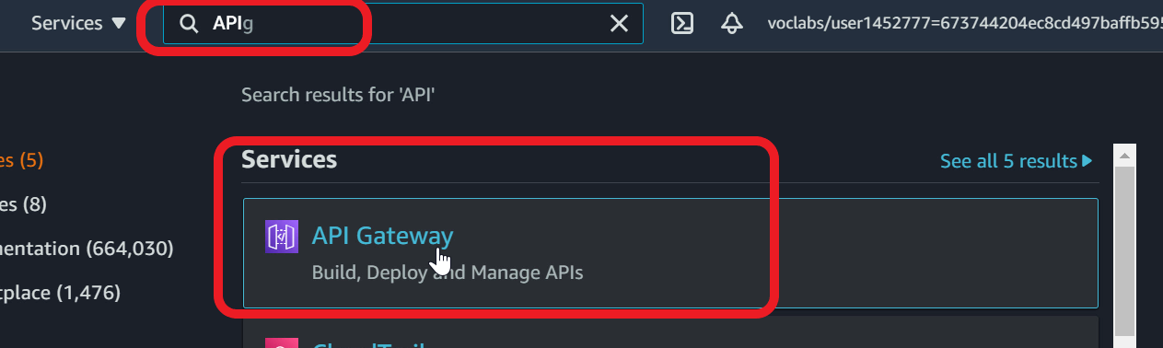

1. In the banner page, under **HTTP API**, Click **Build**

Note - if you don't see the banner page, click on **APIs** in the navigation pane and **Create API** and click **Build**under HTTP API

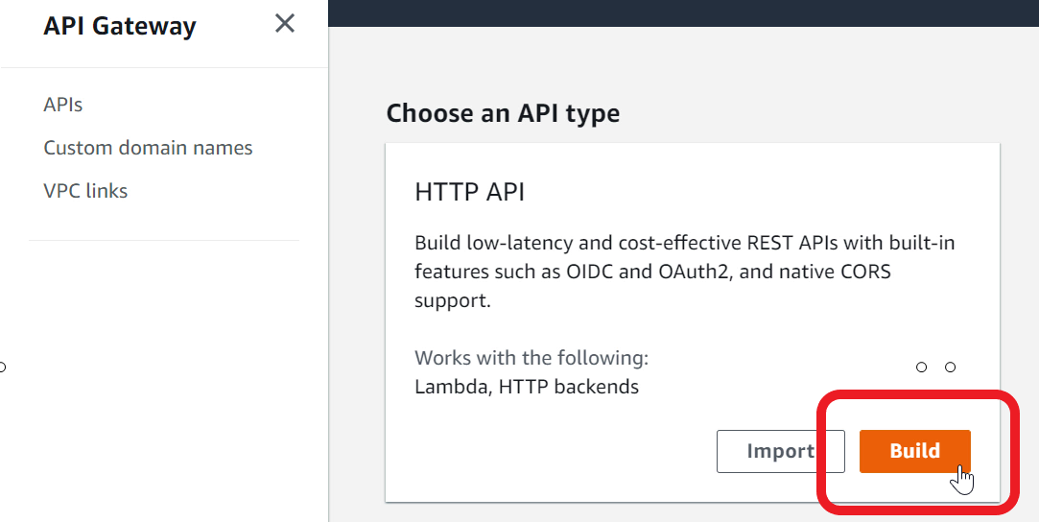

1. Under **Integrations** - Click **Add Integration**

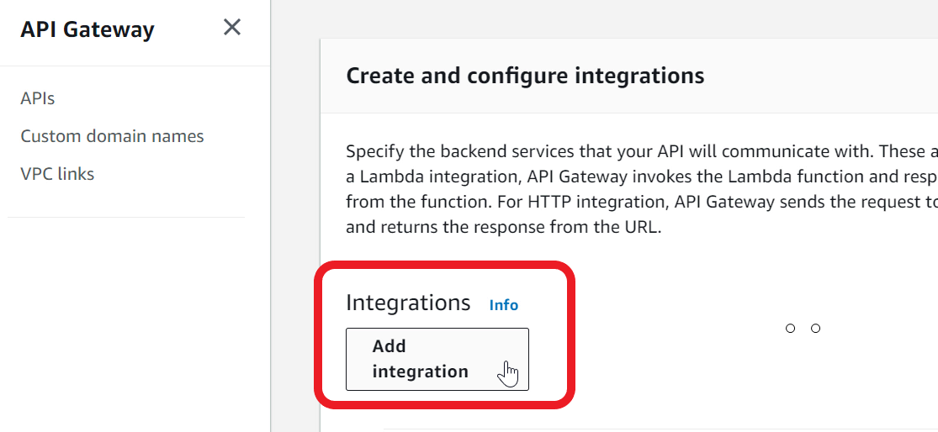

1. Choose **Lambda** from drop down
2. In the **Lambda function** - type **product_review_rds**

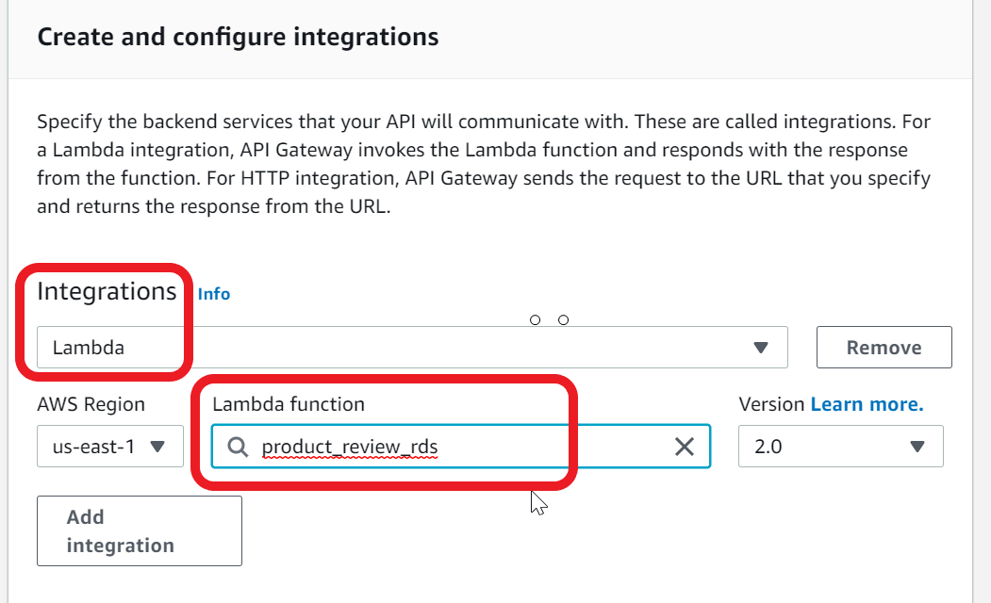

1. For **API name** - type **productReview**

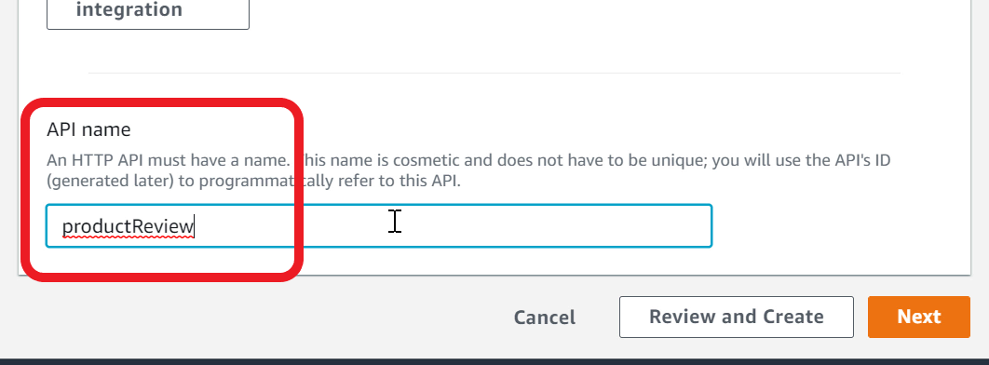

1. Go to the **Next** page
2. You can now configure the HTTP method, resource and integration target
3. For **Method**, select **GET**. For **Resource path** - type **/products.**For **Integration target**, ensure **product_review_rds** is selected

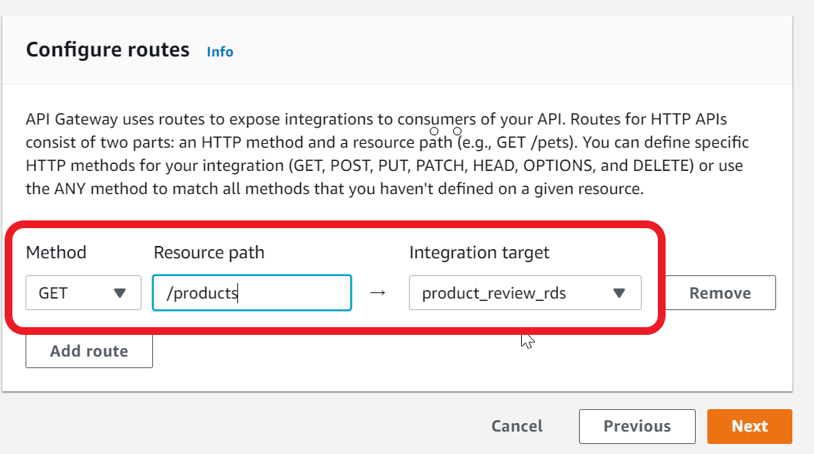

1. Click **Add route** to add all the routes with **integration target** **product_review_rds.**Ensure resource path matches exactly as specified below (including the case):
2. Method - POST, Resource path - /products
3. Method - PUT, Resource path - /products
4. Method - GET, Resource path - /products/{productId}
5. Method - DELETE, Resource path - /products/{productId}
6. Method - GET, Resource path - /products/{productId}/reviews
7. Method - POST, Resource path - /products/{productId}/reviews
8. Method - GET, Resource path - /products/{productId}/reviews/{reviewId}
9. The completed routes should look like

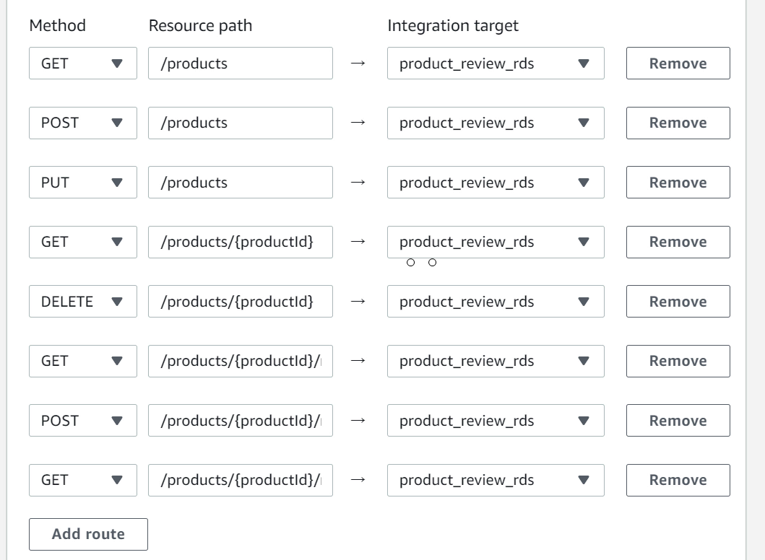

1. Go to **Next** page and continue to **Next** page
2. Review the routes and **Create**

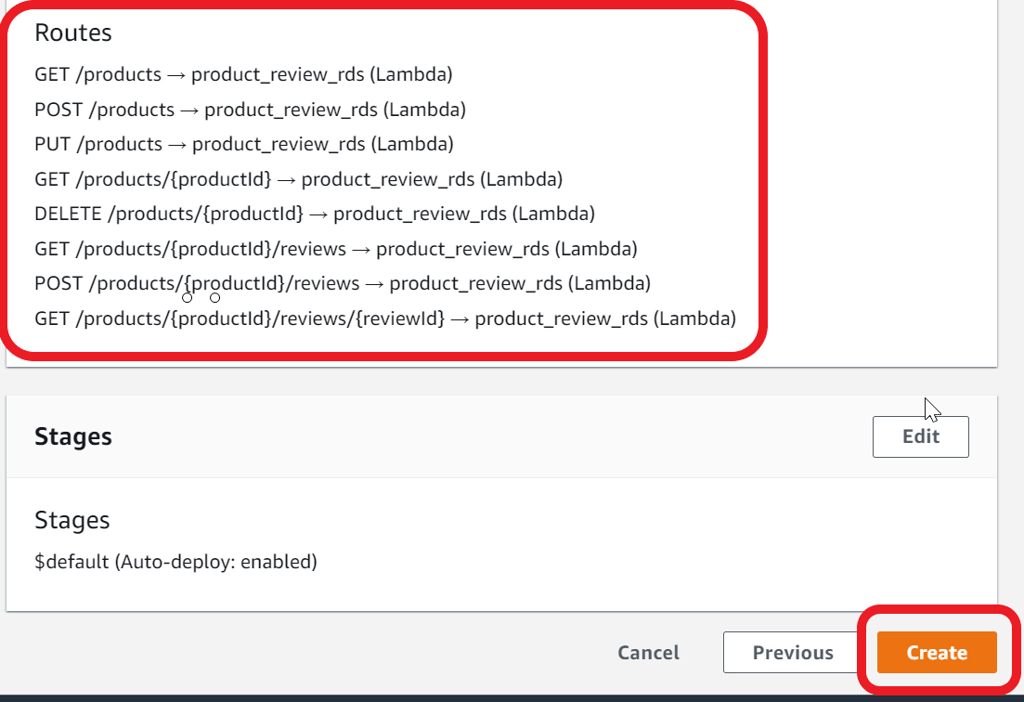

1. Select **Integrations** from the navigation pane. Here is what your route configuration should look like

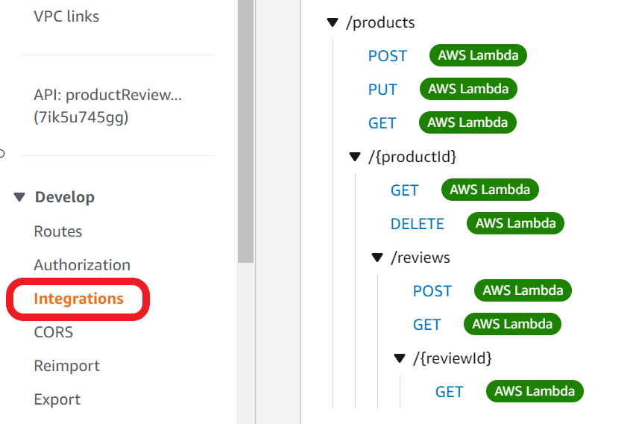

1. Select **CORS** from the navigation pane

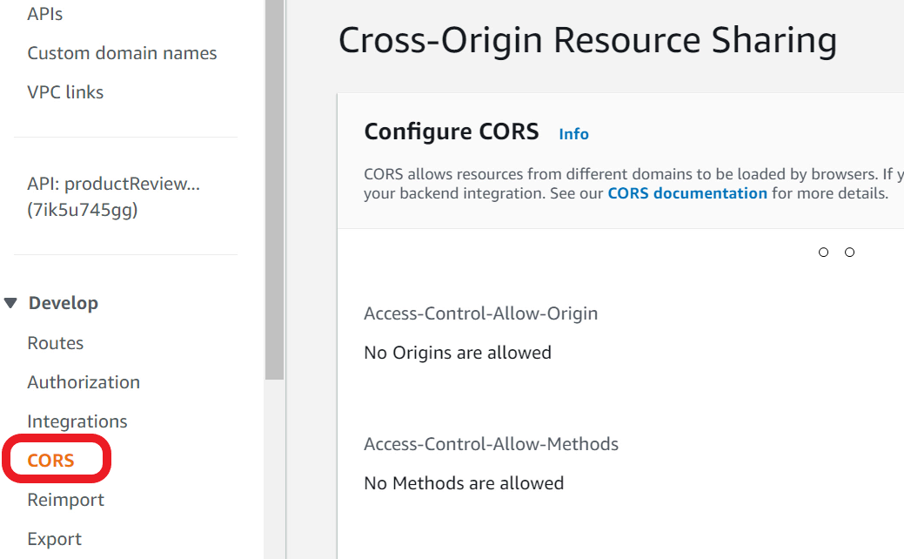

1. Click **Configure**

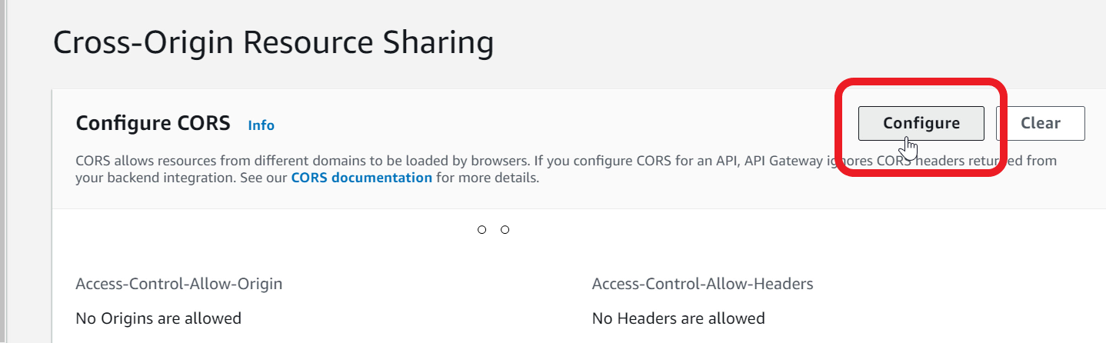

1. For **Access-Control-Allow-Origin** - type **\***
2. Click **Add**

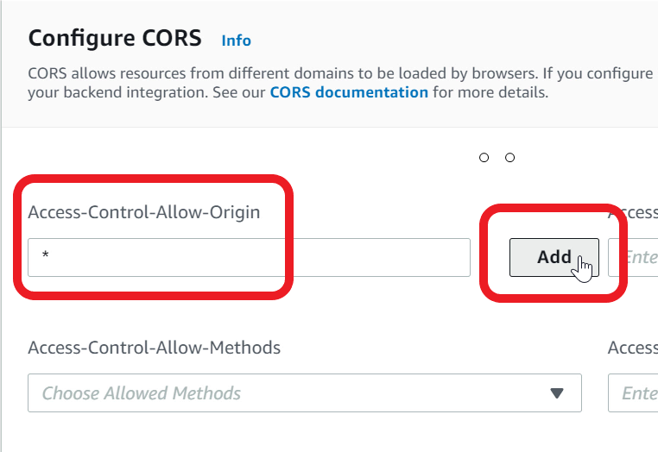

1. For **Access-Control-Allow-Methods** - Choose **\*** from the list

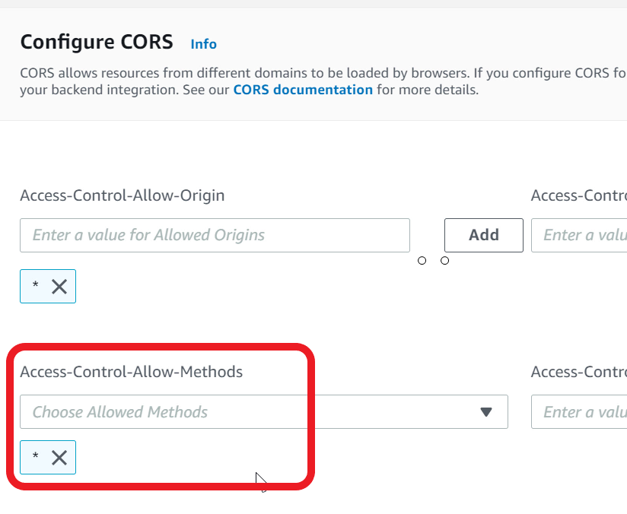

1. Click **Save**to save the CORS changes

Mark task as complete

Report issue

Integration Test using API Gateway

You can now perform an integration test using API Gateway Invoke URL. Invoke various API methods and check the **product_review_rds** Lambda function response.

1. Select your API from navigation pane
2. Copy the **Invoke URL**and save this as you would need this later

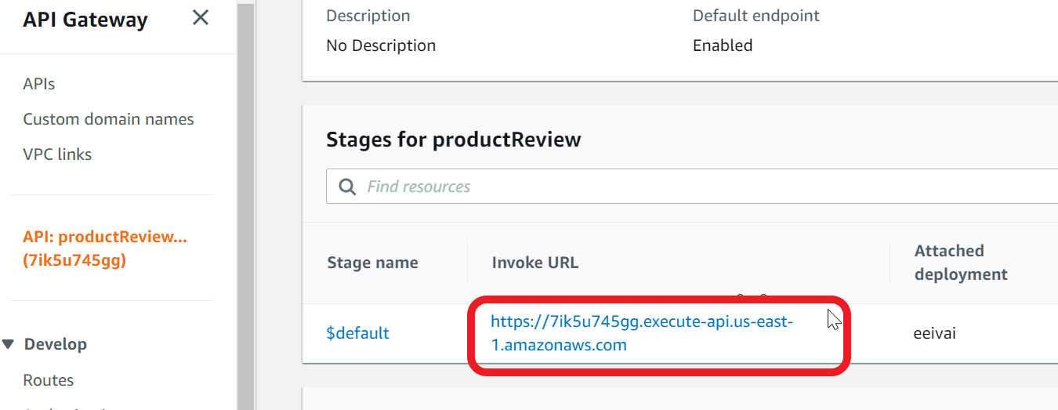

1. Paste the URL in the browser address bar
2. To read the list of products, use https://apigatewayinvokeurl**/products**

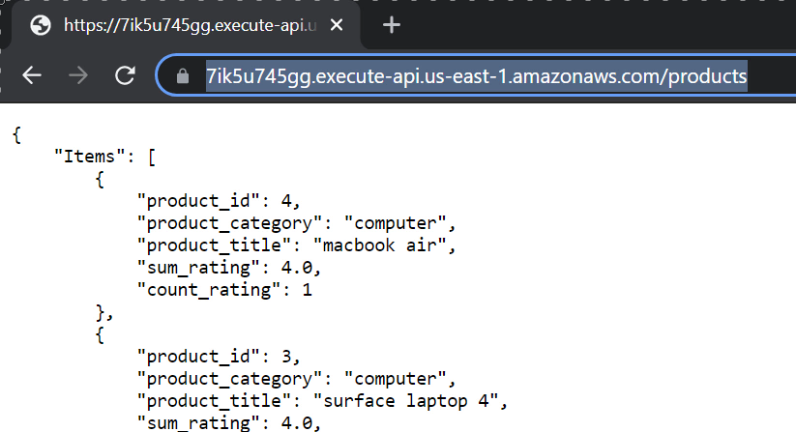

1. To read a specific product, specify the **productId**

https://apigatewayinvokeurl**/products/1**

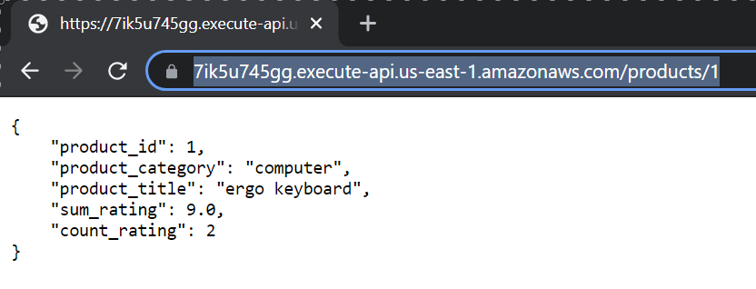

1. To read the reviews for a product, specify **reviews** resource

https://apigatewayinvokeurl**/products/1/reviews**

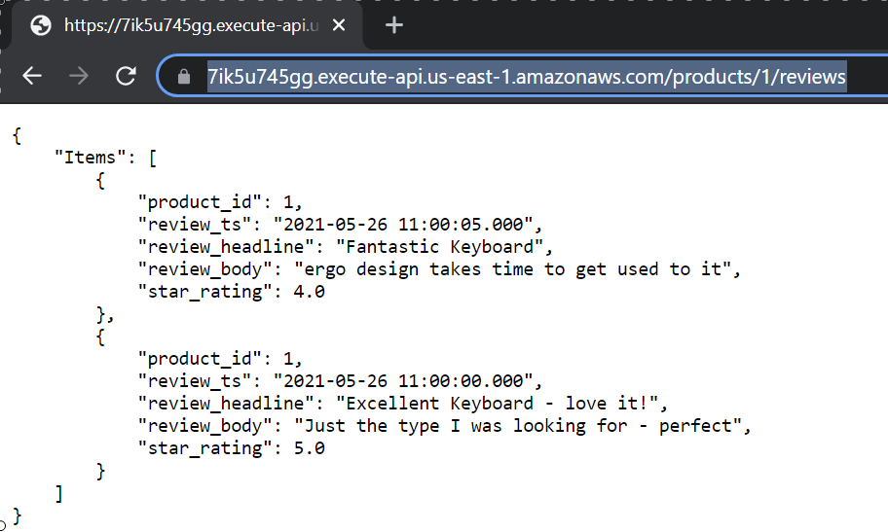

1. To read a specific review for a product, specify the review timestamp. You can copy the timestamp from the **review_ts** attribute

https://apigatewayinvokeurl**/products/1/reviews/2021-05-26 11:00:00.000**

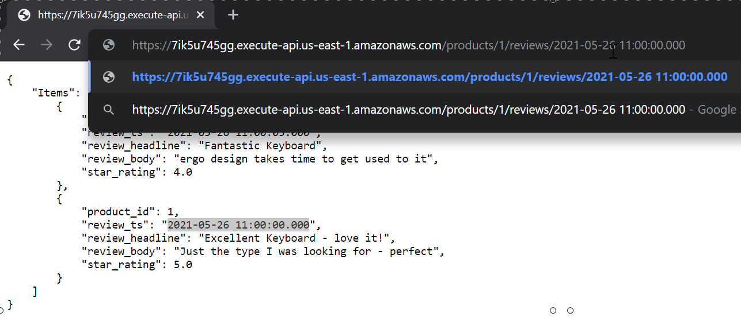

1. Optional - For POST, PUT and DELETE methods, you can use a tool like **Postman** or **RESTer**browser plug-in

<https://www.postman.com/downloads/>

<https://chrome.google.com/webstore/detail/rester/eejfoncpjfgmeleakejdcanedmefagga>

Configure a bucket in S3 to host your website

So far, you have built the API and the backend functionality. You can now work on a web client for product and review. You should use S3 for hosting your website. You need to create and configure an S3 bucket for website hosting.

1. Open **S3** console

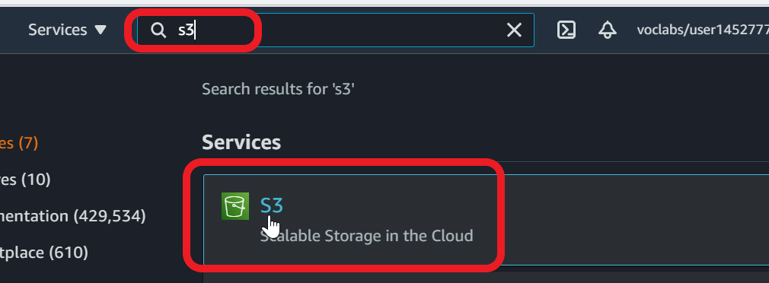

1. Click **Create bucket**

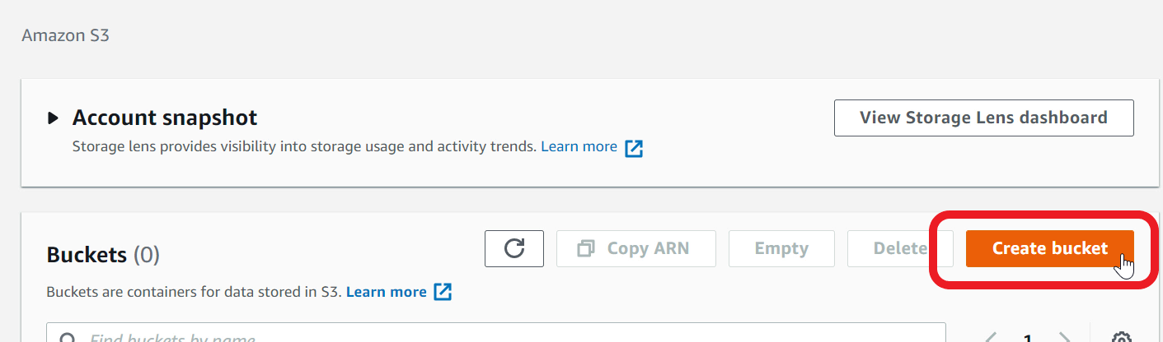

1. For **Bucket name** - specify a unique name. For example, productreview-randomvalue. If you get an error that name is not available, try a different random value.

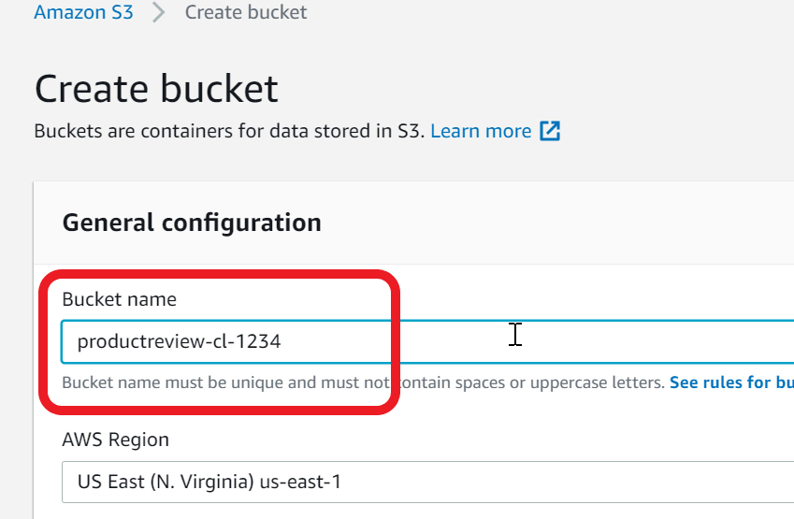

1. **Block all public access** - **uncheck**the checkbox. We need to allow public access as the bucket will be used for hosting a website

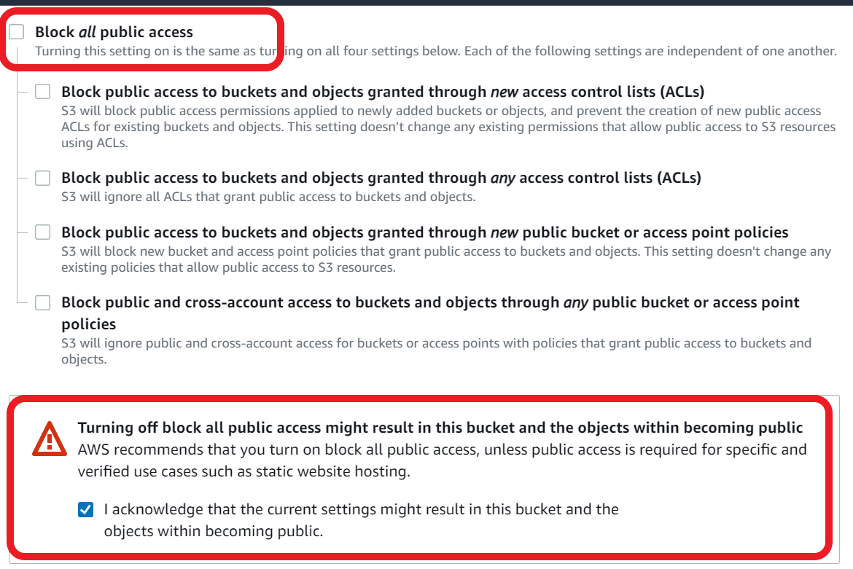

1. **Acknowledge** by selecting the checkbox that you want the bucket to be public
2. Click **Create bucket**
3. Click on the bucket name to open the details page

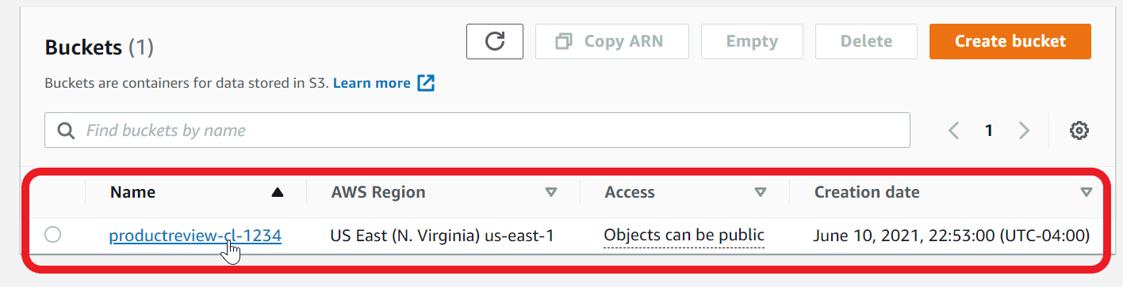

1. Go to the **Permissions** tab

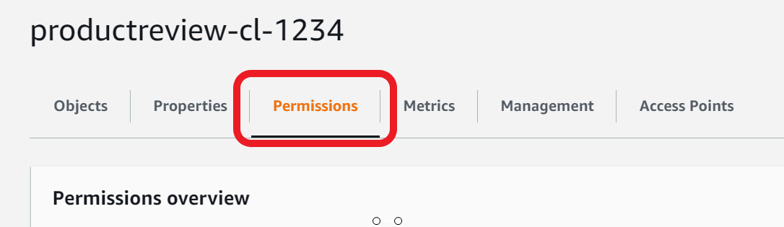

1. Scroll down to **Bucket policy**
2. Click **Edit**
3. Paste the below policy in the editor
4. {
5. "Version": "2012-10-17",
6. "Id": "Policy1621277578739",
7. "Statement": [
8. {
9. "Sid": "Stmt1621277577617",
10. "Effect": "Allow",
11. "Principal": "*",
12. "Action": "s3:GetObject",
13. "Resource": "arn:aws:s3:::your_bucket_name/*"
14. }
15. ]
16. }
17. In the policy, specify your bucket name in the resource attribute. Make sure**/\*** is there at the end

"Resource": "arn:aws:s3:::**your_bucket_name**/*"

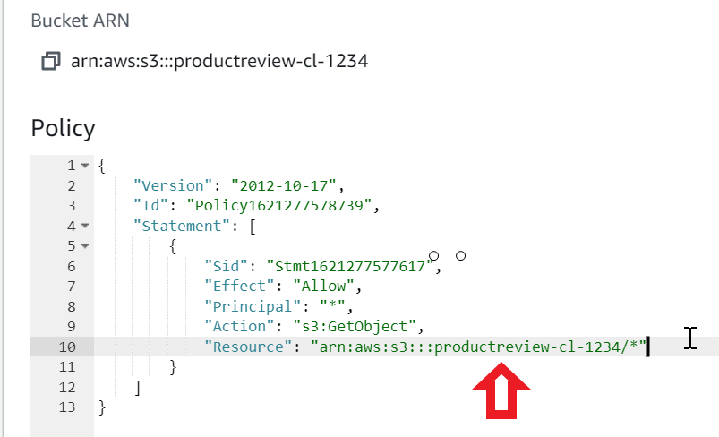

1. Click on **Save changes**
2. Go to **Properties** tab

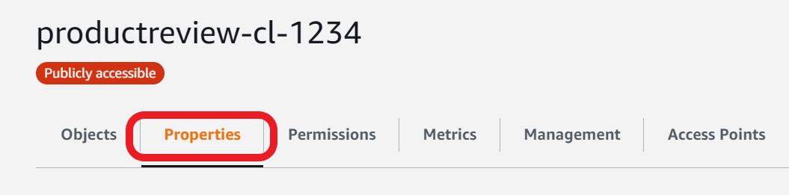

1. Scroll down to **Static website hosting**
2. Click **Edit**

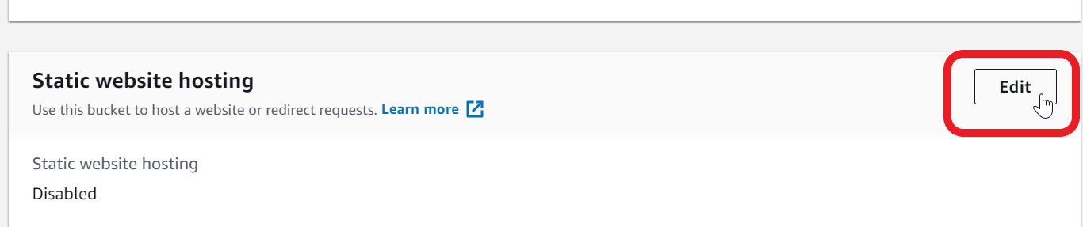

1. For **Static website hosting** - choose **Enable**
2. For **Hosting type** - select **Host a static website**

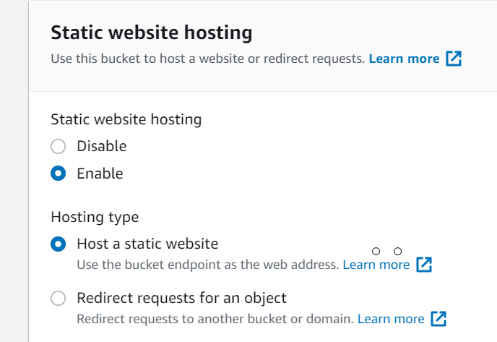

1. Specify **Index document** - type **index.html**

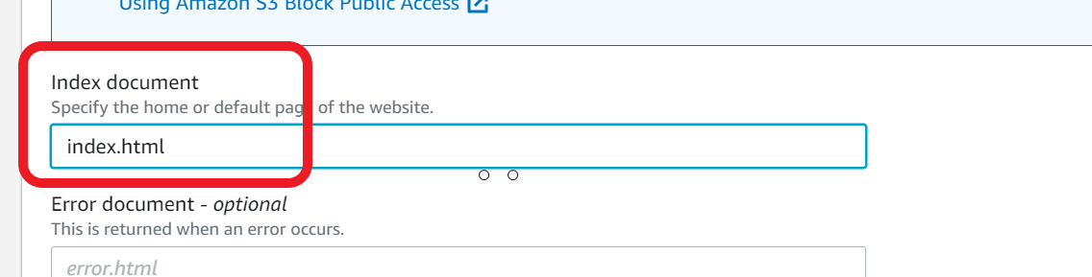

1. **Save changes**
2. Copy the **Bucket website endpoint**URLas you will need this to visit your website

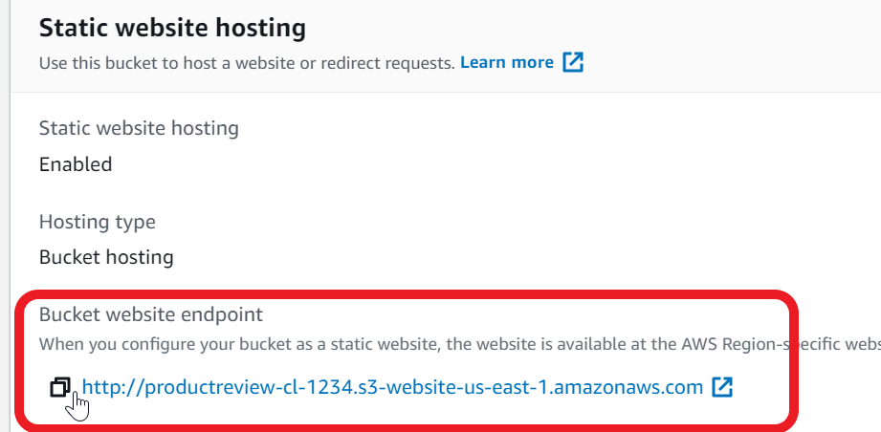

1. S3 bucket is now ready for hosting your web application

Upload webpage to S3

You now need to build a web client that talks to API Gateway for managing products and reviews. Once the web client is ready, upload to your S3 bucket.

1. Download the **WebPage.zip** file available in the Resources folder under assets
2. Open the zip file and extract the files to a local folder on your computer
3. The WebPage.zip contains an **index.html**page that is a single page client for product and review
4. Open the **index.html** in a text editor (use notepad, notepad++ or nano. Do not use editors like Word)

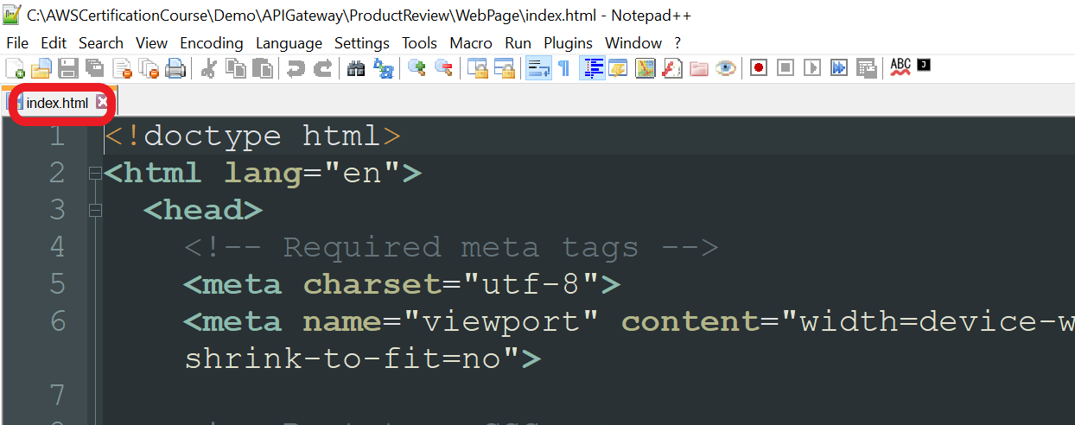

1. Look for the variable **API_GW_URI** in the **script** section

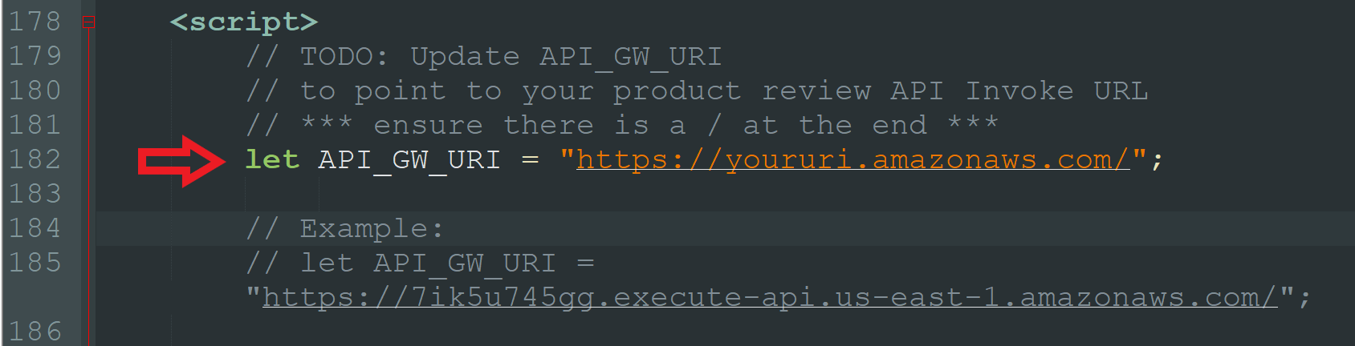

1. Update the value to point to **your product review API Gateway Invoke URL**. Ensure there is a**/**at the end. For example:

**let** **API_GW_URI** = "[**https://7ik5u745gg.execute-api.us-east-1.amazonaws.com/**](https://7ik5u745gg.execute-api.us-east-1.amazonaws.com/)";

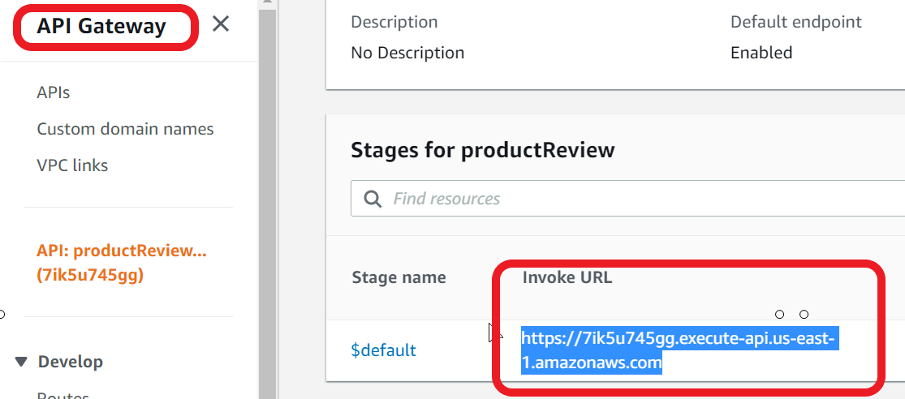

1. **Save** the changes

Note: You will get an error if you load this local file in your browser. Browser will not allow a local html file to talk to another domain. You can test from S3 or optionally use a tool like Visual Studio Code with Live Server plugin

1. In the **S3**console, open your S3 bucket
2. Click **Upload**

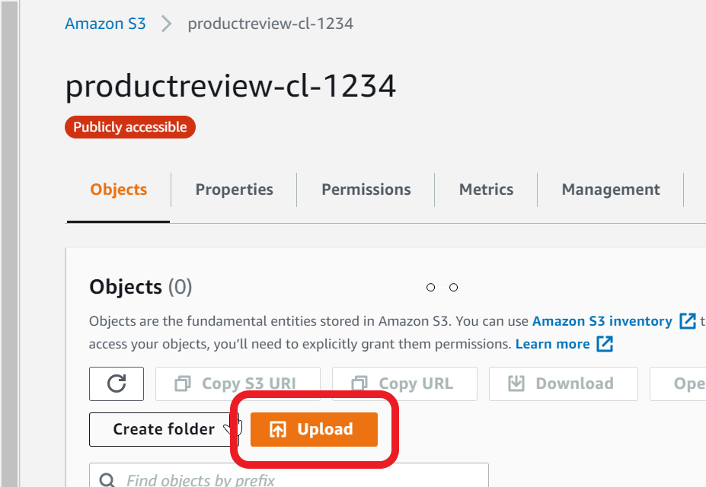

1. Click **Add files**
2. Select **index.html** on your local computer. This is the file that you modified in the earlier step
3. Click **Upload**
4. **Close** the window
5. Confirm **index.html**is in your bucket

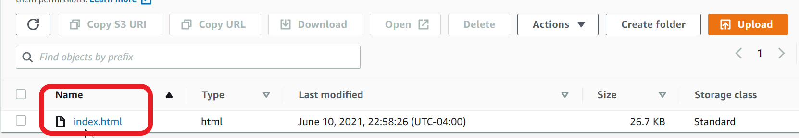

1. Your web app is now ready for testing

Ref Webpage.zip

Visit the product-review website and test all features

You must now test all the features for managing products and reviews.

1. Visit **Bucket website endpoint**from your browser**.**This URL is available in **S3** bucket **Properties** tab, **Static website hosting**



1. The web page will talk to the API Gateway and list available products

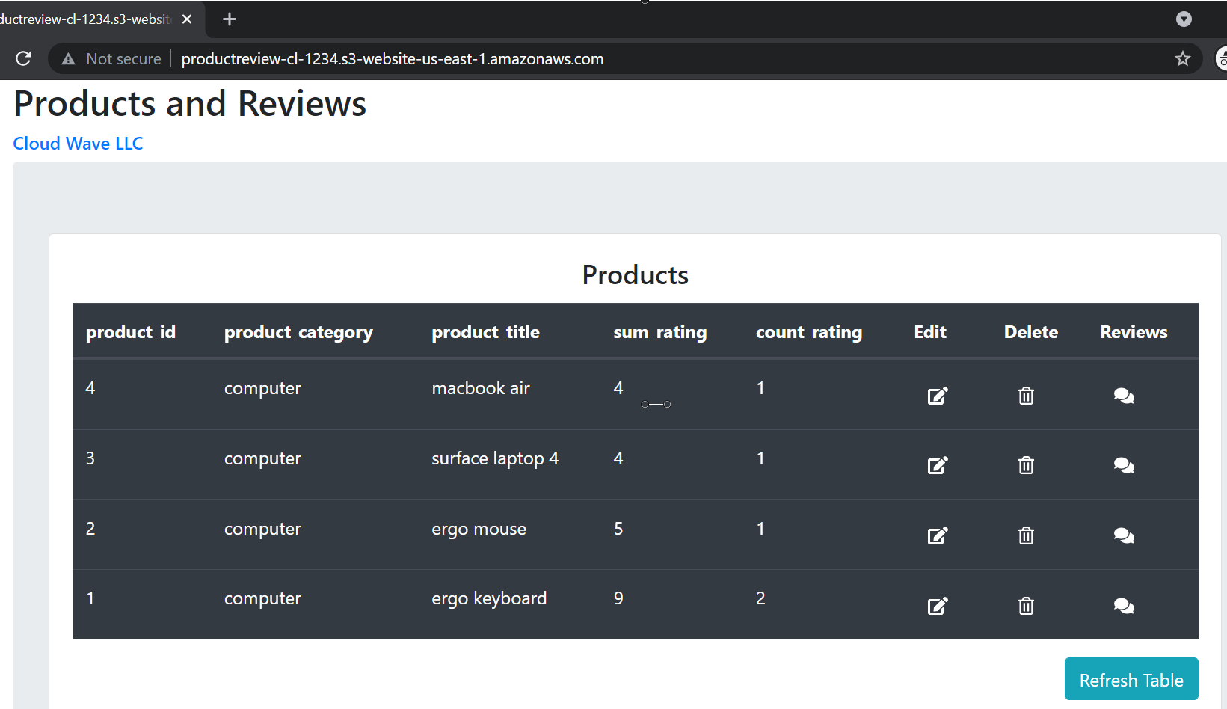

1. To view reviews for a product, click on the **review** icon

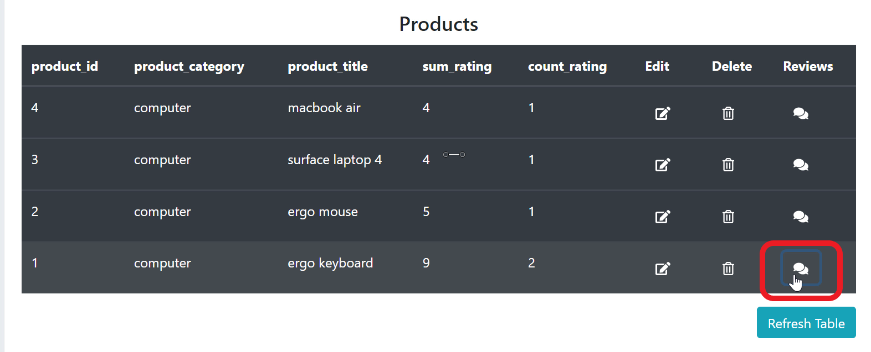

1. You can now see reviews for the selected product

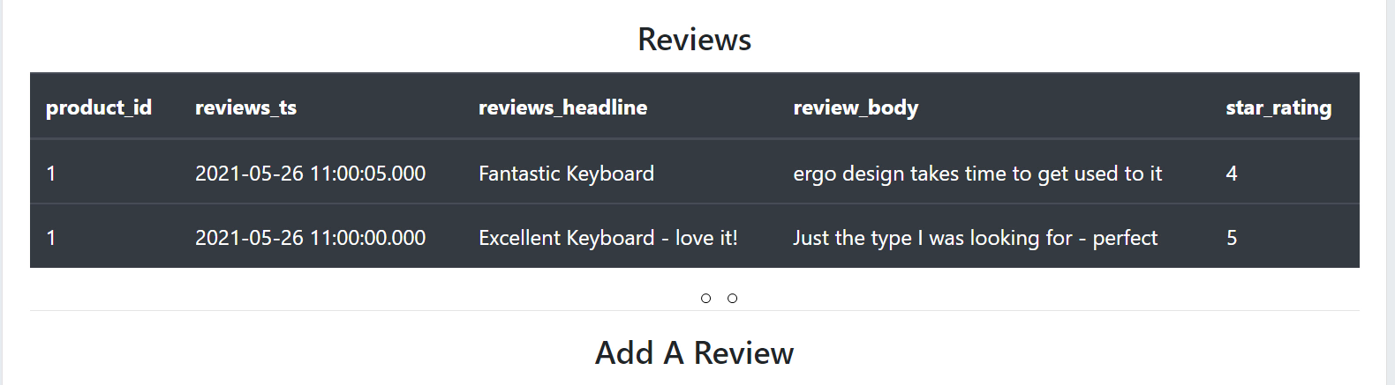

1. To add product, go the Add / Edit Product section

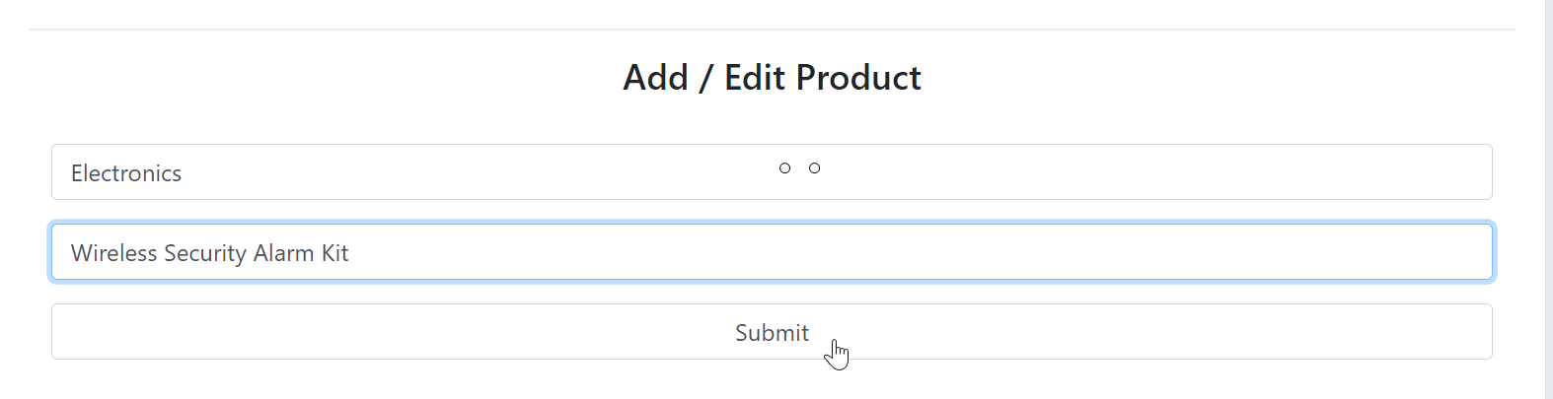

1. Specify values for Product Category and Product title
2. Click **Submit**
3. The newly added product is listed at the top in the products table

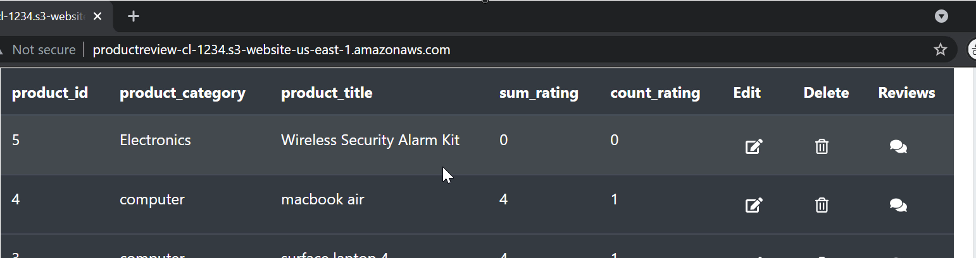

1. To add a review for the product, click on review icon
2. Specify values for **Review headline**, **Review body**, provide a numeric value for **Star Rating** and click **Submit**

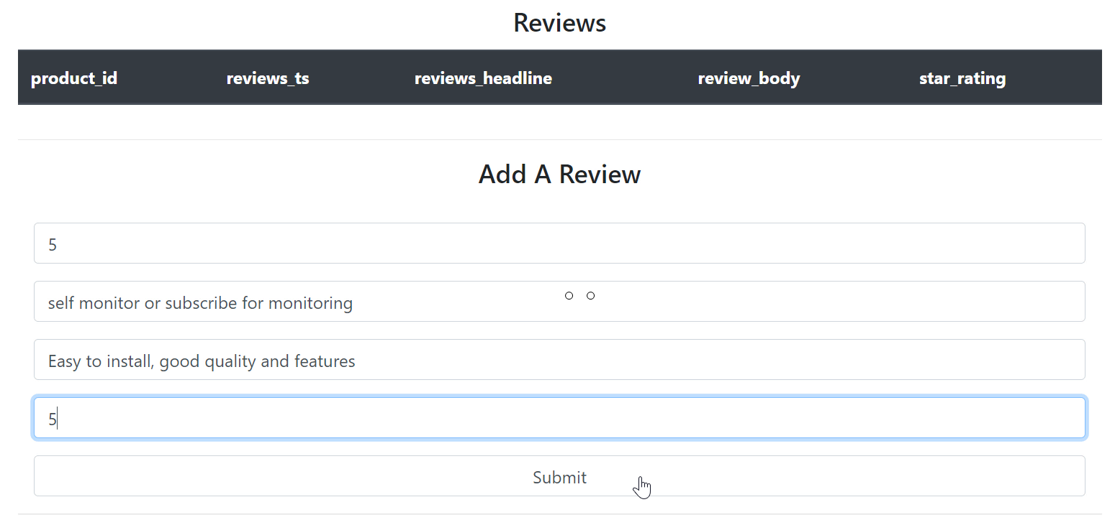

1. You can see the newly added review in the review table

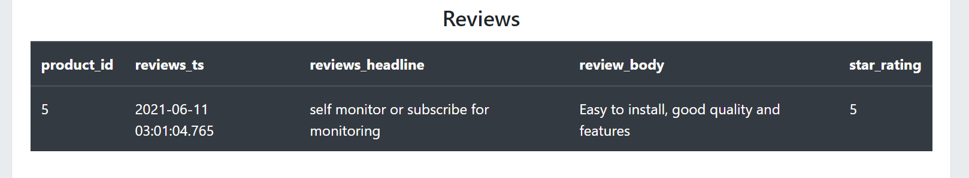

1. You can also filter reviews for a product by star rating
2. Click the review icon for a product, and scroll down to the **Filter reviews By Star Rating** section. Specify value for star rating. For example, if you specify a value 4, it will list all reviews for the product that are rated 4-star or above.

Clean Up

You need to now clean up all the resources. Remove the S3 bucket, API, Lambda functions, Database Proxy and the Aurora Database instance.

1. Open **S3** Console
2. Select your bucket
3. Click **Empty** and follow the prompt to empty the bucket
4. You can now click **Delete** to remove the bucket
5. Open **API Gateway** Console
6. Select **productReview** API
7. From **Actions** dropdown, choose **Delete**
8. Open **Lambda** Console
9. Select **product_review_rds** function
10. From **Actions** dropdown, choose **Delete**
11. Select **product_review_healthcheck** function
12. From **Actions** dropdown, choose **Delete**
13. Open **RDS** console
14. Click **Proxies** from navigation pane
15. Select **productreviewproxy**
16. From the **Actions** dropdown, choose **Delete.**Follow the prompt to delete
17. Click **Databases** from navigation pane
18. Select **demodatabase-instance-1**
19. From the **Actions** dropdown, choose **Delete**
20. Uncheck **Create final snapshot** and **Acknowledge**and follow the prompt to delete

# Building Private REST API with AWS Lambda and Amazon API Gateway

Created by[in28Minutes Official](https://deloittedevelopment.udemy.com/user/in28minutes/)

**AWS Workspace**

**90-180 minutes**

In this lab, you will be an engineer at a company using AWS as their cloud platform. You need to build a REST API for Todo management. Your architecture team wants to try out a serverless approach. You are planning to use Amazon API Gateway, AWS Lambda and Amazon DynamoDB. Your boss wants you to build a proof-of-concept. You want to host the REST API privately until you are ready for a public release.

We are planning to build a REST API for our enterprise Todo management platform. Our architecture team recommends trying out a serverless approach to keep our operations and costs to a minimum. We will start with a proof of concept building a private REST API exposing the following operations on a todo resource - add, delete, update and retrieve. Here's the recommended starting architecture: REST API will be exposed using an Amazon API Gateway. Business logic will be written in AWS Lambda. Amazon DynamoDB will be the data store.

Your system will provide a REST API for managing todos. You would want to be able to add, delete, modify and retrieve todos. You want to build an auto scaling and highly resilient serverless REST API using Amazon API Gateway, AWS Lambda and Amazon DynamoDB.

**How you'll work**

Your project has been broken into a set of tasks. To complete these tasks, use the provided workspace. You can launch your workspace by clicking below or using the button in the top right of the screen.

Launch workspace

TASK

1-Create a hello world Lamda Function

2-Create a Private API Gateway

3-Integrate hello world Resource GET Method with Lamda Function

4-Create a DynamoDB to store todos

5-Create IAM Role for Lambda Functions

6-Create todos REST API to retrieve detail of specific todos(GET method)

7-Create Todo REST API to retrieve details of specific todo(GET method)

8-Add Resource to delete a todo(DELETE nethod)

9-ADD Resource Method to create a todo(POST method)

10-Add Resource Method to update a todo(PUT method)

11-Deploy and test the REST API

12-Clean up resources

Create a hello world Lamda Function

Your task is to create a hello world Lambda Function returning a JSON response. Example JSON Response: *{"statusCode": 200, "body": "SOME_JSON"}*.

1. Select **region** US East (N. Virginia) - us-east-1. All our resources in this lab will be created in us-east-1.

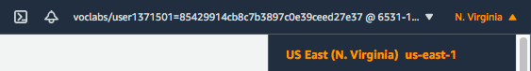

1. In the **AWS Console**, from **Services** menu - choose **Lambda**. Click **Create function**.
2. Choose to **Author from scratch**. Enter the Function**name** as *HelloWorld*.
3. Choose **Runtime** as Node.js 14.x. Choose defaults for the rest of the options.

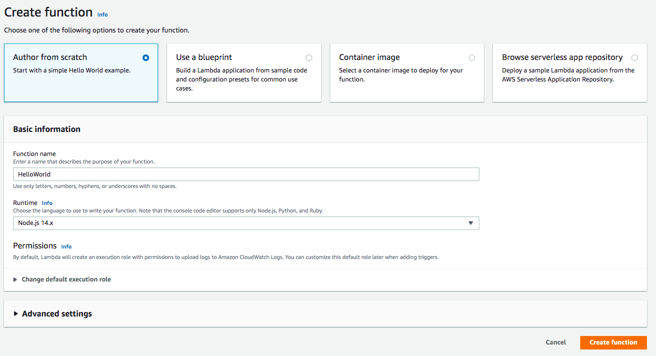

1. Click **Create function**
2. On the **Lambda Source Code** screen, Under **Code** > **Code Source** > Select the file **index.js** under the folder **HelloWorld**. Copy code from file lambda-function-01-hello-world.js. Your screen should look like:

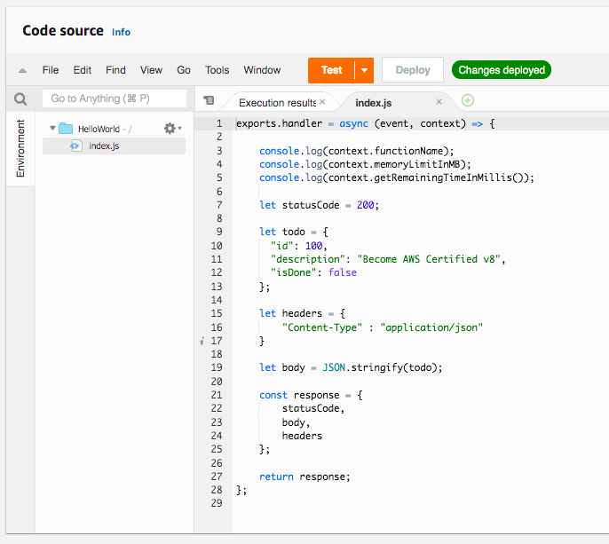

1. Click **Deploy**

Your hello world Lambda function is ready

1. Click **Test**
2. On the **Configure test event** screen, select**Create new test event**.
3. Choose **Event template** hello-world. Enter the Event name as HelloWorld and click **Create**.
4. Click **Test** again

Result of execution is shown below:

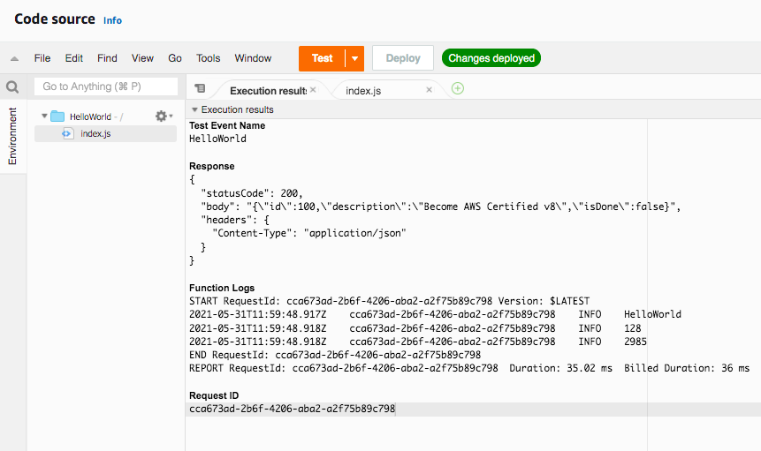

Lambda function returns a *JSON response* containing the fields - *statusCode*, *body* and *headers*. This will be mapped to the REST API response from API Gateway in the subsequent steps.

Ref lamda-function-01-hello-world.js

<https://docs.aws.amazon.com/apigateway/latest/developerguide/set-up-lambda-proxy-integrations.html#api-gateway-simple-proxy-for-lambda-output-format>

Create a Private API Gateway

Your task is to create a Private API Gateway. Prerequisites to create a Private API Gateway are a Security Group and a VPC Endpoint . You will start with creating a Security Group that allows inbound traffic from the default VPC on port 443. Next, you will create a VPC Endpoint connected to the Security Group. Lastly, you will create the Private API Gateway of type REST API.

1. In the AWS Console, search for VPC in the search bar. From **Services**, select **VPC**. Click the **VPCs** link on the next screen. You should see one VPC on the **Your VPCs** page. Note down the **VPC ID** as VPC-ID and **IPv4 CIDR** as IPV4-CIDR. Both these values will be used when creating the Security Group later.

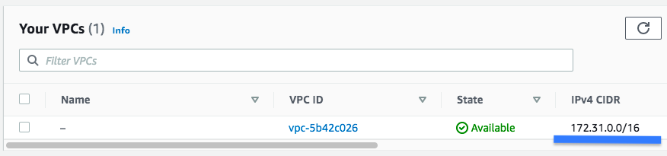

1. In the **AWS Console**, search for **Security groups** in the search bar. From **Features**, select **Security groups - VPC feature**.
2. Click **Create security group**
3. Under **Basic details**, enter *Security group name* as vpc-endpoint-security-group. Enter Description as vpc-endpoint-security-group.
4. Choose the **default VPC** as the VPC
5. Under **Inbound rules**, click **Add rule**. Choose **Type** as HTTPS. Enter **Destination** as the CIDR Range of the default VPC - 172.31.0.0/16 (You noted this down earlier - IPV4-CIDR).
6. Under **Outbound rules**, click **Add rule**. Choose **Type** as All Traffic and **Destination** as Anywhere.

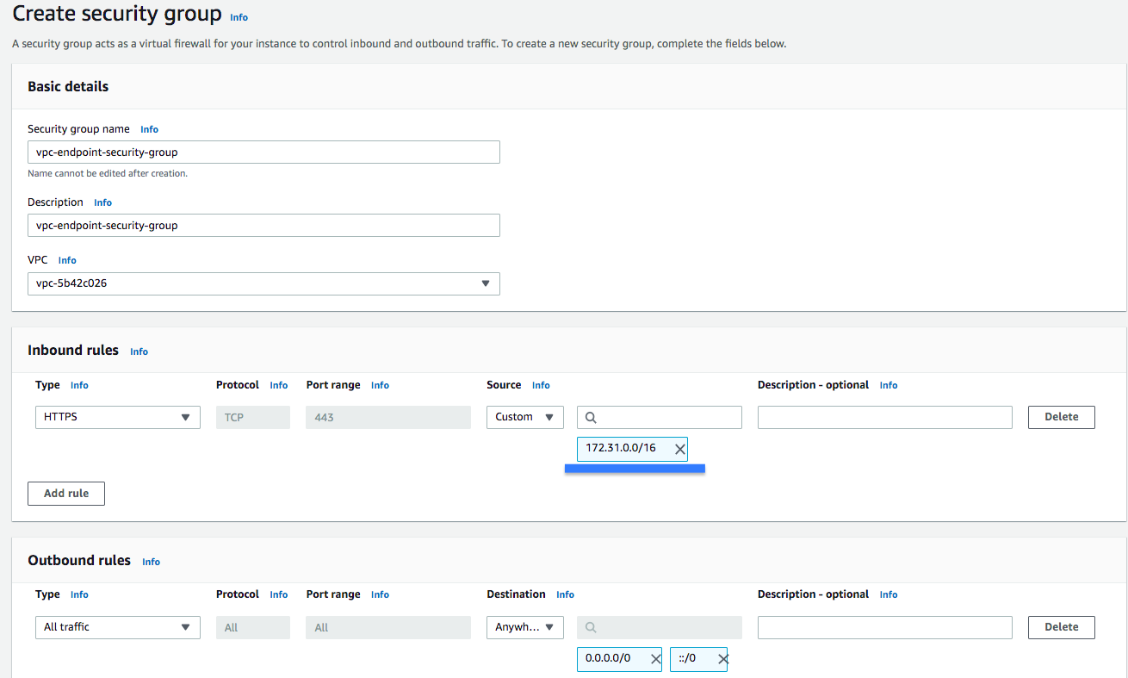

1. Click **Create security group**
2. In the **AWS Console**, search for **VPC Endpoints** in the search bar
3. From **Features**, select **Endpoints - VPC feature**
4. Click **Create Endpoint**
5. On the **Create Endpoint** screen, choose **Service category** as AWS services
6. Under **Service Name** search for execute-api and choose com.amazonaws.us-east-1.execute-api
7. Select ***default*** VPC (make sure that the ID matches VPC-ID noted down earlier)
8. Choose all 6 subnets from default VPC
9. Enable (check) the check box **Enable DNS name** **- Enable for this endpoint**

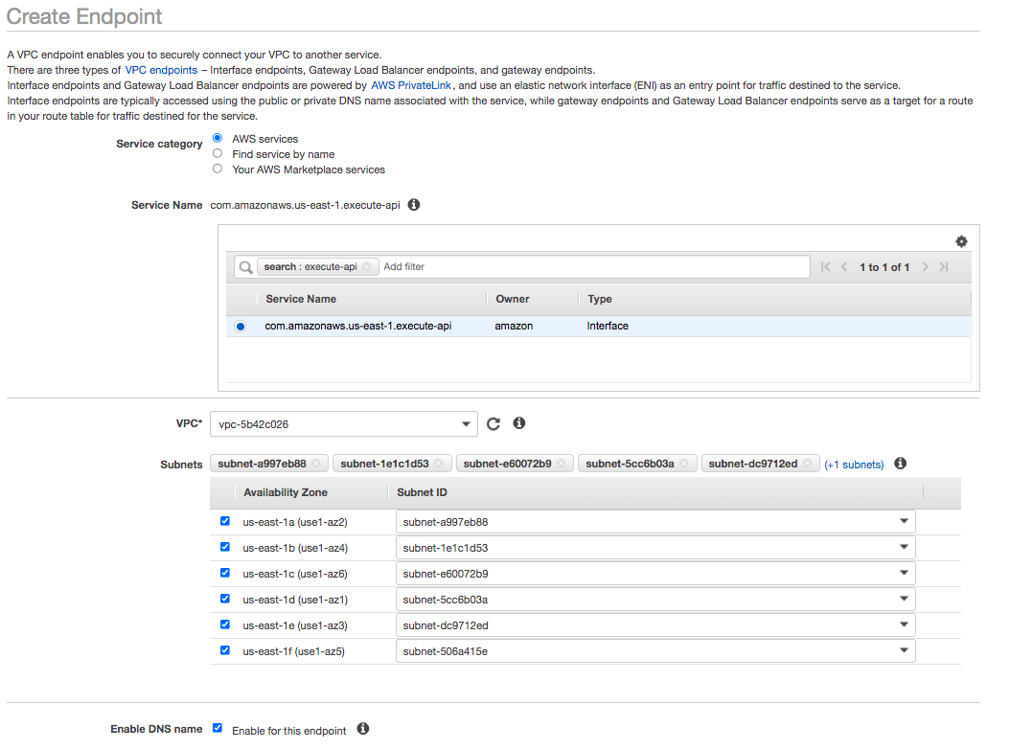

1. You need to select vpc-endpoint-security-group as the **Security Group**. Delete the suggestion to use the default security group by clicking the X button beside it. From the list of security groups displayed, choose the **Security Group** with name vpc-endpoint-security-group.
2. Under **Policy**, choose Full Access and click **Create Endpoint**

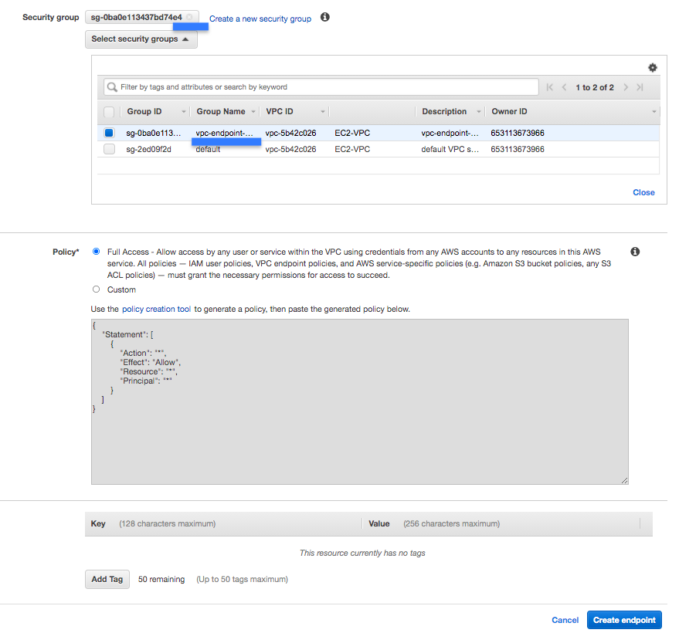

1. *Note down* the id of the VPC Endpoint as VPC-ENDPOINT-ID for use in the next step
2. In the **AWS Console**, from **Services** menu - choose **API Gateway**
3. On the welcome screen, choose the **API type** - REST API Private. Click **'Build'**.
4. Click '**OK'** on the welcome popup
5. Choose the protocol **REST**
6. Under **Create new API** choose New API
7. Under **Settings** enter **API name** as TodoRestAPI and Choose **Endpoint Type** as Private.
8. Choose **VPC Endpoint IDs** as the VPC Endpoint you created earlier (Type in vpce and you should see the endpoint listed)

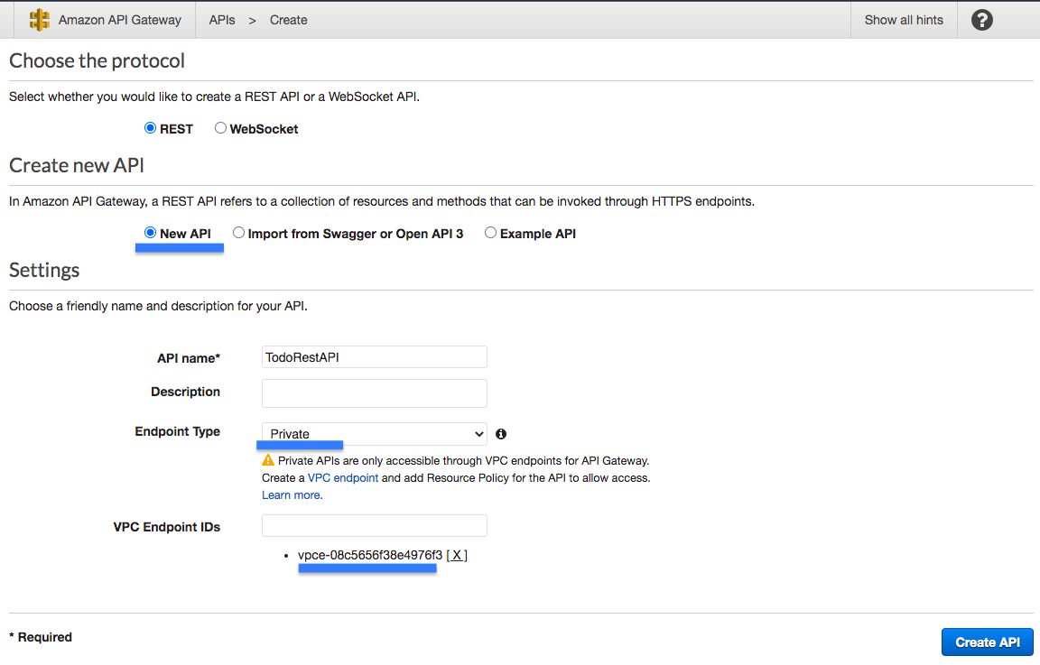

1. Click **Create API**

Integrate hello world Resource GET Method with Lamda Function

Your task is to integrate the private REST API Gateway with the hello world lambda function you created earlier. You will start with creating a hello world resource in the API Gateway. After that you will create a GET method and integrate it with the hello world Lambda function.

1. In the **Actions** dropdown beside **Resources**, Choose **Create Resource**
2. On the **New Child Resource** screen, leave **Configure as a proxy resource** as unchecked
3. Enter **Resource Name** as hello-world. Enter ***Resource Path*** as hello-world.

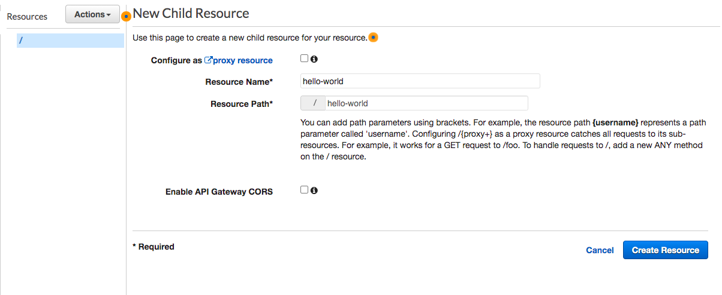

1. Choose defaults for other options and click **Create Resource**
2. Select */hello-world* resource and select **Create Method** from **Actions**
3. Choose **GET** and click the **check** icon beside it
4. On the **/hello-world - GET - Setup** screen, choose **Integration type** - Lambda Function.
5. Check the checkbox **Use Lambda Proxy integration**
6. Choose the Lambda Region us-east-1
7. Choose the Lambda Function HelloWorld

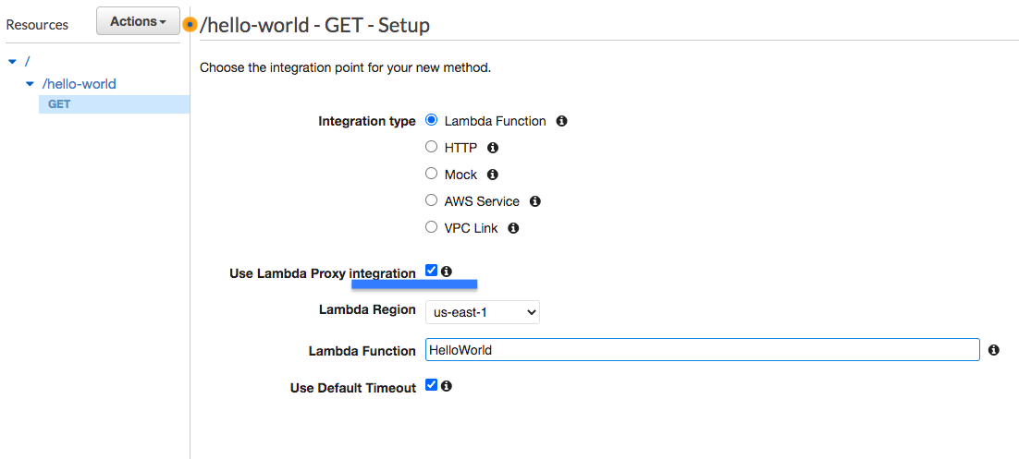

1. Choose defaults for other options and click Save
2. Click **'OK'** on the Add Permission to Lambda Function popup
3. Your Hello World REST API Resource and Resource Methods are now ready
4. Click **Test** inside **/hello-world - GET - Method Execution** (Top left corner)
5. On the **Method execution** screen, scroll down and click **Test**.  
   You should see a response as shown:

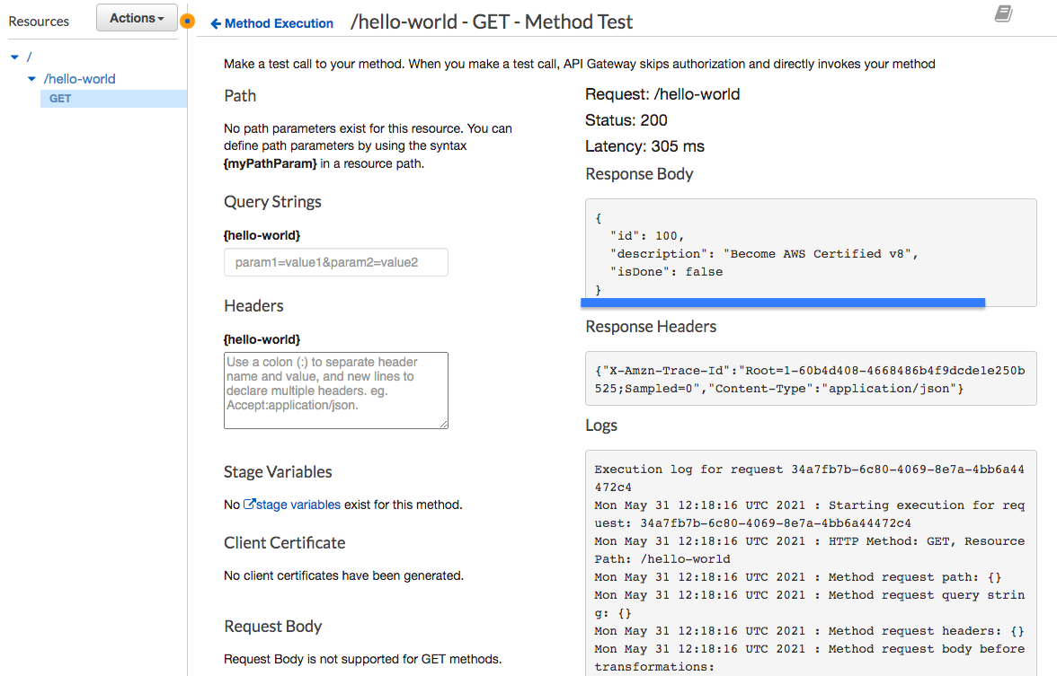

1. You have now integrated your API Gateway with a Lambda function

<https://docs.aws.amazon.com/apigateway/latest/developerguide/set-up-lambda-proxy-integrations.html#api-gateway-simple-proxy-for-lambda-output-format>

<https://docs.aws.amazon.com/lambda/latest/dg/nodejs-context.html>

<https://docs.aws.amazon.com/apigateway/latest/developerguide/set-up-lambda-proxy-integrations.html#api-gateway-create-api-as-simple-proxy>

Create a DynamoDB to store todos

Your task is to create a DynamoDB table, named *todos*, to store your todos. You will also create a couple items in the *todos* table.

1. In the **AWS Console**, from **Services** menu - choose **DynamoDB**
2. Click **Create table** and then set the **Table name** to todos
3. Enter id as **Primary key** with **type** as String
4. Take the defaults for all other settings and click **Create**

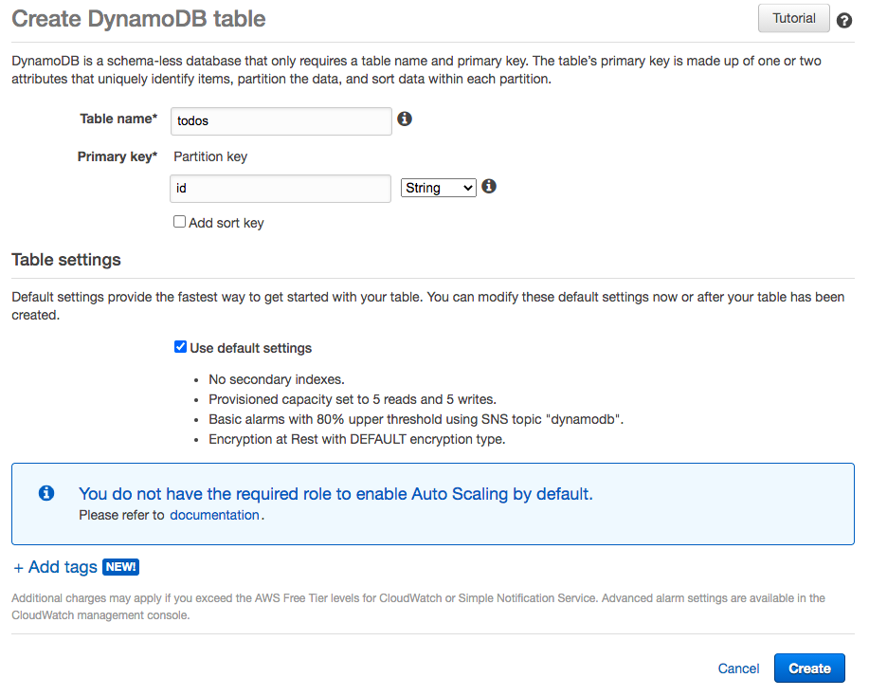

1. Select table todos in DynamoDB
2. Choose the **Items** tab
3. Click **Create Item**
4. Choose the **Text** option from the dropdown in the **Create Item** screen
5. Copy item JSON content from resource todo-item-1.json
6. Click **Save**

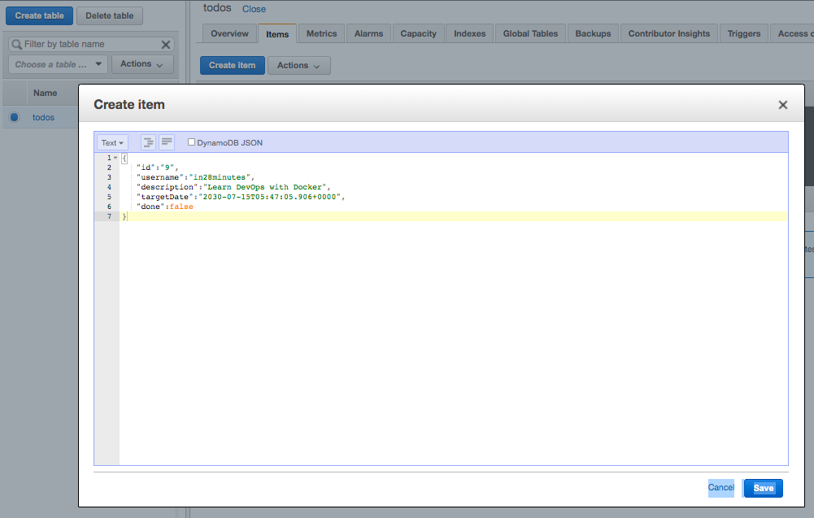

1. Create another item using JSON content from resource todo-item-2.json

Ref todo-item-1.json, todo-item-2.json

Create IAM Role for Lambda Functions

Your task is to create a IAM Role LambdaRoleForProcessingTodos with the permissions to insert, delete, update and retrieve items from the DynamoDB Table. You will create an IAM Policy LambdaDynamoDBAccessPolicy with right permissions and assign it to the IAM Role LambdaRoleForProcessingTodos.

1. In the **AWS Console**, from **Services** menu - choose **IAM**
2. Choose **Policies** from the left hand side menu
3. Click **Create policy**
4. On the **Create policy** screen, click the **JSON** tab
5. Copy JSON from resource iam-role-lambda-function.json into the JSON editor
6. Click **Next: Tags**
7. Click **Next: Review**
8. On the **Create policy** screen, Enter **Name** as *LambdaDynamoDBAccessPolicy*
9. Take the defaults for all other settings and click **Create policy**
10. Choose **Roles** from the **IAM** left hand side menu
11. Click **Create role**
12. Choose the **type of trusted entity** as **AWS service**
13. **Choose a use case** Lambda. Your screen should look like:

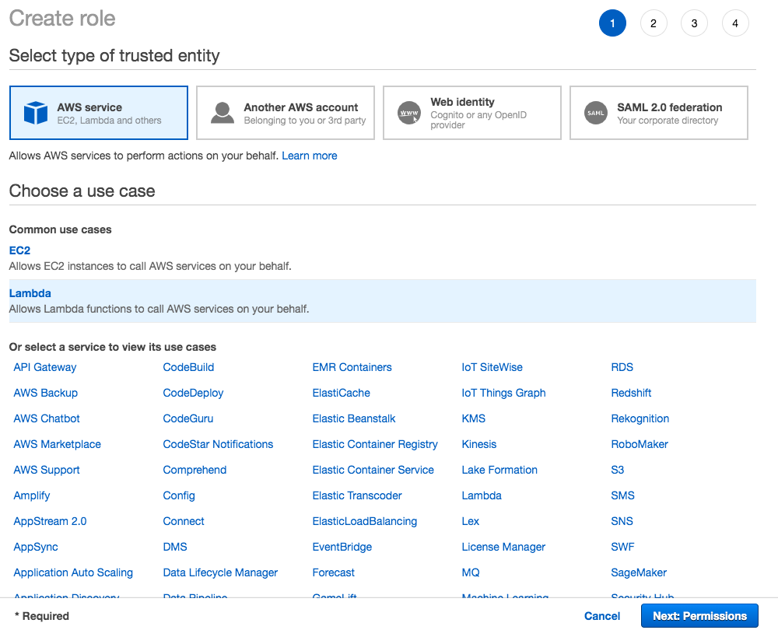

1. Click **Next: Permissions**
2. **Search** and choose the policy *LambdaDynamoDBAccessPolicy*
3. Click **Next: Tags**
4. Click **Next: Review**
5. Enter the **Role name** as *LambdaRoleForProcessingTodos*

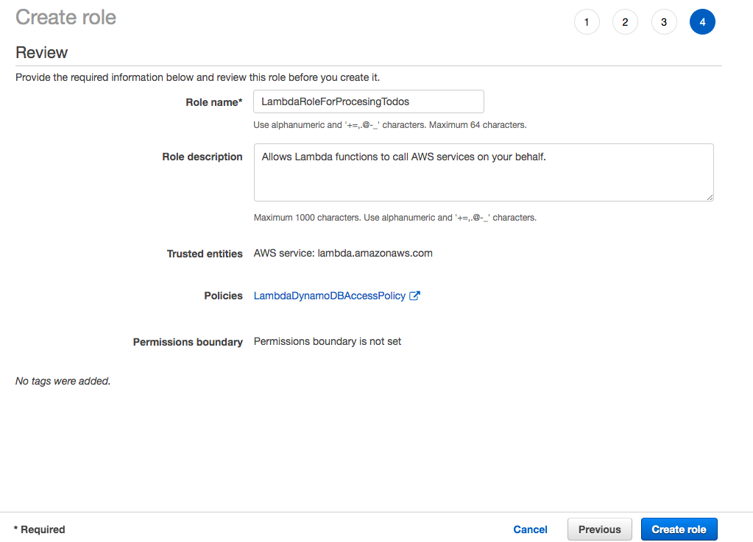

1. Click **Create role**
2. You should see a message ***The role LambdaRoleForProcessingTodos has been created***

Ref Iam-role-lambda-function.json

Create todos REST API to retrieve detail of specific todos(GET method)

Your task is to create a REST API to retrieve all the todos from the DynamoDB table. You will start with creating a Lambda function, named *ListTodos*, to retrieve all items from the todos DynamoDB table. You will create a Todo resource in the API Gateway and create a GET method invoking the Lambda function *ListTodos*.

1. In the **AWS Console**, from **Services** menu - choose **Lambda**
2. Click **Create function**
3. Choose to **Author from scratch**. Enter **Function name** as ListTodos
4. Choose **Runtime** as Node.js 14.x
5. In **Permissions** expand **Change default execution role**. Choose **Use an existing role**.
6. Choose Existing role as *LambdaRoleForProcessingTodos*

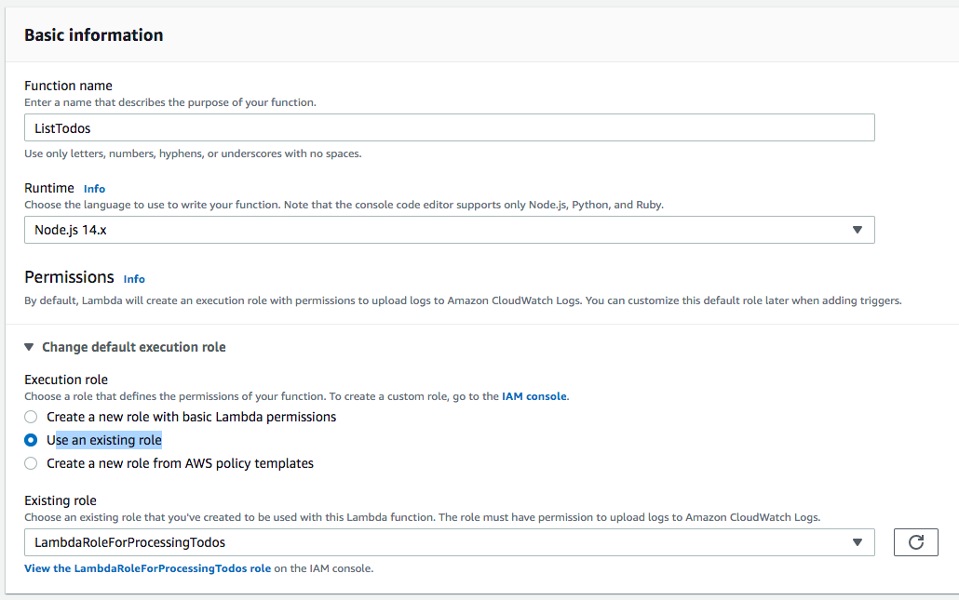

1. Click **Create function**
2. On the **Lambda Source Code** screen, Under Code > Code Source > Select the file index.js under the folder ListTodos
3. **Copy** the code from the file lambda-function-03-list-todos.js
4. Click **Deploy**

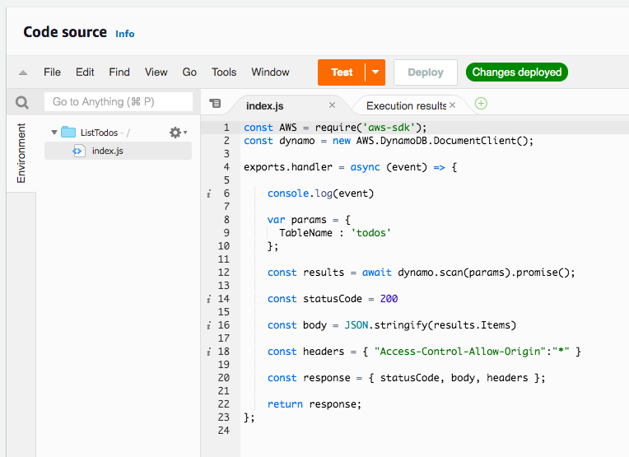

1. Click **Test**
2. On the **Configure test event** screen, select **Create new test event**
3. Choose **Event template** hello-world
4. Enter the **Event name** as HelloWorld and click **Create**
5. Click **Test** again. You should be able to see the result of execution as shown below:

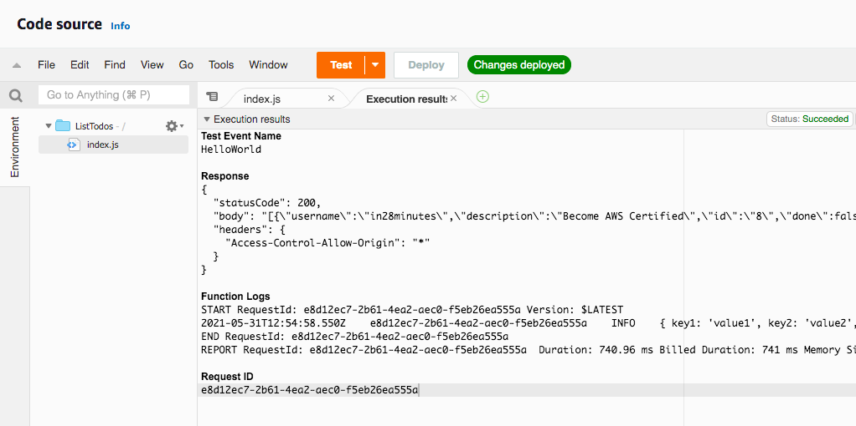

1. In the **AWS Console**, from **Services** menu - choose **API Gateway**
2. Select the API Gateway you created earlier - *TodoRestAPI*
3. **Select**/ as a resource.
4. In the **Actions** dropdown beside **Resources**, Choose **Create Resource**
5. On the **New Child Resource** screen, leave **Configure as a proxy resource** as unchecked
6. Enter **Resource Name** as todos
7. Enter **Resource Path** as *todos*

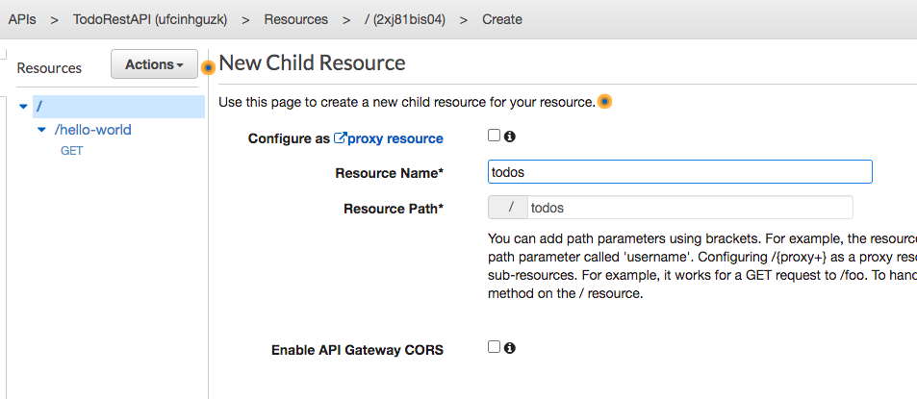

1. Choose defaults for other options and click **Create Resource**
2. **Select** /todos resource and select **Create Method** from **Actions** dropdown
3. Choose **GET** and click the **check**icon beside it
4. On the **/todos - GET - Setup** screen, choose **Integration type** - Lambda Function
5. Check the checkbox **Use Lambda Proxy integration**
6. Choose the **Lambda Region** us-east-1
7. Choose the **Lambda Function** *ListTodos*



1. Choose defaults for other options and click **Save**
2. Click **'OK'** on the **Add Permission to Lambda Function** popup
3. Click **Test**
4. On the '**Method execution**' screen, scroll down and click **Test**.

You should see a response as shown below:

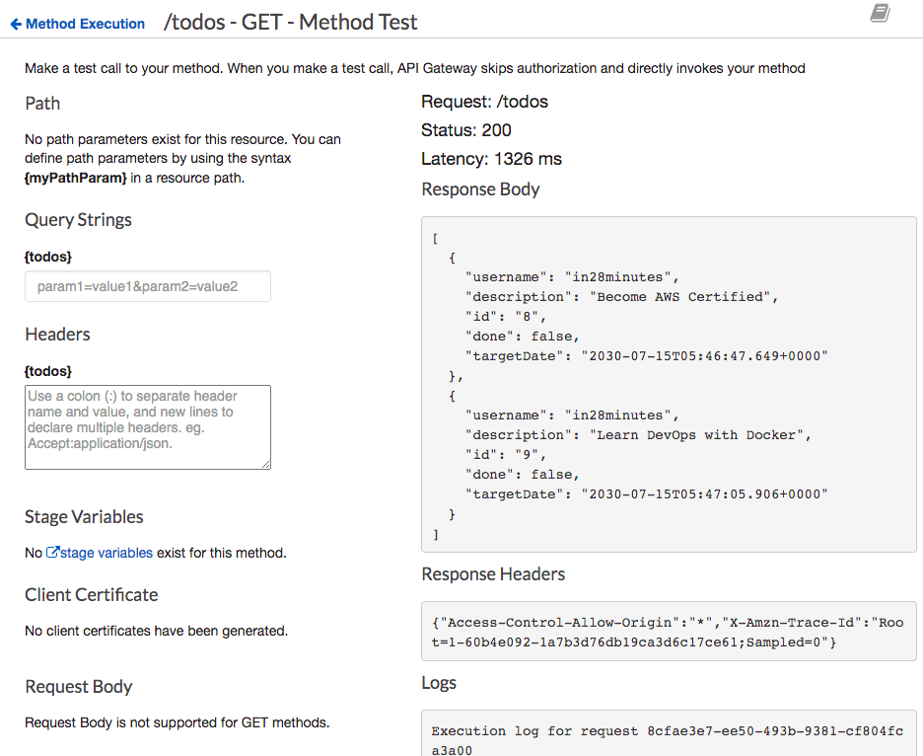

Ref Lamda-functio-03-list-todos.js

Create Todo REST API to retrieve details of specific todo(GET method)

Your task is to create a REST API to retrieve the details of a specific todo. You will pass todo id as a path parameter. You will start with creating a Lambda function, GetTodo, to retrieve the details of a specific todo id from the DynamoDB todos table. After that, you will integrate the API Gateway with the Lambda Function GetTodo.

1. In the **AWS Console**, from **Services** menu - choose **Lambda**
2. Click **Create function**
3. Choose to **Author from scratch**
4. Enter the Function**name** as *GetTodo*
5. Choose **Runtime** as Node.js 14.x
6. In **Permissions** expand **Change default execution role**
7. Choose **Use an existing role**
8. Choose Existing role as *LambdaRoleForProcessingTodos*
9. Click **Create function**
10. On the **Lambda Source Code** screen, Under **Code** > **Code Source** > Select the file index.js under the folder *GetTodo*
11. **Copy** the code from the file lambda-function-04-get-todo.js
12. Click **Deploy**

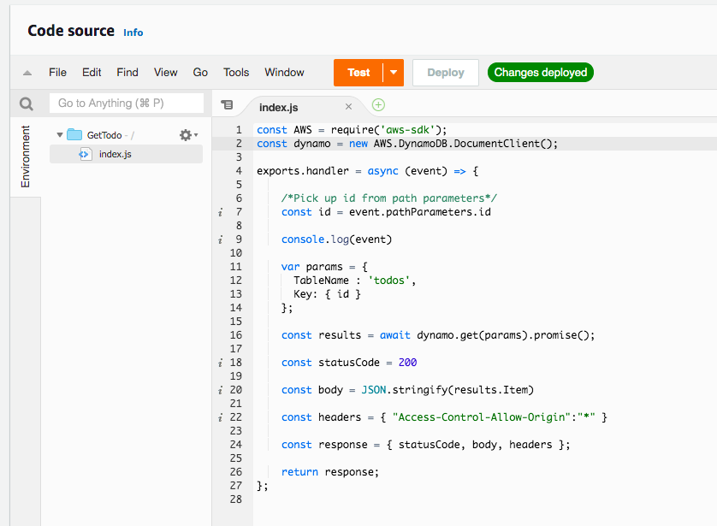

1. In the **AWS Console**, from **Services** menu - choose **API Gateway**
2. Select the API Gateway you created earlier - TodoRestAPI
3. **Select** /todos as resource
4. In the **Actions** dropdown beside **Resources**, Choose **Create Resource**
5. On the **New Child Resource** screen, leave **Configure as a proxy resource** as unchecked
6. Enter **Resource Name** as todo-by-id
7. Enter **Resource Path** as {id} to represent an id parameter

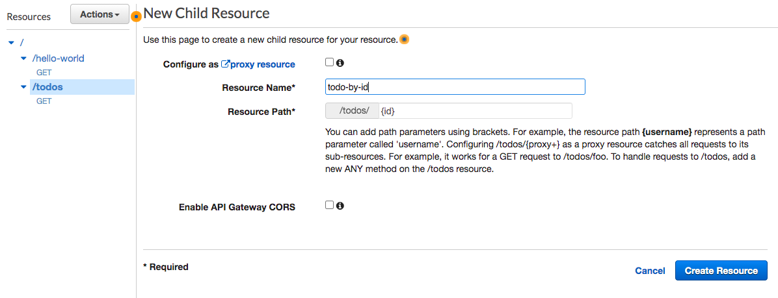

1. Choose defaults for other options and click **Create Resource**
2. **Select** /todos/{id} resource and select **Create Method** from action
3. Choose **GET** and click the **check** icon beside it
4. On the **/todos/{id} - GET - Setup** screen, choose **Integration type** - Lambda Function
5. Check the checkbox **Use Lambda Proxy integration**
6. Choose the **Lambda Region** us-east-1
7. Choose the Lambda Function GetTodo

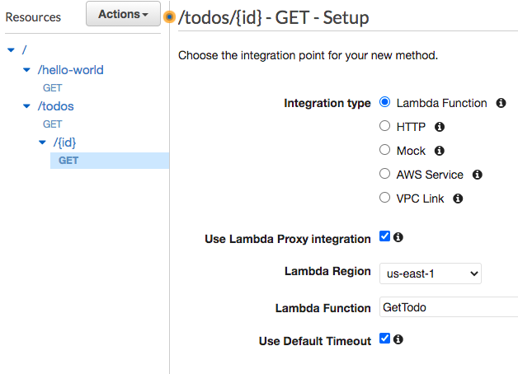

1. Choose defaults for other options and click **Save**
2. Click **'OK'** on the **Add Permission to Lambda Function** popup
3. Click **Test**
4. On the '**Method execution'** screen, scroll down and click **Test**
5. In Path {id} enter 9 (You can pick any id of items which are present in DynamoDB todos table)

You should see a response as shown below:

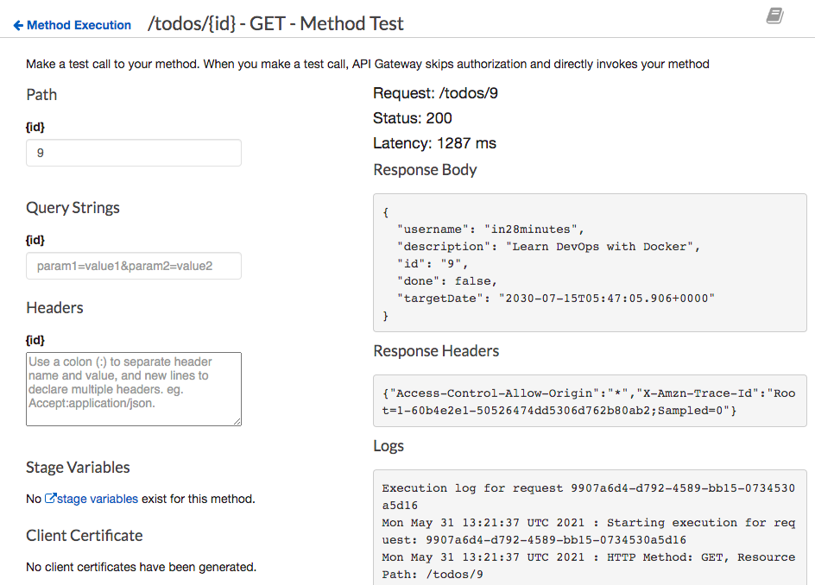

Ref Lambda-function-04-get-todo.js

Add Resource to delete a todo(DELETE nethod)

Your task is to create a REST API to delete a specific todo. You will pass todo id as a path parameter. You will start with creating a Lambda function, DeleteTodo, to delete a todo with a given id from the DynamoDB todos table. After that, you will integrate the API Gateway with the Lambda Function DeleteTodo.

1. In the **AWS Console**, from **Services** menu - choose **Lambda**
2. Click **Create function**
3. Choose to **Author from scratch**
4. Enter the Function**name** as *DeleteTodo*
5. Choose **Runtime** as Node.js 14.x
6. In **Permissions** expand **Change default execution role**
7. Choose **Use an existing role**
8. Choose Existing role as *LambdaRoleForProcessingTodos*
9. Click **Create function**
10. On the Lambda Source Code screen, Under **Code**> **Code Source** > Select the file index.js under the folder *DeleteTodo*
11. Copy the code from the file lambda-function-05-delete-todo.js
12. Click **Deploy**

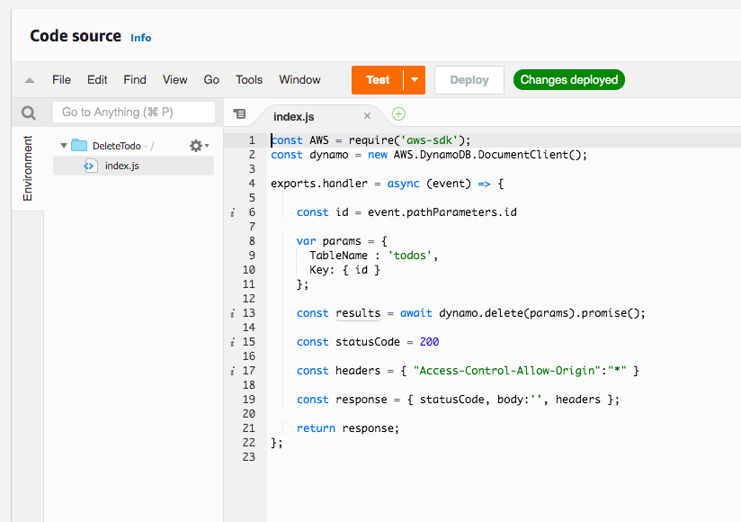

1. In the **AWS Console**, from **Services** menu - choose **API Gateway**
2. Select the API Gateway you have created earlier - TodoRestAPI
3. **Select** /todos > /{id} resource and select **Create Method** from actions
4. Choose **DELETE** and click the **check** icon beside it
5. On the**/todos/{id} - DELETE - Setup** screen, choose **Integration type** - Lambda Function
6. Check the checkbox **Use Lambda Proxy integration**
7. Choose the **Lambda Region** us-east-1
8. Choose the Lambda Function *DeleteTodo*

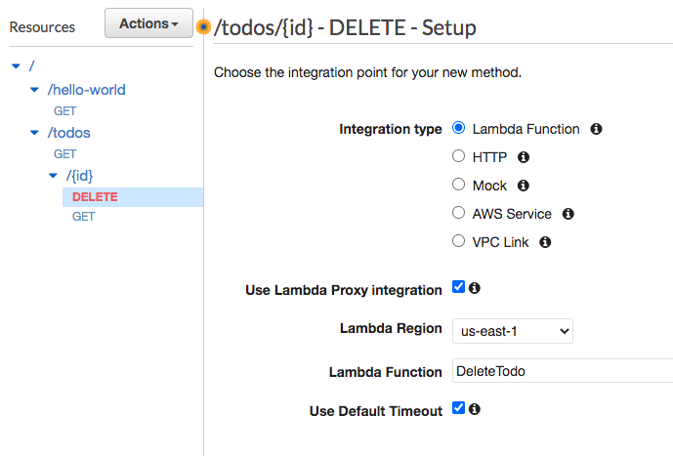

1. Choose defaults for other options and click **Save**
2. Click 'OK' on the **Add Permission to Lambda Function** popup
3. Click **Test**
4. On the '**Method execution**' screen, scroll down and click **Test**
5. In Path {id} enter 9 (You can pick any id of items which are present in DynamoDB todos table)
6. You should see a successful response

Ref lamda-function-05-delete-todo.js

ADD Resource Method to create a todo(POST method)

Your task is to create a REST API to create a new todo. You will pass todo details as body of the request. You will start with creating a Lambda function, AddTodo, to add a todo item into the DynamoDB todos table. After that, you will integrate the API Gateway with the Lambda Function AddTodo.

1. In the **AWS Console**, from **Services** menu - choose **Lambda**
2. Click **Create function**
3. Choose to **Author from scratch**
4. Enter the Function**name** as *AddTodo*
5. Choose **Runtime** as Node.js 14.x
6. In **Permissions** expand **Change default execution role**
7. Choose **Use an existing role**
8. Choose Existing role as *LambdaRoleForProcessingTodos*
9. Click **Create function**
10. On the Lambda Source Code screen, Under **Code**> **Code Source** > Select the file index.js under the folder AddTodo
11. **Copy** the code from the file lambda-function-06-create-todo.js
12. Click **Deploy**

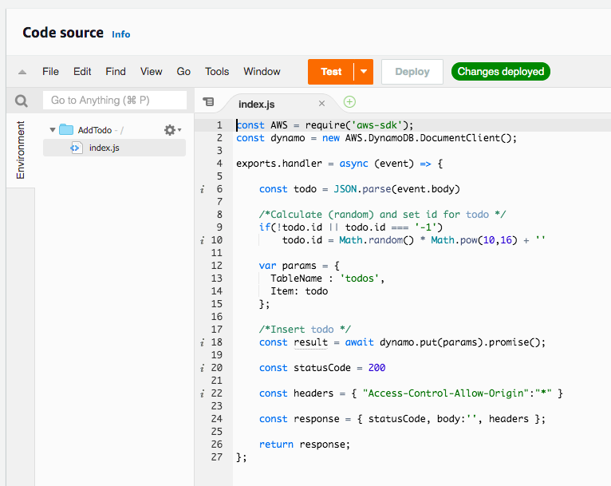

1. In the **AWS Console**, from **Services** menu - choose **API Gateway**
2. Select the API Gateway you created earlier - TodoRestAPI
3. **Select** /todos as a resource and select **Create Method** from actions
4. Choose **POST** and click the **check** icon beside it.
5. On the **/todos - POST - Setup** screen, choose **Integration type** - Lambda Function
6. Check the checkbox **Use Lambda Proxy integration**
7. Choose the **Lambda Region** us-east-1
8. Choose the **Lambda Function***AddTodo*

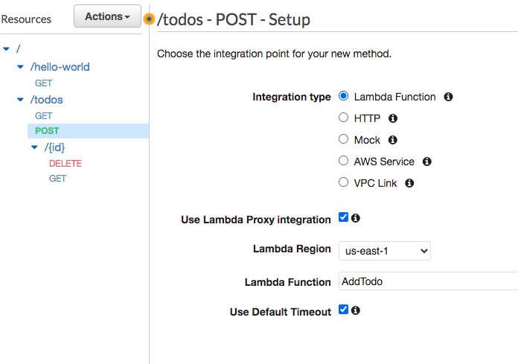

1. Choose defaults for other options and click **Save**
2. Click **'OK'** on the Add Permission to *Lambda Function* popup
3. Click **Test**
4. On the '**Method execution**' screen, enter **Request Body** as text from the resource lambda-function-06-create-todo-request.json, scroll down and click **Test.**

You should see a response as shown below:

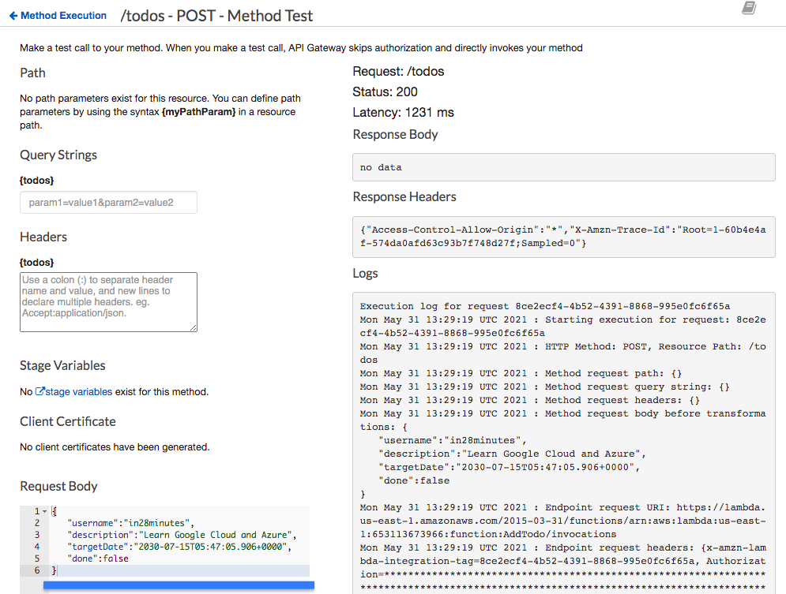

Ref lambda-function-06-create-todo.js

lamda-function-06-create-request.js

Add Resource Method to update a todo(PUT method)

Your task is to create a REST API to update a specific todo. You will pass todo id as a path parameter. You will start with creating a Lambda function, UpdateTodo, to update a todo with a given id in the DynamoDB todos table. After that, you will integrate the API Gateway with the Lambda Function UpdateTodo.

1. In the **AWS Console**, from **Services** menu - choose **Lambda**
2. Click **Create function**
3. Choose to **Author from scratch**
4. Enter the Function**name** as *UpdateTodo*
5. Choose **Runtime** as Node.js 14.x
6. In **Permissions** expand **Change default execution role**
7. Choose **Use an existing role**
8. Choose Existing role as *LambdaRoleForProcessingTodos*
9. Click **Create function**
10. On the **Lambda Source Code** screen, Under **Code** > **Code Source** > Select the file index.js under the folder *UpdateTodo*
11. **Copy** the code from the file lambda-function-07-update-todo.js
12. Click **Deploy**

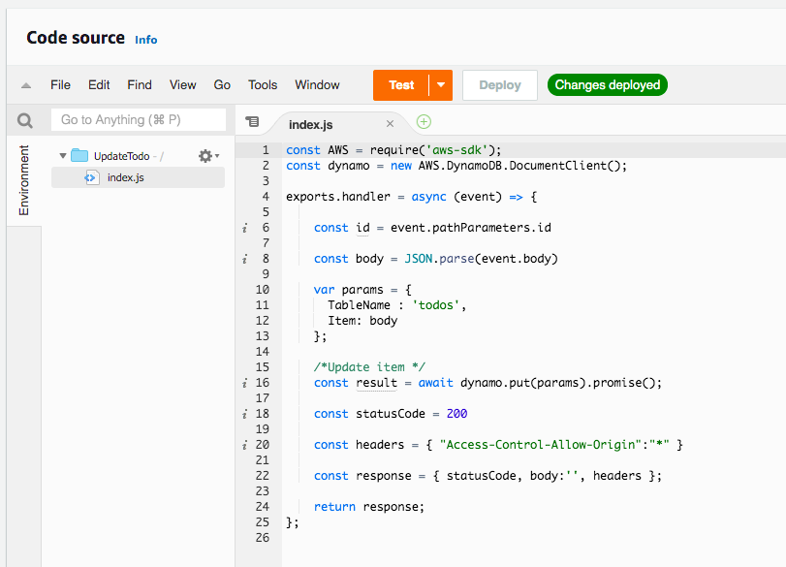

1. In the **AWS Console**, from **Services** menu - choose **API Gateway**
2. Select the API Gateway you created earlier - *TodoRestAPI*
3. Select **/todos > /{id}** resource and select **Create Method** from **Actions**
4. Choose **PUT** and click the **check** icon beside it
5. On the /todos/{id} - PUT - Setup screen, choose **Integration type** - Lambda Function
6. Check the checkbox **Use Lambda Proxy integration**
7. Choose the **Lambda Region** us-east-1
8. Choose the Lambda Function *UpdateTodo*

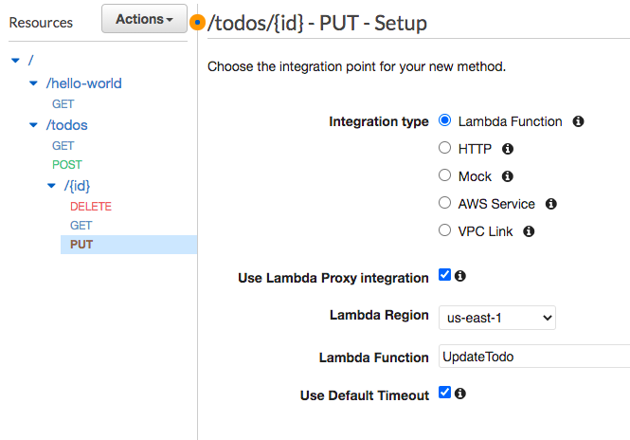

1. Choose defaults for other options and click **Save**. Click **'OK'** on the ***Add Permission to Lambda Function*** popup.
2. Click **Test**. On the '**Method execution**' screen, scroll down and click **Test**
3. In Path {id} enter 9 (You can pick any id of items which are present in DynamoDB todos table)
4. Enter **Request Body** as content from lambda-function-07-update-todo-request-body.json. You should see a response as shown below:

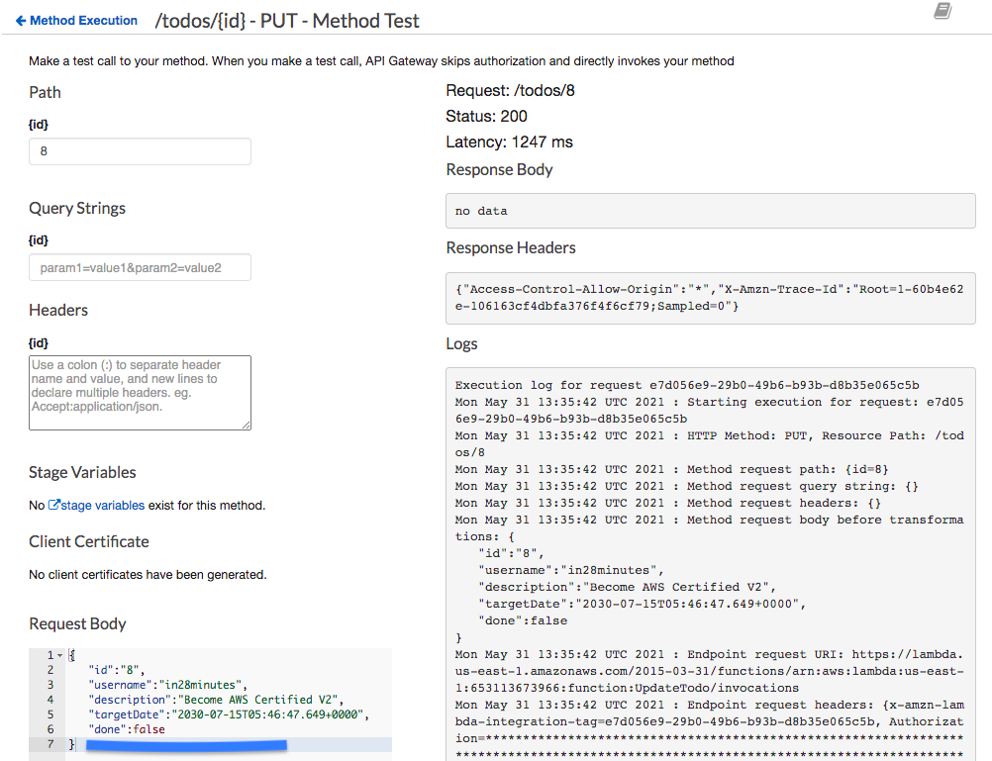

1. Execute a test for the GET method of /todos/{id} with id 8 to test if the update is successful

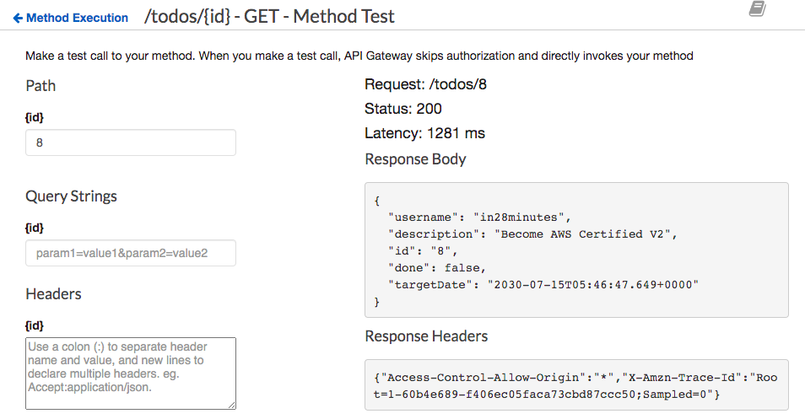

Ref lambda-function-07-update-todo.js

lamda-function-07-update-todo-request-body.js

Deploy and test the REST API

Your task is to deploy the REST API to an environment and test it. To deploy a private REST API Gateway, you need to create a Resource Policy. You will start with creating a Resource Policy allowing access to API Gateway from the default VPC through the VPC endpoint you created earlier. After that, you will deploy the API Gateway resources to a stage named Dev. At the end, you will test the private REST API from an EC2 instance created in the default VPC.

1. In the **AWS Console**, from **Services** menu - choose **API Gateway**
2. Select the API Gateway you created earlier - TodoRestAPI
3. Go to **Resource Policy**
4. In the **Resource Policy** screen, configure policy using the content from *api-gateway-resource-policy.json*
5. **Make sure** that you replace *{{VPC-ENDPOINT-ID}}* with the id of the VPC endpoint (you noted it down as VPC-ENDPOINT-ID) created earlier.

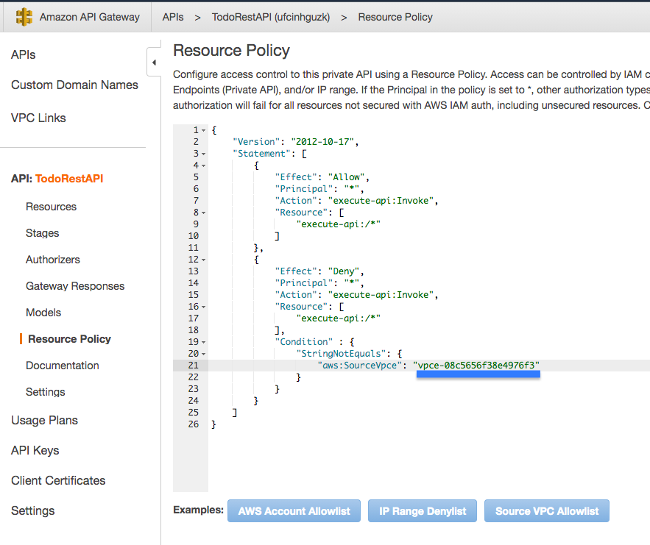

1. Click **Save**
2. Go to **Resources**
3. **Select** the *root* / resource
4. In **Actions** dropdown, Choose **Deploy API**
5. On the Deploy API screen, Choose **Deployment Stage** as [New Stage] and enter the **Stage name** as Dev
6. Click **Deploy**
7. Note down the URL of the Dev stage (as API_GATEWAY_STAGE_URL)

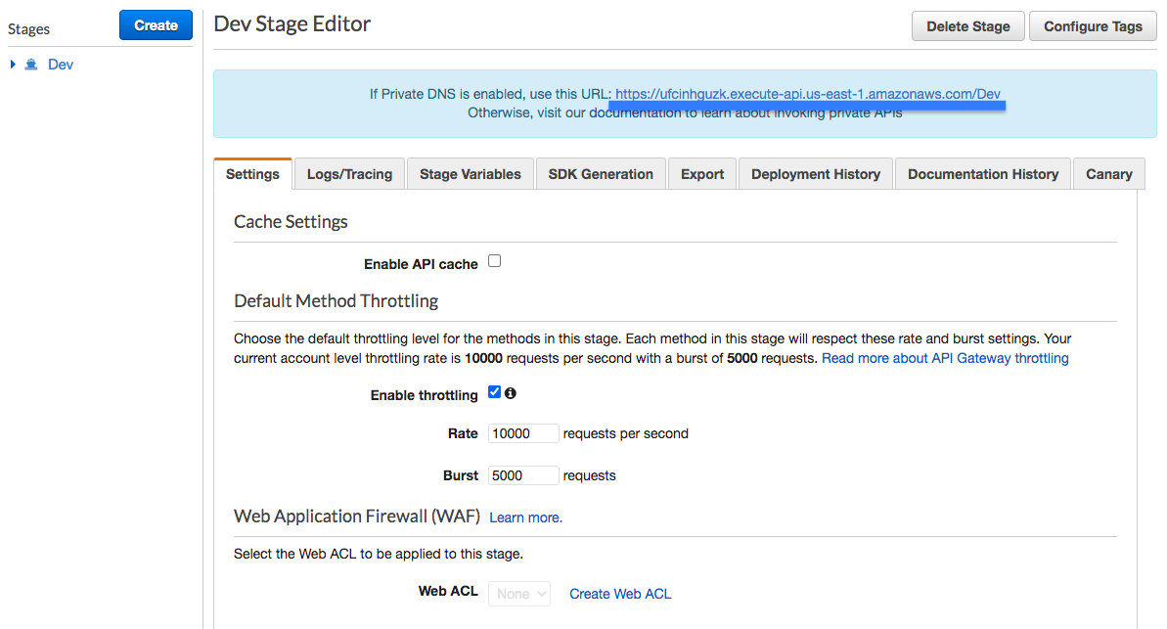

1. In the **AWS Console**, from **Services** menu - choose **EC2**
2. Click**Launch Instance** to start creation of EC2 instance
3. In **Step 1: Choose an Amazon Machine Image (AMI)** choose Amazon Linux 2 AMI (HVM) and click **Select**

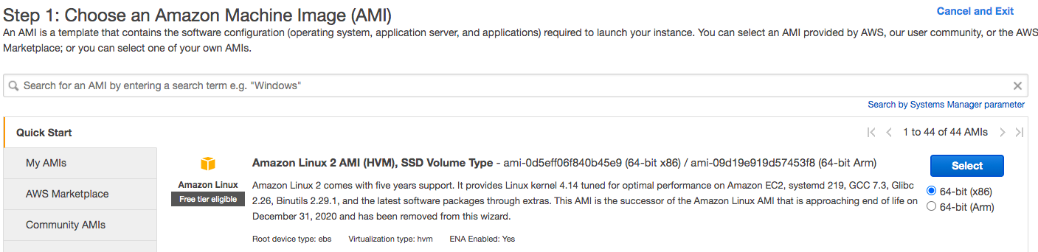

1. On **Step 2: Choose an Instance Type** choose t2.micro instance and click **Review and Launch**

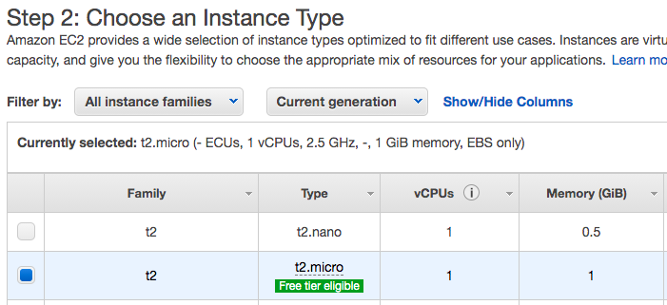

1. On **Step 7: Review Instance Launch**, check Network under Instance Details to ensure that you are launching the EC2 instance into the default VPC
2. Click **Launch**
3. Choose default options on **Select a Key Pair** popup. Enable (check) the check box I acknowledge that I have access to the selected private key file ....
4. Click **Launch Instances**
5. Wait until your EC2 instance is ready
6. Once the instance is launched, click the instance link
7. Select the instance in the **Instances** screen and click **Connect**
8. On the **Connect to instance** page, choose the defaults and click **Connect**

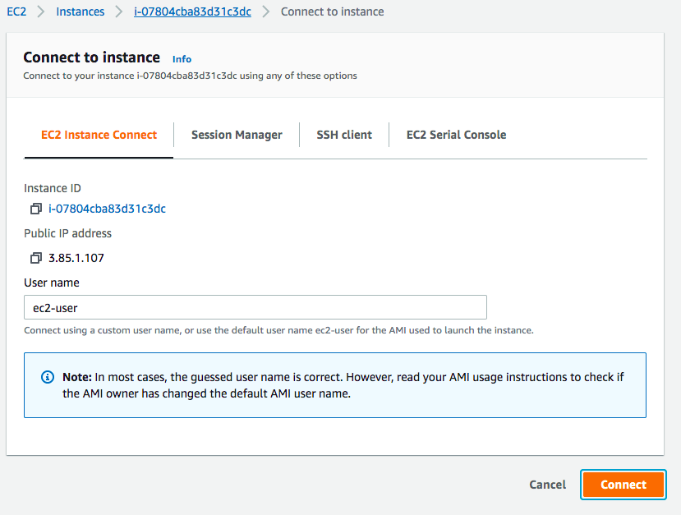

1. You can send requests to the REST API from the EC2 instance. Replace *API_GATEWAY_STAGE_URL* with the path to the API Gateway Dev stage you noted down earlier.

*curl API_GATEWAY_STAGE_URL/hello-world*

*curl API_GATEWAY_STAGE_URL/todos*

*curl --header "Content-Type: application/json" --request POST --data '{"username":"in28minutes", "description":"Learn to Dance", "targetDate":"2030-07-15T05:47:05.906+0000","done":false}' API_GATEWAY_STAGE_URL/todos*

***Examples are shown below:***  
curl <https://ufcinhguzk.execute-api.us-east-1.amazonaws.com/Dev/hello-world>curl <https://ufcinhguzk.execute-api.us-east-1.amazonaws.com/Dev/todos>curl --header "Content-Type: application/json" --request POST --data '{"username":"in28minutes", "description":"Learn to Dance", "targetDate":"2030-07-15T05:47:05.906+0000","done":false}' <https://ufcinhguzk.execute-api.us-east-1.amazonaws.com/Dev/todos>

Result of execution is shown below:

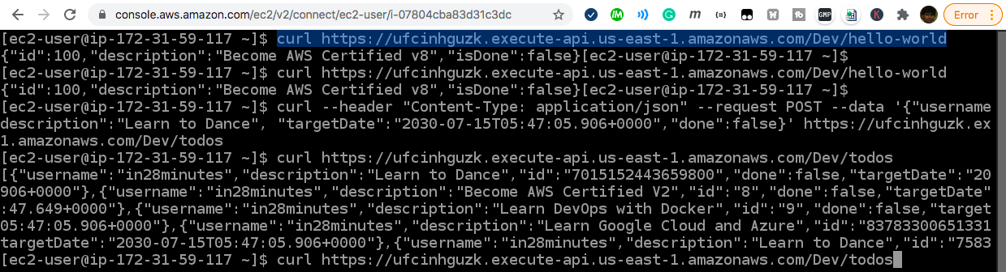

Ref api-gateway-resource-policy.json

Clean up resources

You are done with your POC. Your task is to clean up all the resources you have created for your proof of concept. Ensure that you delete them in the right order.

1. Delete EC2 instance first. In the **AWS Console**, from **Services** menu - choose **EC2**. In the navigation pane, choose **Instances**. Select the instance, and choose **Actions**, **Instance State**, **Terminate**. Choose **Yes**, **Terminate** when prompted for confirmation.
2. Delete API Gateway - TodoRestAPI. In the **AWS Console**, from **Services** menu - choose **API Gateway**. On the **APIs** page, select the API. Choose **Actions**, and then choose **Delete**. Choose **Delete**. Confirm your selection on the confirmation dialog.
3. Delete all Lambda functions. In the **AWS Console**, from **Services** menu - choose **AWS Lambda**. On the **Functions** page, select all the functions. Choose **Actions**, and then choose **Delete**. Choose **Delete**. Confirm your selection on the confirmation dialog.

Delete DynamoDB items Table. In the **AWS Console**, from **Services** menu - choose **DynamoDB**. In the navigation pane, choose **Tables**.In the list of tables, choose ***todos***. Choose **Delete Table**. Confirm your selection on the confirmation dialog